**Introducing 'Hingey' – Hettich Australia's new AI chatbot for enhanced customer service!**

**We’re always looking at new ways to improve the Hettich experience. The team are excited to announce the launch of our very own Chatbot, 'Hingey', designed to revolutionise customer support and assistance in navigating Hettich products and tools.**

Powered by cutting-edge AI technology with ChatGPI, Hingey provides customers with an intuitive and efficient means to access information about Hettich and our comprehensive product line. Whether you have questions about our offerings, need assistance with product recommendations, or seek historical information about Hettich, Hingey is here to help.

**Key features of Hingey**

* Hingey provides recommendations based on your needs and preferences to help you find the right product for your project.
* You can find historical information about Hettich.
* Hettich offers various services including Warranty, After Sale Services, Trade Showroom, and Industry Advocate.
* Linking to our online portal that assists in technical assembling and adjusting Hettich products, including small processing tools.
* Where you can access Hettich product catalogues online.
* If you are looking for details about employment opportunities at Hettich, you can find all the information

Say hello to Hingey and experience Hettich’s AI customer support by visiting our [Trade](https://web.hettich.com/en-au/home)  website.

For further inquiries or assistance, our dedicated Customer Service team in Australia is available at [support-au@hettich.com](mailto:support-au@hettich.com)

The following picture material is available for downloading from the **"Press" menu** at **www.hettich.com**:

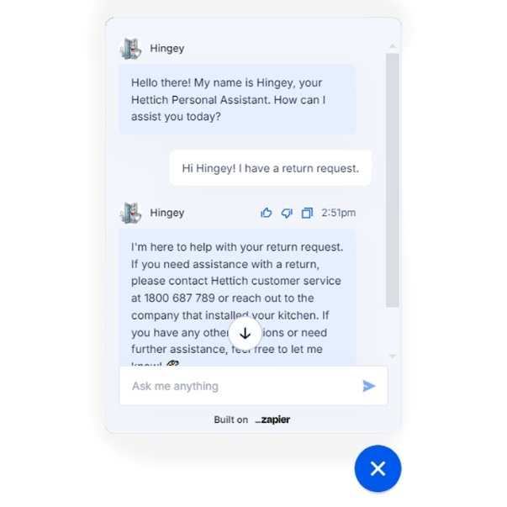

**Introducing Hingey.jpg**

Meet 'Hingey,' Hettich's Personal Assistant. Ask Hingey for expert advice and assistance with all your Hettich needs!

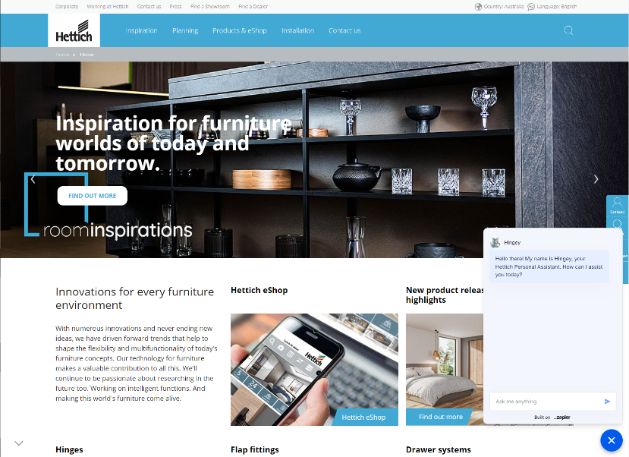

**Introducing Hingey (1).png**

The Hettich chatbot is available on our homepage - Visit web.hettich.com/en-au/ in the bottom right corner for instant virtual assistance.

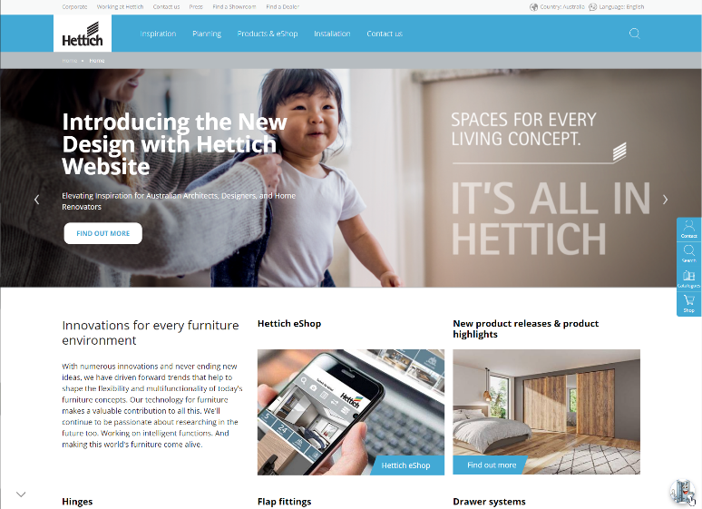

**Introducing Hingey (2).png**

The Hettich chatbot is available on our homepage - Visit web.hettich.com/en-au/ in the bottom right corner for instant virtual assistance.

About Hettich

Founded in 1888, Hettich is one of today's largest and most successful manufacturers of furniture fittings on the international stage. The family-owned company is based at Kirchlengern in the furniture-making cluster of Germany's East Westphalia region. Some 8,600 members of staff work together to provide our future-proof solutions in over 100 countries. Promising "It's all in Hettich", the Hettich brand provides a comprehensive portfolio of services that is consistently and resolutely geared to the needs of customers across the globe. By tradition, top priority has always been at the focus of everything we do to ensure sustainability at social, societal and ecological levels. [www.hettich.com](http://www.hettich.com)