Hettich DIY Makes Self-Build Projects a Success
New Products Showcased at the 2024 Hardware Fair

Hettich is always a safe bet when setting trends in the DIY segment. At the Hardware Fair from 3 to 6 March 2024 in Cologne, the fittings specialist and one of the world's market leaders in this field will demonstrate what today's DIY product ranges can encompass with an approach that speaks to consumer emotions at the point of sale (POS) and in online retailer marketing. Alongside professional quality, the main focus here is on customers with good manual skills looking for inspiring ideas and greater sustainability. Hettich DIY is extending an invitation to "its own home" in Cologne, hall 11.1, stand no. K011, K010, L011. This refers to a 66-square-metre dwelling packed with DIY solutions created using the latest products from Hettich.

Whether it's a cleverly designed utility room, a living and dining area with a room divider, or a homeworking space, every room is nothing short of heaven for DIY enthusiasts. To spark interest in the many new DIY ideas before consumers even reach the home improvement store shelf, Hettich is using "#Change of perspective: world beneath the table" to present a new advertising campaign. This campaign will also be made available to retail partners for their online marketing activities on websites and social media channels. The clever twist: photos and videos showcase the world of furniture through the eyes of little ones at home, like children and pets, and from the angle of objects such as robot vacuum cleaners or toy cars. Viewing the DIY table and furniture projects below reveals astonishing idea-generating potential. Not only does it present products in a different light, but it also unveils new creative solutions, for example, using table legs as a great way of making a sturdy surface-mounted shelf unit. The campaign is being launched on the Hettich DIY Instagram channel in time for the hardware fair and will also be shown on the exhibition stand. Hettich has also integrated the new campaign motifs into its POS shelf displays, which will be showcased on the DIY Boulevard.

Novisys – Soft Closing Convenience for DIY Furniture
With immediate effect, the Novisys hinge system is bringing the luxury of soft-closing doors to the DIY world at an affordable price. Novisys is synonymous with quality Made in Germany. This is precisely what distinguishes it from hinges of comparably low price: Novisys sets a new quality standard with its reliable Silent System performance and long service life. As part of the platform concept, the hinge with integrated Silent System can also be clipped onto other Hettich mounting plates later. This makes Novisys the ideal replacement hinge in DIY and furniture hardware stores.

Products and Packaging Are Becoming Greener
When it comes to using resources efficiently, Hettich is treading new paths with its innovative Novisys hinge technology, proving that placing exacting demands on product quality does not necessitate the use of more material and energy. This makes ecological sense and is cost-effective – progressively, sustainability is becoming a key indicator in purchasing decisions. On the packaging side, Hettich is also offering more and more sustainable packaging made of cardboard for the store shelf, many of which contain no plastic whatsoever.
Trend Towards "Modern Rustic"
Lastly, DIY enthusiasts will discover the hippest interior design trends from various TV formats or social media. Hettich's modern decorative fittings and accessories allow retailers to respond to their customers' desires immediately. Catering to coat racks, hooks, furniture handles, and knobs, Hettich will not only be showing new models for classic styles but also ones that cater to the "modern rustic" trend, for example. A rustic style in a modern Scandinavian design with loads of natural materials. A couple of new handles here or a wooden coat rack there brings the furnishing right back on trend. This is why, from a sales point of view, keeping these product lines up to date is so important.

MOOV – Height Adjustable Table Leg Series
Infinite height adjustment is the magic formula set to fire the imagination of DIY enthusiasts everywhere because the options provided by the MOOV table leg series to customise applications and solutions are vast. Be it a table for kids that grows with them, for better ergonomics working from home, in the workshop or craft room, or for customising surface heights, e.g., of kitchen counters, the list goes on. Ideas abound – and MOOV now at last provides an easy way of realising them. Each table leg adjusts individually, levelling out any unevenness with minimum effort. This is done without the need to turn or pull the height adjust

MultiGreen cabinet body template – sturdy connections
For many, giving free rein to creativity and being able to make furniture ideas come true is the motivation to become a DIYer. Little assistants like the new MultiGreen cabinet body template boost the fun factor and the prospects of successfully building sturdy furniture. In future, the cabinet body template is set to replace tape measure and pencil when it comes to fitting recessed cabinet body connectors. The new MultiGreen hole marking template not only makes placing Rastex type concealed connectors easy but, above all, failsafe too. This lets amateur furniture designers create high strength, flush fitting cabinet body joints at low cost too.

Heavy Duty runners – big and strong
Bringing out the new Heavy Duty runners, Hettich DIY pushes previous load capacity boundaries and closes an important gap. Because so far, the end of the road for conventional runners was reached at 35 kg load capacity and 550 mm depth. Providing a nominal length of up to 1350 mm and load capacity of 180 kg, nothing is too heavy or too large for these Heavy Duty runners. Ideal for all self build projects such as camper conversions and storage solutions that call for exceptional load capacity.

For anyone unable to make it to the 2024 Hardware Fair in Cologne, all solutions can be viewed online as well: https://diy.hettich.com/en-de/home

The following picture material is available for downloading from the "Press" menu at www.hettich.com:

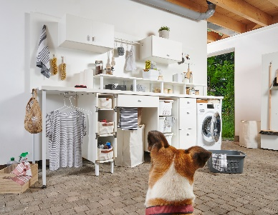
072024_a
The attention grabbing DIY online campaign #Change of perspective: world beneath the table" shows the world of furniture through the eyes of a dog, say. This is where all sorts of creative solutions are just waiting to be discovered. Photo: Hettich

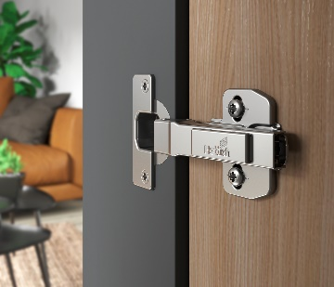
072024_b
Providing top value for money, Novisys brings soft closing convenience, greater sustainability and quality made in Germany to self build furniture. Photo: Hettich

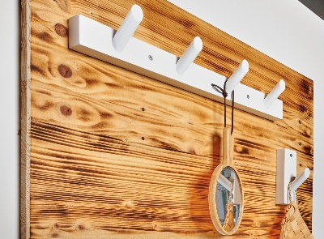
072024_c
Reflecting the "modern rustic" trend, Hettich DIY is showcasing attractive solutions from the decorative fittings & accessories segment. Photo: Hettich

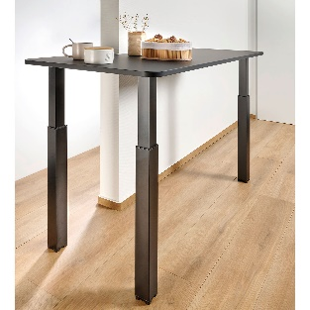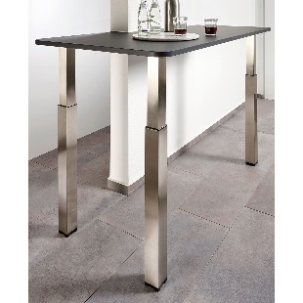
072024_d+e
Given its infinitely variable height adjustment capability, the MOOV table leg series in matt black or brushed stainless steel look gives DIY enthusiasts a huge range of options.
Photo: Hettich

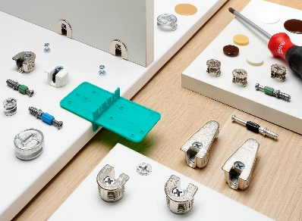
072024_f
The new MultiGreen cabinet body template is the amateur furniture designer's failsafe answer to creating high-strength, flush cabinet body joints. Photo: Hettich

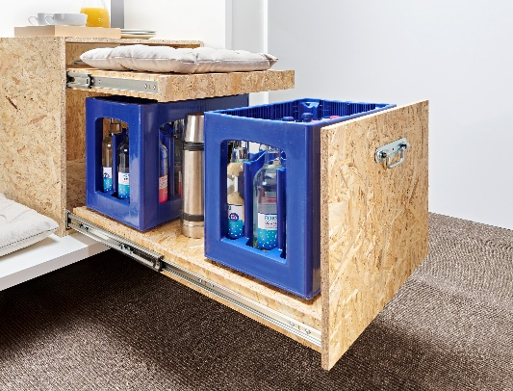
072024_g
At last, the Heavy Duty runners from Hettich DIY virtually puts an end to the limits on runner load capacity in self build projects. Photo: Hettich

About Hettich
Founded in 1888, Hettich is one of today's largest and most successful manufacturers of furniture fittings on the international stage. The family-owned company is based at Kirchlengern in the furniture-making cluster of Germany's East Westphalia region. Some 8,000 members of staff in almost 80 countries work together to give the industry future-proof solutions. Promising "It's all in Hettich", the Hettich brand provides a comprehensive portfolio of services that is consistently and resolutely geared to the needs of customers across the globe. By tradition, top priority has always been at the focus of everything we do to ensure sustainability at social, societal and ecological levels. www.hettich.com

