**A decade of Hettich volunteering**

**Over 1,300 projects and 775,000 euros for social responsibility**

**This year, the Hettich Group is celebrating the tenth anniversary of its "Hettich Ehrenamt" campaign, which has been making a significant contribution to social commitment since 2013. Since its launch to mark the company's 125th anniversary in 2013, the company has already supported 1,368 projects and donated a total of 775,500 euros.**

In the current year alone, Hettich colleagues have been involved in 133 different projects worldwide. The Hettich Group supported voluntary work in Germany, the Czech Republic, Australia, England and Spain with 500 euros per project and issued donation cheques totalling 66,500 euros.

"Many colleagues at Hettich worldwide are involved in social projects on a voluntary basis alongside their work. We would like to express our appreciation to all of them for dedicating their free time to various activities in the social sector and have therefore been supporting this commitment since 2013," says Jana Schönfeld, Managing Director of the Hettich Group.

Anyone working at Hettich can apply for funding in aid of projects

they do voluntary work for. Funding in the amount of € 500 go to

projects related to social matters, education, science, nutrition,

exercise, culture and the environment.

The diversity of the commitment is reflected in the support for children and youth projects, help for the sick and those in need of care, support for local clubs, rescue services and sporting institutions. "Hettich volunteering is more than just supporting projects, because it means that we at Hettich care for others. We receive a lot of positive feedback from the organisations we support, which shows that we are making a valuable contribution," says Laura-Sophie Fuchs, Corporate Communications at Hettich.

The Hettich Group is reaffirming its commitment to voluntary work and emphasising that it will continue to invest in social projects even in difficult economic times. The company is thus sending a clear signal for sustainable social responsibility. "We look forward to continuing to support the diverse commitment of our colleagues within the framework of Hettich Ehrenamt in the future and thus making a sustainable contribution to society," emphasises Schönfeld.

The following picture material is available for downloading from the "**Press**" **menu** at **www.hettich.com**:

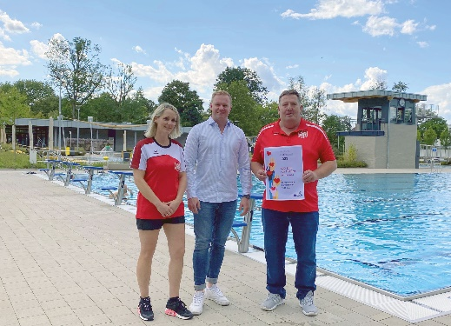

**412023_a**

Hettich colleague Ivonne Terbeck from Germany is involved with the Turngemeinde Ennigloh von 1887 e.V. The organisation supports children who have completed the seahorse course with further swimming training. This teaches them different types of swimming, gives them confidence in the water and improves their fitness. The funding from Hettich will be used to purchase new training materials. Photo: Hettich

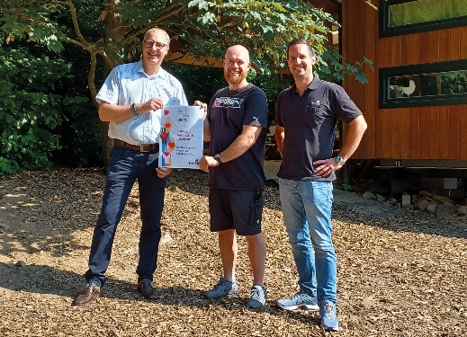

**412023_b**

Hettich colleague Benjamin Mester from Germany is actively involved in the forest kindergarten "Die Käferbande". Hettich's donation will be used to purchase a wooden workbench and to carry out maintenance work directly on site. The children will have the opportunity to obtain a tool driving licence. This teaches them how to use tools such as a hammer or a saw in a controlled manner. In a playful way, they learn how to repair things themselves. Photo: Hettich

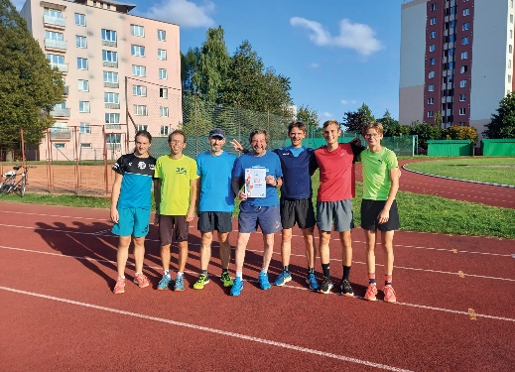

**412023_c**

Hettich colleague Roman Řezníček from the Czech Republic supports the athletics department TJ Nové Město na Moravě as an assistant coach. In the "Athletics is fun" project, summer camps are organised in Svratka and Budišov where juniors can improve their skills with the help of qualified coaches. The 500 euros from Hettich will be used for the summer camp and for the purchase of sports equipment and aids. Photo: Hettich

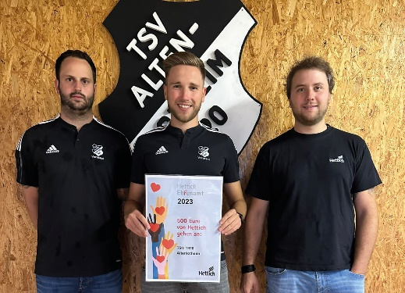

**412023_d**

Hettich colleague Nico Backhaus from Germany is committed to TSV 1920 Altenlotheim. The floodlight system at the sports ground is being converted to LED lights, as these consume less electricity and are therefore more environmentally friendly. This investment is supported by the grant from Hettich. Photo: Hettich

About Hettich

Founded in 1888, Hettich is one of today's largest and most successful manufacturers of furniture fittings on the international stage. The family-owned company is based at Kirchlengern in the furniture-making cluster of Germany's East Westphalia region. Some 8,000 staff members in almost 80 countries work together to give the industry future-proof solutions. Promising "It's all in Hettich", the Hettich brand provides a comprehensive portfolio of services that is consistently and resolutely geared to customers' needs across the globe. By tradition, top priority has always been at the focus of everything we do to ensure social, societal and ecological sustainability. [www.hettich.com](http://www.hettich.com)