**Act today – think about tomorrow**

# Hettich publishes new Sustainability Report 2023

**With its fourth voluntary sustainability report, the Hettich Group provides an insight into its sustainability strategy, measures implemented and planned, and successes and challenges along the way.**

As a family business with 135 years of history, Hettich's long-term goal is to combine economic success with social, societal and ecological responsibility. The extent to which sustainability is anchored in Hettich's corporate DNA is also reflected in its tradition of reporting: Hettich published its first sustainability report back in 2015 and has been updating it continuously ever since – long before the topic gained its current presence in public perception.

**Social responsibility: "We care for each other"**

At Hettich, the focus is on people. So health and safety at work have top priority. For Hettich as an employer, the focus is on well-founded training and further education, the promotion of diversity and equal opportunities as well as the personal responsibility of all colleagues. Hettich creates an attractive working and living environment that allows people to develop and flourish by focusing on their strengths. The strategy includes a sustainable and healthy Hettich culture including the promotion of digital competence as a prerequisite and support for modern cooperation and a sustainable working environment.

**Societal responsibility: "We care for others"**

As a responsible member of society, Hettich is committed across corporate boundaries. For example, Hettich makes monetary and in-kind donations to education and science, art, culture and social causes. At the Hettich locations, the company provides support through sponsoring activities and by promoting the voluntary activities of colleagues. Hettich Group companies also contribute to tax revenue and social security contributions in their respective countries.

**Ecological responsibility: "We care for the environment"**

"We take responsibility for the world in which we live in order to preserve the earth's resources as best as we can for future generations", says Jana Schönfeld, Managing Director of the Hettich Group. For many years now, the Hettich Group has regarded the continuous improvement of resource efficiency, reduction of energy consumption and avoidance of environmental pollution as an obligatory part of its corporate culture.

Binding sustainability principles have been in place at Hettich since the early 1990s and they are also consistently put into practice at a wide variety of levels. At the end of 2022, the Hettich Group has adapted its sustainability principles to its corporate strategy and added the goal of climate neutrality for direct and indirect greenhouse gas emissions (Scope 1 and 2 according to the Greenhouse Gas Protocol) at the company's sites. "We give priority to avoidance and reduction and only consider the compensation of climate-damaging greenhouse gas emissions as a last resort," emphasises Ute Schulz, Corporate Responsibility Team.

**Strong together for sustainability**

"At Hettich, we live a participatory culture in which we can all contribute our strengths, passions and ideas in the best possible way. This naturally also applies to the sustainabilty initiatives," reports Schönfeld. Although principles, guidelines and processes for responsible, sustainable action have been implemented in the Hettich Group for many years, there is still a lot to do to make the future worth living for everyone. "Together as a team, we shape the sustainability agenda and ensure continuous development," Schulz emphasises.

The detailed Hettich Sustainability Report 2023 is available for download on the Internet:

https://www.hettich.com/short/nws2iyr

The following image material is available for download at **www.hettich.com, menu: Press** for download:

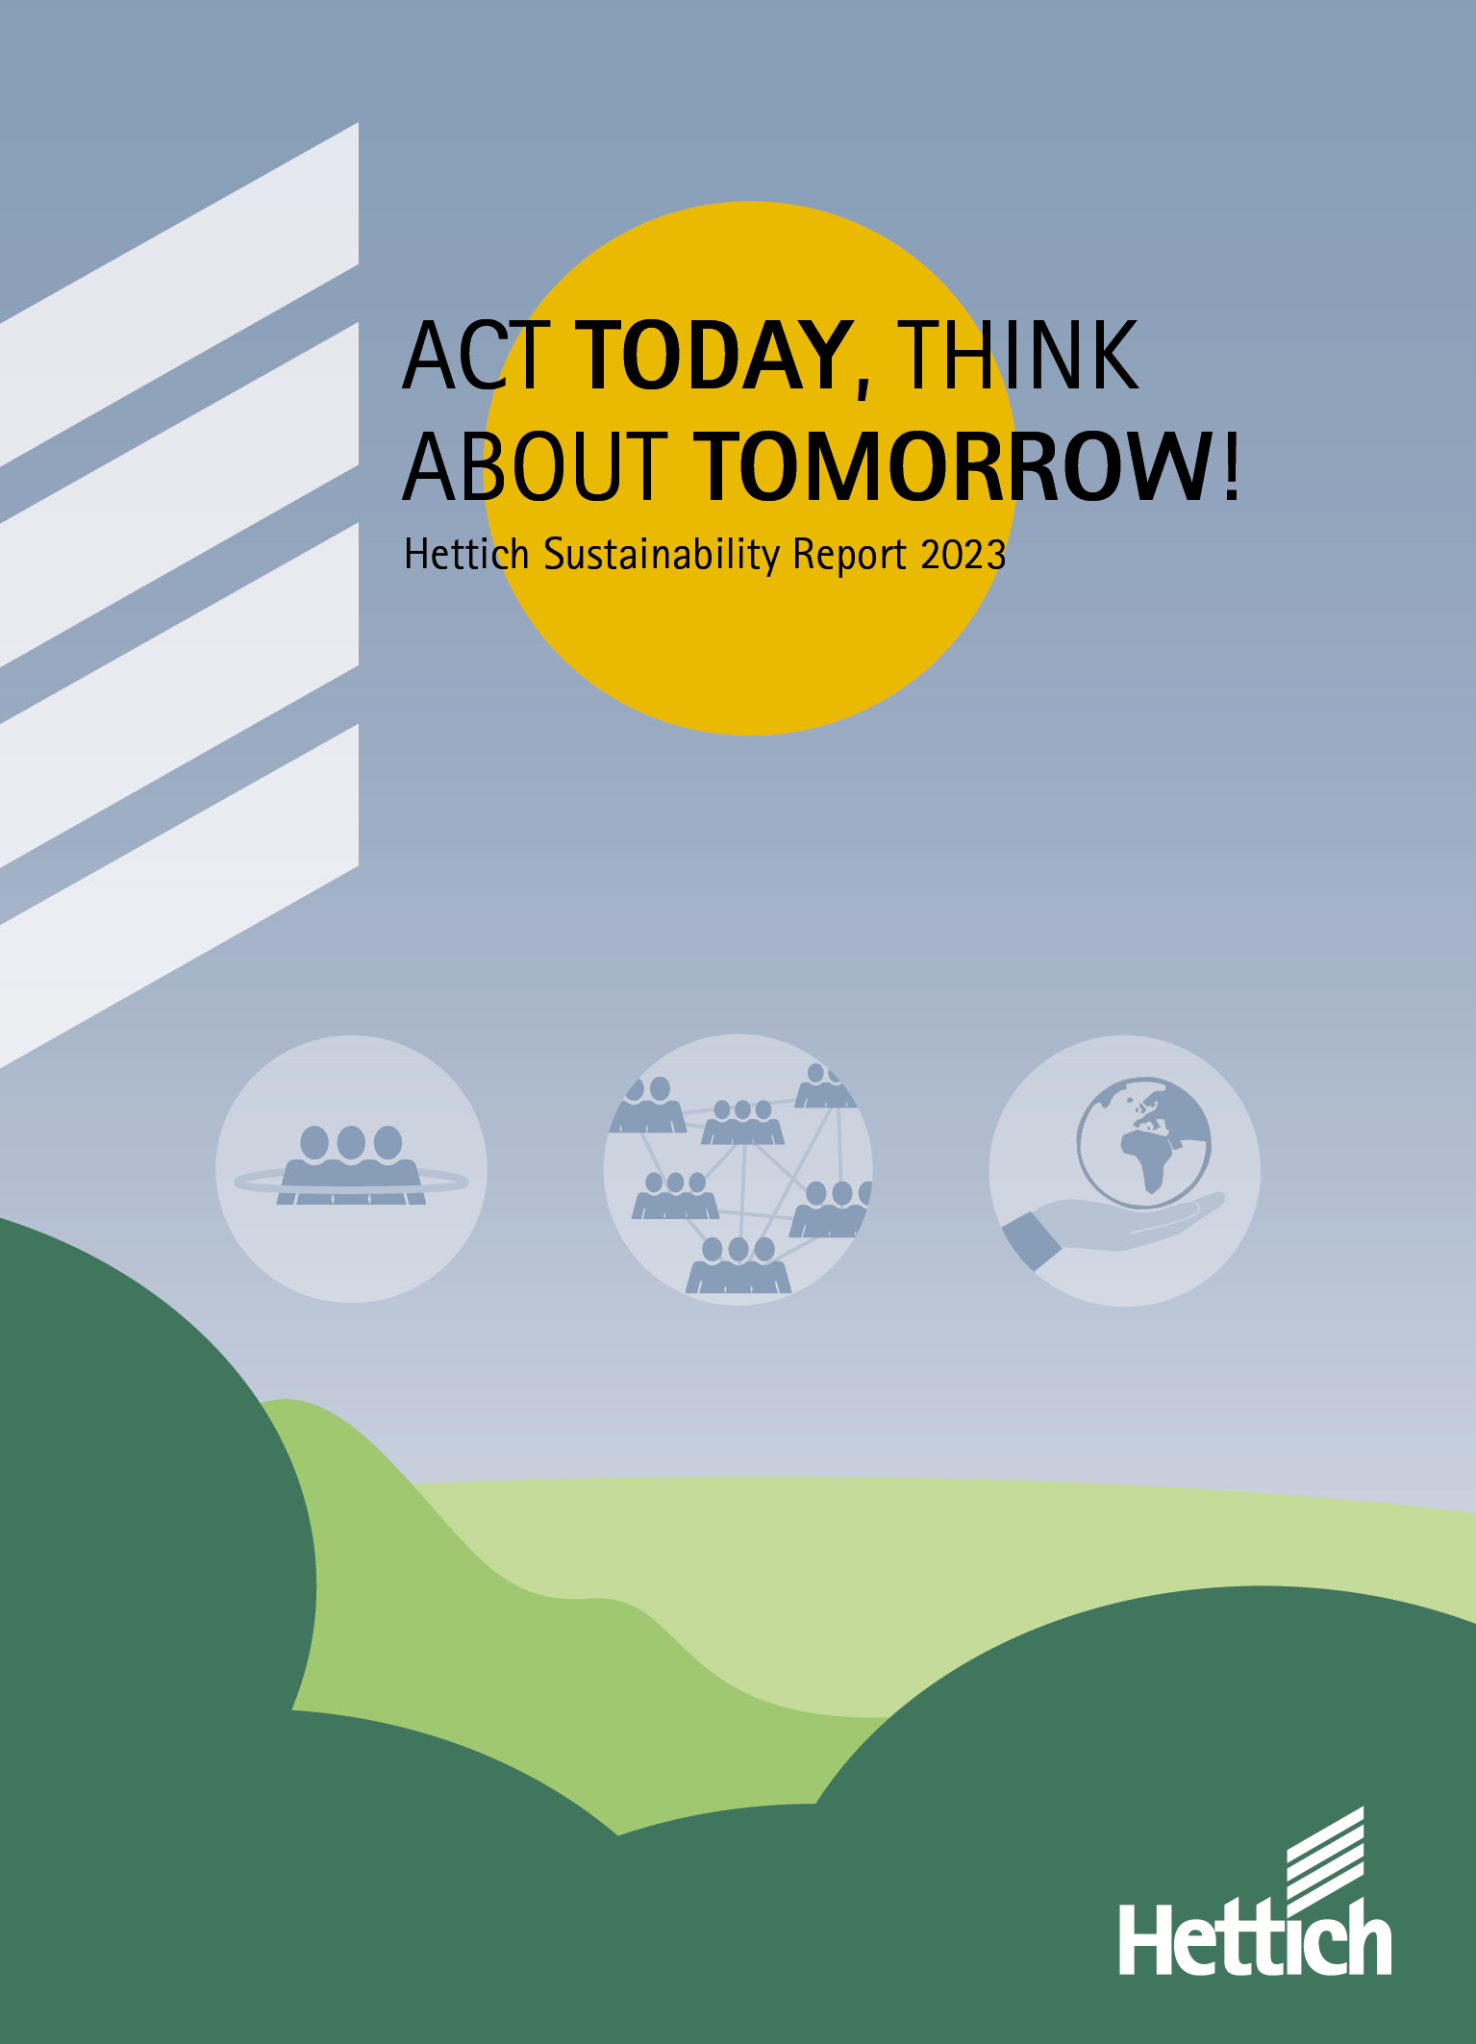

342023_a

"Act today - think of tomorrow": Hettich is committed to a sustainable corporate policy. The current 2023 report highlights focal points for action and targets. Photo: Hettich

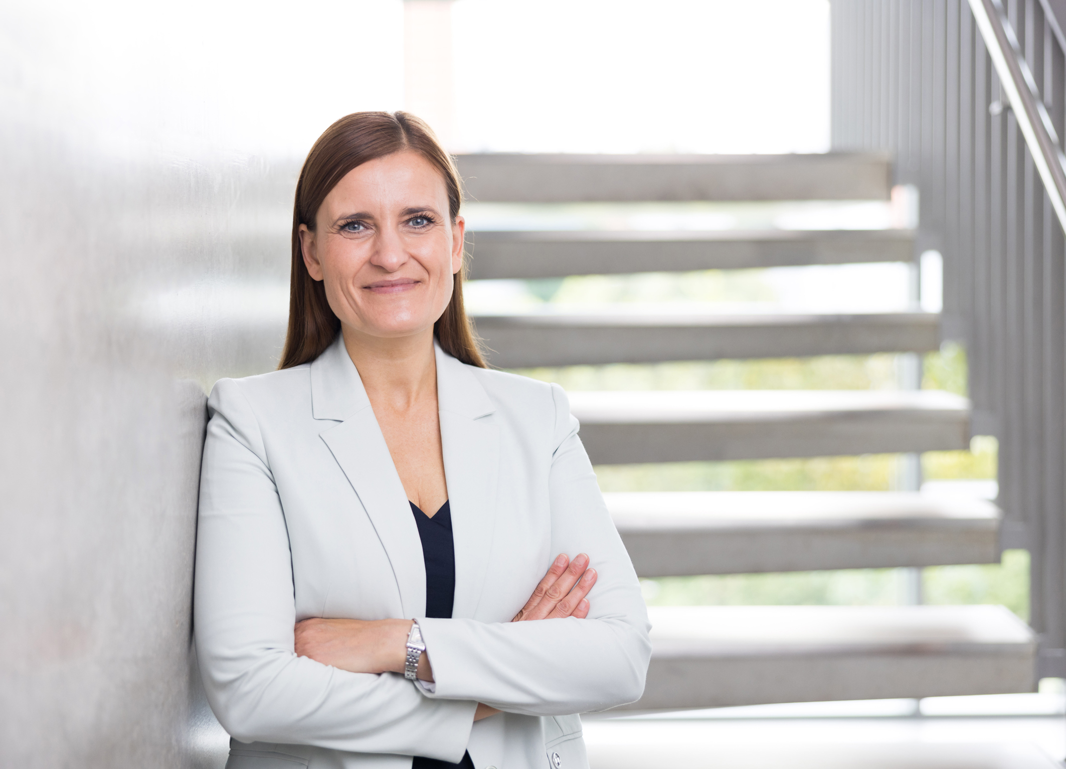

342023_b

Hettich Managing Director Jana Schönfeld: "At Hettich, we live a participatory culture in which we can all contribute our strengths, passions and ideas in the best possible way. This naturally also applies to the sustainability initiatives." Photo: Hettich



342023_c

Ute Schulz, Corporate Responsibility Team: "Together as a team, we shape the sustainability agenda and ensure continuous development." Photo: Hettich

About Hettich

Founded in 1888, Hettich is one of today's largest and most successful manufacturers of furniture fittings on the international stage. The family owned company is based at Kirchlengern in the furniture making cluster of Germany's East Westphalia region. Some 8,000 members of staff in almost 80 countries work together to give the industry future proof solutions. Promising "It's all in Hettich", the Hettich brand provides a comprehensive portfolio of services that is consistently and resolutely geared to the needs of customers across the globe. By tradition, top priority has always been at the focus of everything we do to ensure sustainability at social, societal and ecological level. www.hettich.com