Architecture + Office 2024 Innovation Award for "Layers moved by Hettich RoomSpin"
Choreographed rotation as new interior design principle

Topmost acknowledgement comes no later than premiere: for the 13th time, architectural journals AIT and AIT-Dialog in cooperation with Koelnmesse had initiated the "Innovation Award Architecture + Office" during ORGATEC 2024. And, as a world first, the high profile jury members from the fields of architecture and interior design selected "Layers moved by Hettich RoomSpin" from Hettich and its subsidiary Kuhn. It is the first office furnishing concept that features unique movement sequences to make office spaces flexible usage rooms with defined zoning.

The "Innovation Award Architecture + Office" recognises conceptual solutions for selected objects and products that are equally convincing in terms of design and functionality. And this is precisely what the sensational new "RoomSpin - Your Room Changer" product release can do. The award winning office furnishing concept gives interior architects and project planners new perspectives for creating transformable, multifunctional spaces: unlike furniture that can be moved about on castors and glides, Hettich together with subsidiary Kuhn use the benefits of choreographed rotation as a new and revolutionary interior design principle.

Utilising lever forces, turning RoomSpin based furnishing solutions is far more convenient than moving mobile furniture items.
Furnishing can now be configured in any chosen way: from cabinets and room dividers permitting use from both sides to single person workstations and areas for holding meetings. Nonetheless, office space remains clearly zoned, making it possible in advance to do a perfect job of planning ambiance as well as lighting and sockets. The idea is based on Hettich's innovative turning swivelling fitting and was developed in collaboration with the Münster School of Architecture and Professor Ulrich Blum, Senior Associate at Zaha Hadid Architects.

New work with "Layers moved by Hettich RoomSpin"
The "Layers" interior design approach from Kuhn gives the Hettich Group its first office furnishing line up. It not only includes stunningly designed seating and meeting solutions in steel and recycled felt but covers storage furniture too. "Layers" follows an intelligent grid system while remaining dynamic and permitting modular individualisation without the need for tools.
On top of this, Hettich also assists architects in planning customised RoomSpin solutions through its exclusive "workplace2architecture" partner network: the interior furnishings are produced by cabinet makers and furniture manufacturers who can obtain certification as RoomSpin partners from Hettich. In future, the aim is for the partner network to get the uniquely rotating interior design principle into as many creative applications and furniture ranges as possible.
To bet more on RoomSpin, go to: https://roomspin.hettich.com

The following picture material is available for downloading from the "Press" menu at www.hettich.com:

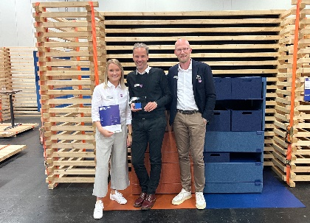
402024_a
Awarded at ORGATEC 2024 in Cologne: the "Innovation Award Architecture + Office 2024" was given on 22 October to ‘Layers moved by Hettich RoomSpin’, the first office furnishing concept from Hettich and its subsidiary Kuhn (from left: Luisa Bartnick, Daniel Rehage and Sebastian Voss from the Hettich team). Photo: Hettich

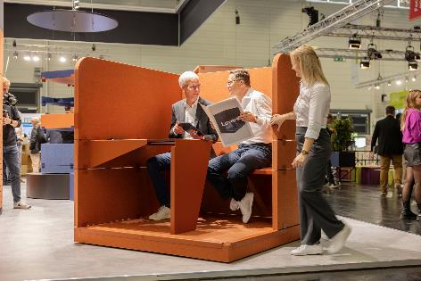
402024_b
"Layers moved by Hettich RoomSpin": the workstation modules easily rotate into the chosen position within seconds. Photo: Hettich

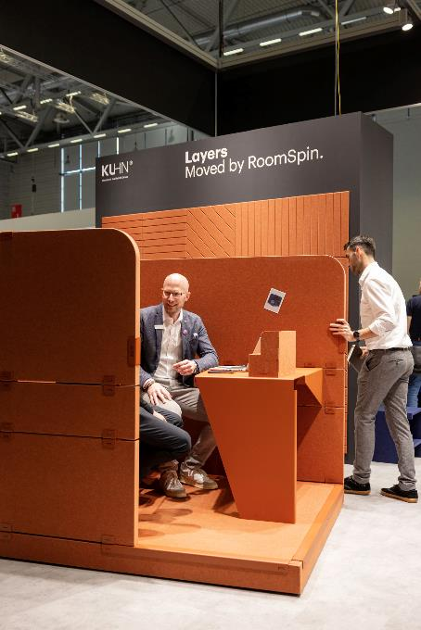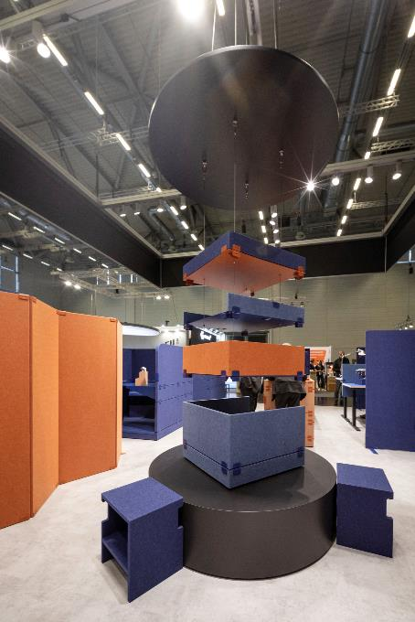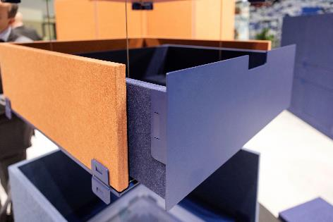
402024_c, 402024_d, 40204_e
The "Layers" interior design not only includes stunningly designed seating and meeting solutions in steel and recycled felt but covers storage furniture too. "Layers" follows an intelligent grid system while remaining dynamic and permitting modular individualisation without the need for tools. Photos: Hettich

About Hettich
Founded in 1888, Hettich is one of today's largest and most successful manufacturers of furniture fittings on the international stage. The family owned company is based at Kirchlengern in the furniture making cluster of Germany's East Westphalia region. Some 8,600 members of staff work together to provide our future proof solutions in over 100 countries. Promising "It's all in Hettich", the Hettich brand provides a comprehensive portfolio of services that is consistently and resolutely geared to the needs of customers across the globe. By tradition, top priority has always been at the focus of everything we do to ensure social, societal and ecological sustainability. www.hettich.com

