FurnSpin Impresses at Alpnach Küchen AG
Live presentation at "Kitchen Innovations Day 2025"

The Swiss Kitchen Association's trade show in Safenwil gave Kitchen Manufacturer Alpnach Küchen the arena to present three versions of Hettich's innovative, turning and swivelling fitting, FurnSpin, using different installation examples. The elegant turning movement that FurnSpin produces brought dynamics to kitchen design that left show goers impressed, and so did the creative applications options realised by Alpnach Küchen in partnership with Hettich.

When FurnSpin made its debut at Interzum, the world's leading trade fair for furniture production and interior design, in 2023, the innovative turning, swivelling fitting immediately caught the interest of Fabian Breisacher, Managing Director at Alpnach Küchen. "For us, Hettich's newly engineered opening mechanism was interzum's absolute highlight. Even the prototype was faultless in the way it worked. Now inquisitive, we wanted to test FurnSpin for ourselves and integrate it into our kitchens," he explains. The Swiss kitchen manufacturer has been producing bespoke kitchens for over 25 years, presenting them in four exclusive showrooms across Switzerland. Quality, design and functionality are paramount at Alpnach Küchen. So grabbed were Fabian Breisacher and his team by FurnSpin that they decided to show the product's versatility in as many looks and functions as they could in a compact kitchen at the kitchen industry's trade show.

In house design concept developed
The technology was planned for three installation variants: at wall unit level, at island base unit level and in the form of a larder unit. Leaving everyone impressed, it was the larder unit in particular that gave the Alpnach team an impelling idea: a design providing access to the unit from both front and rear. This concept provides flexibility in how the larder unit can be used. Integrating three FurnSpin units led to an astonishing variety of designs. Closed fronts create a clean, tidy look. Open, the FurnSpin elements lend the kitchen modern aesthetic appeal with design elements from the Cadro system and classy veneered pull-out shelves. The result is a combination of practical benefit and added aesthetic value: all utensils are in easy reach while cooking – whether baking accessories or bags of pasta. At the same time, the exposed shelves provide space for stylish decorative items.

Design support from Hettich
"Designing cabinetry with FurnSpin was both challenging and fascinating," says Fabian Breisacher, describing the planning process. "We especially appreciated the excellent support Hettich gave us. From the very outset, experienced technicians were at our side with valuable advice. It was this professional backing that enabled us to realise our designs with optimum results and make sure flawless functionality was given," he concludes. He adds: "A big thank you to Hettich for this outstanding liaison!"

Alpnach Küchen sees its show presence a resounding success. Particularly impressive was FurnSpin's elegant movement – a mechanism that needs witnessing firsthand! After over 200 movement cycles during the event, it was revealed: no adjustment needed – the fitting system proved extremely sturdy and carefully engineered. For Fabian Breisacher, one thing's certain: "We're now going to offer our customers FurnSpin too, and are convinced that this innovative fitting system will open up new avenues in design and functionality, winning over many delighted customers."

The following picture material is available for downloading from the "Press" menu at www.hettich.com:

Images
Captions

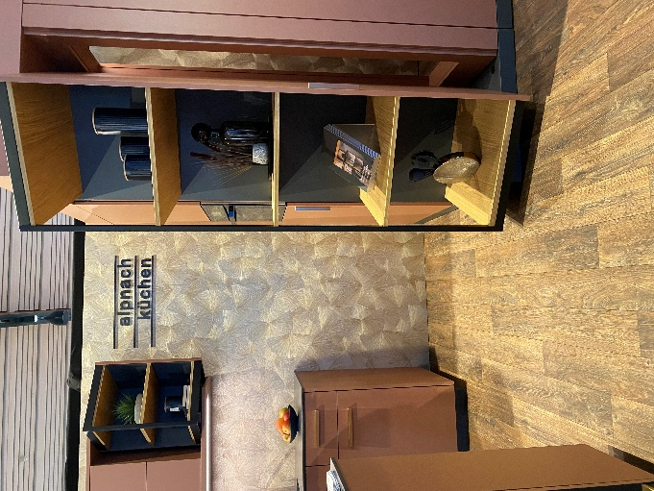
122025_a
FurnSpin needs to be witnessed firsthand: at the Swiss Kitchen Association's "Kitchen Innovations Day 2025", Alpnach Küchen presented the innovative FurnSpin fitting solution in three application variants. Photo: Hettich

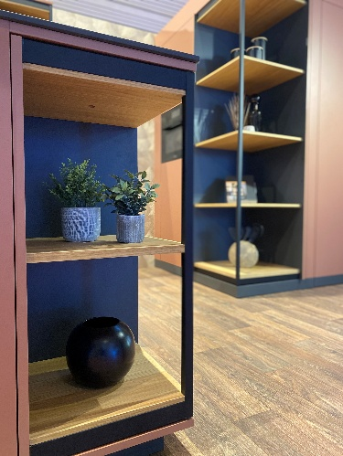
122025_b
FurnSpin from Hettich combines added aesthetic value and practical benefit: open, the FurnSpin elements lend the kitchen modern aesthetic appeal with design elements from the Cadro system and classy veneered pull-out shelves. Photo: Hettich

About Hettich
Founded in 1888, Hettich is one of today's largest and most successful manufacturers of furniture fittings on the international stage. The family-owned company is based at Kirchlengern in the furniture making cluster of Germany's East Westphalia region. Some 8,400 members of staff work together to provide our future proof solutions in over 100 countries. Promising "It's all in Hettich", the Hettich brand provides a comprehensive portfolio of services that is consistently and resolutely geared to the needs of customers across the globe. By tradition, top priority has always been at the focus of everything we do to ensure sustainability at social, societal and ecological levels. www.hettich.com

