**Hettich Group: 1.3 billion euros turnover in 2023**

**The Hettich Group, one of the world's leading manufacturers of furniture fittings headquartered in Germany, takes stock of the challenging year 2023 and starts 2024 with a significant milestone in its history: the merger with the FGV Group.**

The past year was economically challenging for the furniture industry, characterized by exploding construction costs, high interest rates, inflation and general investment uncertainty in many countries around the world. The tense economic situation in the German furniture industry was also felt by the Hettich Group, with turnover falling by 14 per cent compared to the previous year to 1.3 billion euros. The foreign share was 75 per cent. Around 7,700 colleagues worked for Hettich around the globe in 2023, 3,600 of them in Germany.

**Investing in the future**

"Especially in difficult times, it is very important for us to look ahead and also act in the interests of future generations," emphasises Jana Schönfeld, Managing Director of the Hettich Group. In 2023, the Hettich Group continued important future projects, process optimizations and further developments. Around 170 million euros were invested in new products, infrastructure projects, buildings, facilities, digitalization and sustainability, as well as in capacity expansions. Examples of this include the expansion of the production areas in Germany as well as investments in growth markets in Asia, such as Vadodara in India and Zhuhai in China.

**Innovations: Hettich's revolutionary "FurnSpin" fittings system**

In 2023, the Hettich Group presented innovative solutions at the leading Interzum trade fair in Cologne under the campaign "It's all in Hettich" - including the revolutionary FurnSpin fittings system for the high-end segment. Sascha Groß, Managing Director of the Hettich Group, is delighted with this innovation, which not only sets new standards in furniture design, but also emphasises Hettich's innovative strength: "Whether room-high furniture or small display cabinet elements - with FurnSpin, everything can be rotated. The fitting remains virtually concealed and offers all the familiar convenience functions such as soft-close or push-to-open for handleless furniture design. FurnSpin is a fitting with the potential to change the world of furniture. Together with 285 colleagues from all over the world, we designed our trade fair appearance on site, while numerous other colleagues at various locations supported this effort." This impressively illustrates how the Hettich brand is continuously evolving.

**Merger with FGV: Joining forces for a common future**

The merger of the Hettich Group and the FGV Group in January 2024 was a significant step in the company's history. "With strong roots in the same industry, we are shaping our future together," emphasises Schönfeld, "Hettich and FGV are two family-run companies with more than 200 years of combined experience. And together, we are now around 8,600 colleagues all over the world who use all their strength, passion and ideas to achieve the best for our customers every day." Both companies will complement each other with their strengths in order to offer their customers even better value-added solutions and continuously develop existing business activities and processes together.

**Outlook 2024**

Even if the recovery in the furniture industry is a long time coming, the Group remains confident. "Together with our loyal customers, reliable suppliers and partners, our large Hettich & FGV team, whom we sincerely thank and hold in high esteem, forms a strong network that we can always rely on," emphasises Groß. The Hettich Group remains determined to actively shape the future and develop innovative solutions for the furniture industry while capitalising on global growth potential.

The following picture material is available for downloading from the "**Press**" **menu** at **www.hettich.com**:

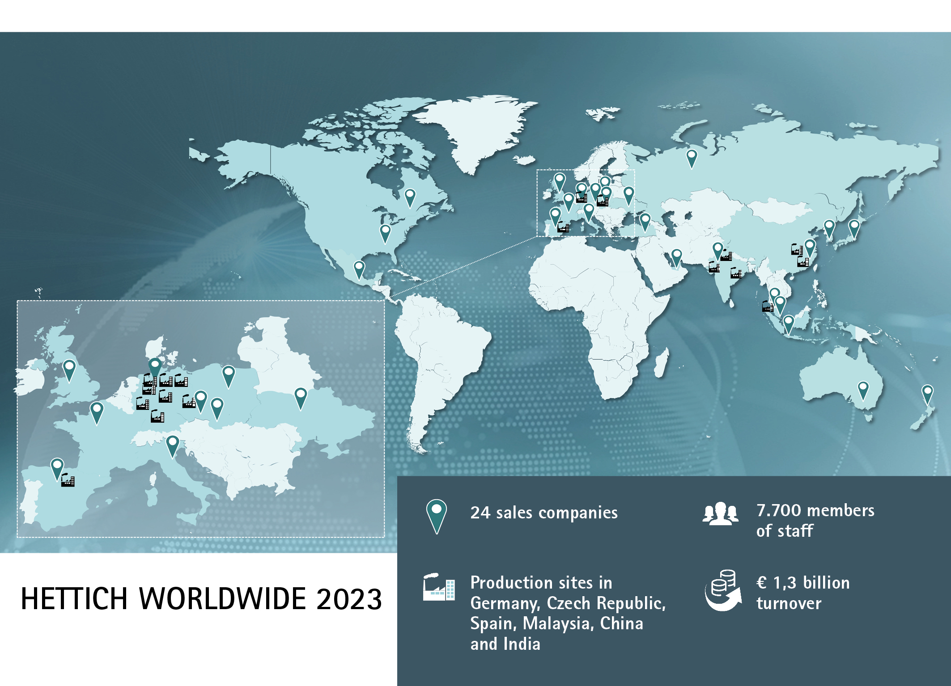

062024_a

The Hettich Group takes stock for 2023.  
Photo: Hettich

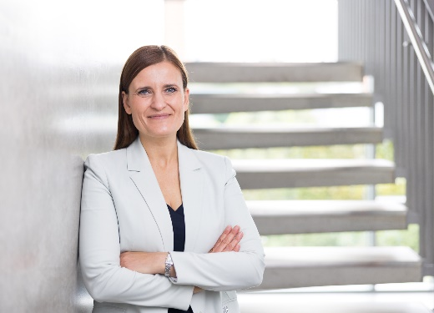

062024_b

Jana Schönfeld, Managing Director of the Hettich Group.   
Photo: Hettich

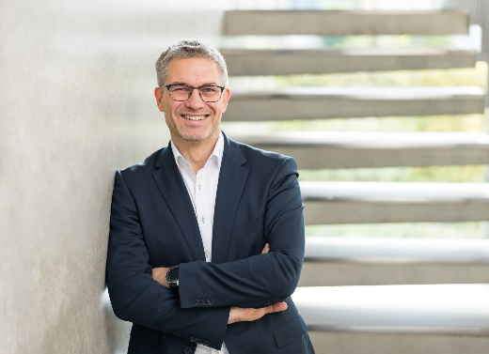

062024_c

Sascha Groß, Managing Director of the Hettich Group.

Photo: Hettich

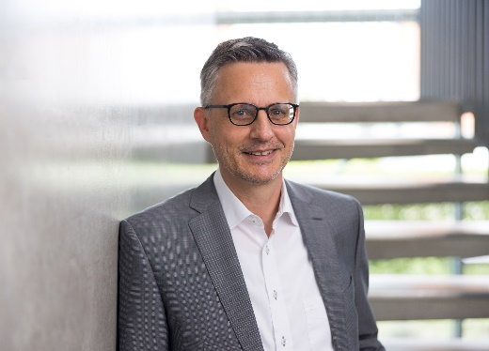

062024_d

Dr Andreas Hettich, Chairman of the Advisory Board of the Hettich Group. Photo: Hettich

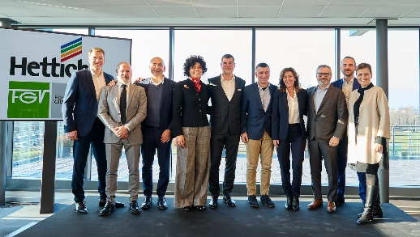

062024_e

Together at the handover ceremony in Veduggio, the main site of the Formenti e Giovenzana Group: representatives of the FGV and Hettich management teams. Photo: Hettich

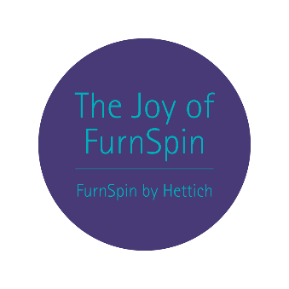

062024_f

"The joy of FurnSpin" provides users with an emotional, magical furniture experience that leaves a lasting impression.

Photo: Hettich

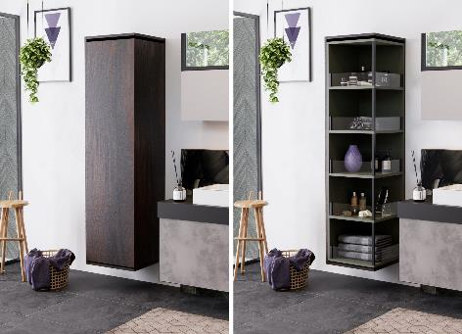

062024_g

The exciting change between "closed" and "open" is effectively staged thanks to FurnSpin. Photo: Hettich

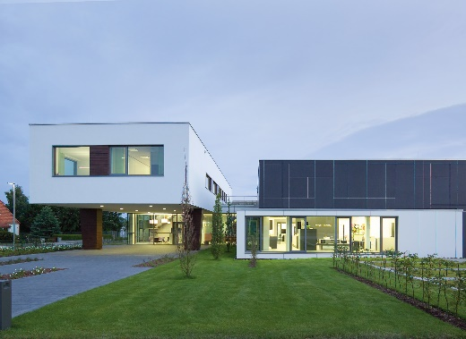

062024_h

Hettich Forum at the headquarters in Kirchlengern in Germany

Photo: Hettich

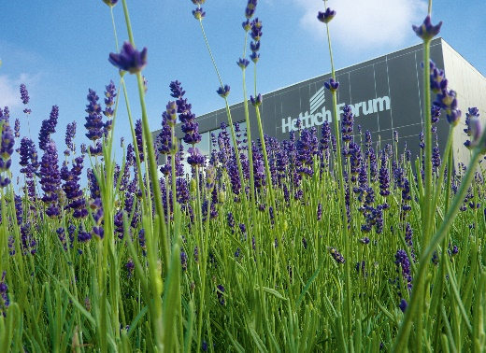

062024_i

Hettich Forum at the headquarters in Kirchlengern in Germany

Photo: Hettich

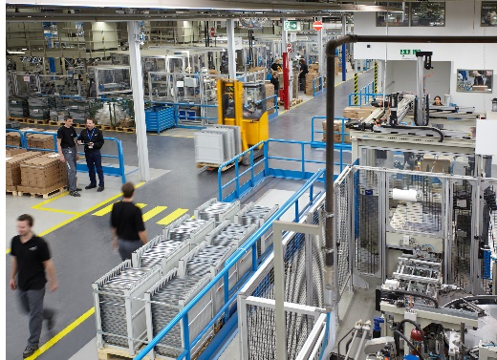

062024_j

Insight into the Hettich production

Photo: Hettich

About Hettich

Founded in 1888, Hettich is one of today's largest and most successful manufacturers of furniture fittings on the international stage. The family owned company is based at Kirchlengern in the furniture making cluster of Germany's East Westphalia region. Around 8.600 colleagues work together to deliver our future proof solutions to over 100 countries. Promising "It's all in Hettich", the Hettich brand provides a comprehensive portfolio of services that is consistently and resolutely geared to the needs of customers across the globe. By tradition, top priority has always been at the focus of everything we do to ensure sustainability at social, societal and ecological level. [www.hettich.com](http://www.hettich.com)