**Hettich Group turnover up 12 percent in 2024**

**Sales worth €1.4 billion in wake of successful coming together with FGV**

**The Hettich group of companies, one of the world's leading furniture fittings manufacturers headquartered in Kirchlengern, generated sales of around €1.4 billion in 2024. The merger with FGV in January 2024 brought a turnover increase of around 12 percent compared to the previous year. Sales abroad accounted for 80 percent. Hettich has around 8,400 employees worldwide, around 4,000 of whom are employed in Germany.**

Hettich’s balance sheet press conference this year provided insights into the many-to-many management culture the group practises. Management team representatives along with experts looked back on the 2024 business year and shared future perspectives.

**Hettich and FGV: powerful duo for the future**

Last year, FGV and Hettich, two long established family-owned companies with over 200 years of combined experience, set up a strong network. "The many face-to-face talks and intensive dialogue in international project teams have not only strengthened our liaison but also laid the foundation for a successful future," stresses Jana Schönfeld, Managing Director at Hettich. A significant step in this working partnership was to open the first joint subsidiary, Hettich Vietnam, in January 2025. "We are delighted to be able to boost our presence in Asia with Hettich Vietnam. With its 100 million inhabitants, the Vietnamese market comes with excellent growth opportunities, and our Hettich and FGV brands will let us embrace and target the market's different needs," adds Philipp Rode, Managing Director at Hettich.

**Sustained investment in a shared future**

Over the past three years, the Hettich Group has invested over €450 million in new products and capacities. Sustainably expanding production facilities in Germany is a visible step in this direction. Timo Pieper, Managing Director at Hettich, points out: “Our new production halls exceed the requirements of Germany's Energy Saving Ordinance and set new standards for ecofriendly industrial construction." Hettich is also investing internationally, as demonstrated by the formal opening of the Leg Factory in Penang, Malaysia. This will be the forge of innovative solutions for height adjustable desk systems.

**International accolades**

Hettich products, like FurnSpin and RoomSpin, have received prestigious prizes, including the Interzum Award, the Red Dot Award and the German Design Award. On top of this, the Hettich Group is proud of featuring in the new edition of "The Major German Brands 2025", which showcases outstanding German brand name companies.

Hettich has also received numerous accolades as an employer, including "kununu Top Company 2025" and "Top JobRad Employer". Lars Bohlmann, Managing Director at Hettich, explains: "These awards are testimony to our commitment towards promoting the health and safety of our colleagues while fostering a culture of transparent communication as equals. We want to create a working environment that lets everyone contribute their strengths, passions and ideas." Worthy of particular mention too is Hettich India receiving "Great Place to Work" certification as confirmation of promoting trust, respect and camaraderie.

**Challenges and outlook for 2025**

Michael Lehmkuhl, Managing Director at Hettich, pointed out challenges, such as geopolitical crises, technological uncertainty and declining construction activity. A particular problem is the Carbon Border Adjustment Mechanism (CBAM) which doesn't cover furniture fittings, thereby disadvantaging sustainably produced products from Germany. "Without any comprehensive inclusion of our products in CBAM, we and our fellow European market players face a competitive drawback, undermining efforts to establish sustainable production standards in Europe," Lehmkuhl says.

For 2025, the Hettich Group is seeking to advance further by stepping up collaboration with long standing customers, digitising and streamlining corporate processes as well as networking on the global stage. The company is also getting its climate targets validated through the Science Based Targets Initiative (SBT) in a move to take responsibility in respect of future generations. At Interzum 2025, Hettich will once again be showcasing fascinating, transformable furniture worlds under the “Transforming Spaces – with Innovative Motion” banner, presenting itself as a holistically thinking strategy partner to the furniture industry, fabricators and appliance manufacturers.

The following picture material is available for downloading from **www.hettich.com, Menu: Press.**

Ein Bild, das Text, Karte enthält.

102025_a

The Hettich Group takes stock of 2024.

Photo: Hettich

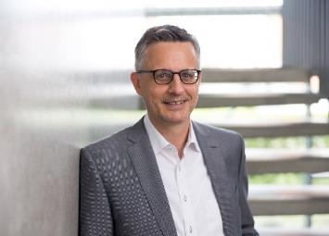

102025_b

Dr. Andreas Hettich, Chair of the Hettich Group's Advisory Board

Photo: Hettich

Ein Bild, das Kleidung, Person, Im Haus, Mobiliar enthält.

102025_c

Press conference reflecting the many-to-many approach.

Photo: Hettich

Ein Bild, das Kleidung, Person, Mann, Im Haus enthält.

062024_d

Together at the opening of Hettich Vietnam. Group: representatives of the FGV and Hettich management teams. Photo: Hettich

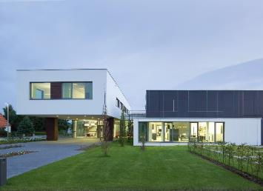

062024_e

Hettich Forum at the headquarters in Kirchlengern, Germany

Photo: Hettich

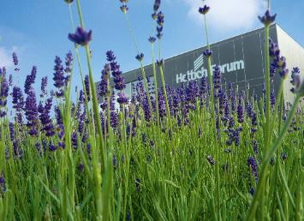

062024_f

Hettich Forum at the headquarters in Kirchlengern, Germany

Photo: Hettich

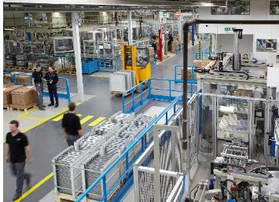

062024_g

Glimpse into Hettich production

Photo: Hettich

About Hettich

Founded in 1888, Hettich is one of today's largest and most successful manufacturers of furniture fittings on the international stage. The family-owned company is based at Kirchlengern in the furniture making cluster of Germany's East Westphalia region. Some 8,400 members of staff work together to provide our future proof solutions in over 100 countries. Promising "It's all in Hettich", the Hettich brand provides a comprehensive portfolio of services that is consistently and resolutely geared to the needs of customers across the globe. By tradition, top priority has always been at the focus of everything we do to ensure social, societal and ecological sustainability. www.hettich.com