**"Good Design Award 2024" for FurnSpin**

**Hettich hardware innovation meets with great approval in Japan**

**The innovative FurnSpin swivel and pivot fitting from Hettich has won the "Good Design Award 2024" from the Japan Institute of Design Promotion (JDP). This is the seventh time Hettich has received this award since 2014.**

The long-established "Good Design Award" is the only comprehensive evaluation and recommendation system for product design in Japan. The annual awards are also recognised internationally as proof of outstanding quality in functionality and design. This year, the jury praised the FurnSpin for its "revolutionary movement" thanks to the swivelling cabinet body, which introduces a completely new concept for storage space in furniture.

**FurnSpin: Revolutionary swivel and pivot fitting**

Until now, wardrobe furniture was usually fitted with either sliding, folding or hinged doors. The FurnSpin hardware innovation is different. It does away with old design patterns and brings creative momentum to furniture design: open doors or flaps no longer get in the way – the majority of the cabinet body can be moved with ease. With an elegant twist, the furniture reveals its inner workings. With a further twist, the inside of the cabinet disappears from view and the furniture shows closed fronts again. The torque is balanced in such a way that even very light objects do not tip over or slip, but remain in their original place in the unit.

**"The Joy of FurnSpin" inspires in all furniture worlds**

FurnSpin allows new spatial and furniture concepts with unexpected performance in a design quality that clearly stands out from the standard. The characteristic "spin" is simply a joy and provides users with an emotional, magical furniture experience that leaves a lasting impression. The international recognition of the Japanese Good Design Award 2024 for the versatile system once again confirms the added value that FurnSpin offers for architects, craftsmen and industry – but also for furniture buyers all over the world.

More about the innovative FurnSpin from Hettich at:   
[The Joy of FurnSpin - Hettich](https://furnspin.hettich.com/?lang=en)

The following images are available for download in the **"Press" menu** at www.hettich.com:



362024_a

The innovative Hettich FurnSpin swivel fitting system was honoured with the Good Design Award 2024 Photo: Hettich

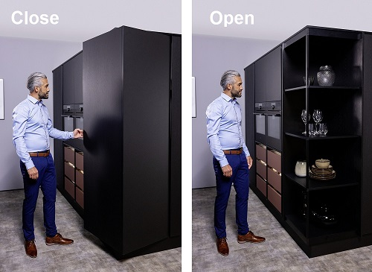

362024_b

If you turn it slightly, the face changes from "closed" to "open". Photo: Hettich



362024_c

The "G-Marke", the official logo of the Good Design Award.

Image: Japanese Institute for Design Promotion (JDP)

## About Hettich

Founded in 1888, Hettich is one of today's largest and most successful manufacturers of furniture fittings on the international stage. The family-owned company is based at Kirchlengern in the furniture making cluster of Germany's East Westphalia region. Some 8,600 members of staff work together to provide our future proof solutions in over 100 countries. Promising "It's all in Hettich", the Hettich brand provides a comprehensive portfolio of services that is consistently and resolutely geared to the needs of customers across the globe. By tradition, top priority has always been at the focus of everything we do to ensure social, societal and ecological sustainability. [www.hettich.com](http://www.hettich.com)

About The GOOD DESIGN AWARD:

Established in 1957, GOOD DESIGN AWARD is Japan’s leading commendation system. Eligible for application are products, architecture, application and software, projects and initiatives that utilize design and more. Through this system, many people come in contact with “good design” and appreciate their value. The recognition rate of the award is 84%*, with its familiar symbol, the G-Mark. (*According to the latest survey by Japan Institute of Design Promotion in 2020).

<https://www.g-mark.org/>