**Red Dot Design Award 2024 for FurnSpin from Hettich**

**Accolade goes to FurnSpin in the "Innovative Products" category for its high level of innovation**

**Hettich not only shows innovation in its products but carries it in its DNA too. Besides milestones in innovation, this is also evident in numerous prestigious awards – once again, Hettich impresses with its tremendous power to innovate: FurnSpin wins the Red Dot Design Award 2024 in the "Innovative Products" category.**

"Among the numerous entries from businesses and design studios across the globe, the outstanding quality and design of your product leaves our international jury in no doubt! We acknowledge this terrific achievement with the Red Dot Winner Label," said the Red Dot Design Award jury.

The innovative FurnSpin fitting for the high-end division gets rid of old-style formats and puts a creative new spin on furniture design. Its unique "translatory rotational movement" can literally turn furniture inside out. Open doors and flaps no longer get in the way: most of the cabinet body can now be moved with effortless ease. A stylish turn leaves furniture to reveal what's inside. Hiding everything from view again, a further spin returns furniture to its closed state. As such, FurnSpin enables ground-breaking spatial and furniture concepts with stunning performance in a quality of design that clearly stands apart from the norm. The characteristic "spin" spells pleasure and gives users a fascinating furniture experience that leaves a lasting mark.

To the Design Awards won by Hettich:   
<https://web.hettich.com/en-de/inspiration/design-award>

Get more on FurnSpin at: <https://furnspin.hettich.com/>

The following picture material is available for downloading from the "**Press**" **menu** at **www.hettich.com**:



142024_a

Winner of the Red Dot Design Award in the "Innovative Products" category. FurnSpin brings elegant dynamic to high end interior design. With a sweep of the hand, the entire cabinet body can be turned from the closed to the open position. Photo: Hettich

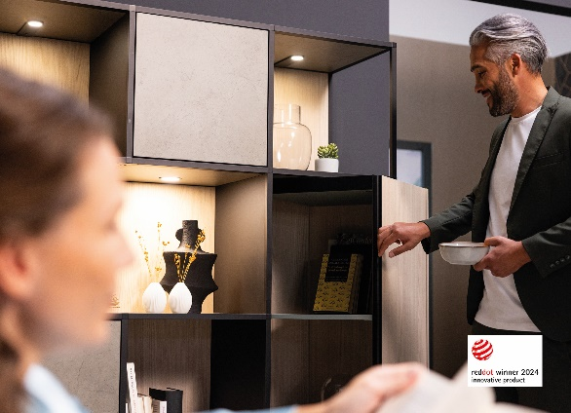  
142024_b  
Innovative and inspirational: open doors and flaps no longer get in the way – most of the cabinet body can now be moved with effortless ease. Photo: Hettich

About Hettich

Founded in 1888, Hettich is one of today's largest and most successful manufacturers of furniture fittings on the international stage. The family-owned company is based at Kirchlengern in the furniture-making cluster of Germany's East Westphalia region. Some 8,600 members of staff work together to provide our future-proof solutions in over 100 countries. Promising "It's all in Hettich", the Hettich brand provides a comprehensive portfolio of services that is consistently and resolutely geared to the needs of customers across the globe. By tradition, top priority has always been at the focus of everything we do to ensure sustainability at social, societal and ecological levels. [www.hettich.com](http://www.hettich.com)