Intuitively Achieve the Perfect Seam Alignment
Introducing the new Actro 5D Runner from Hettich with 5-way adjustment

As the pioneers of the platform principle, continual optimisation of drawer fittings is central to Hettich's philosophy. Good can always be better. The new Actro 5D runner for wooden drawers epitomises customer-centric innovation. It not only facilitates faster assembly and disassembly but also offers precise facade alignment across five dimensions. Plus, its robust stability ensures a lasting and flawless seam alignment.

Quality furniture design with large-scale fronts and wooden drawers remains a prevailing trend. Their popularity is partly due to the slim seams that truly highlight beautiful surfaces. As such, the runners for these large wooden drawers must be powerful and sturdy. Even as Hettich produces in vast quantities, close customer engagement remains fundamental for practical enhancements.

With the enhanced Actro 5D runner, wooden drawers can now be aligned even more intuitively, in five directions: height, side, tilt, depth, and radially - all adjustable effortlessly without tools. The radial adjustment quickly resolves any uneven alignment or offsets between adjacent carcasses. The result? A perfect seam profile for handle-free furniture design that makes a striking visual impact. The revamped side adjustment of the evolved latch system makes setting even more intuitive, and detaching the drawer with a button press is noticeably easier.
Lasting, Precise Seam Alignment
Even with daily use and a fully loaded wooden drawer, the seam's precise alignment remains unchanged. With load capacities of 10, 40, or 70 kg, the Actro 5D runner's robust performance maintains consistent stability. The drawer sits more securely than ever on the runner, which also impresses with its smooth, quiet operation. A synchronisation mechanism ensures a seamless movement transition between profiles. Other comfort features include the low extraction forces and the powerful yet gentle "Silent System" damping.

System-agnostic and Flexible
In line with Hettich's system philosophy, different runners for wooden drawers can be used depending on the application, weight category, and comfort preference – drawer dimensions and carcass drillings always match. If only height adjustment is desired, the Actro YOU runner can alternatively be used, which is also compatible with the AvanTech YOU frame system. The uniform drawer construction also facilitates a seamless transition to the new Actro 5D runner. This offers furniture artisans and manufacturers unparalleled design freedom.

Further details on the new Actro 5D runner at: https://web.hettich.com/en-de/products-eshop/runner-systems/actro-5d
The following picture material is available for downloading from www.hettich.com:
Images
Captions
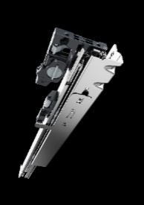
P99_a
The latest Actro 5D runner generation from Hettich with optimised catch permits 5-way adjustment for subtle front panel reveals aligned with perfect precision. Photo: Hettich

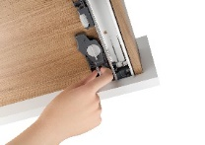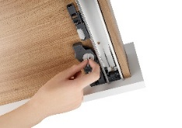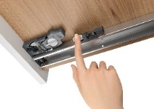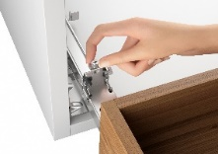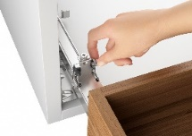
P99_b, P99_c, P99_d, P99_e, P99_f
Installation couldn't be easier: illustrated from left to right, the Actro 5D runner's 5-way adjustment capability (vertically, laterally, depthways, tilt and radially) is entirely intuitive – and leaves the wooden drawer easy to remove. Photos: Hettich
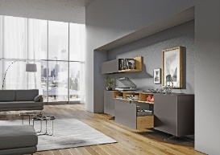
P99_g
The new Actro 5D runner delivers first class running performance for fully laden wooden drawers weighing up to 70 kg. Front panels stay perfectly aligned at all times. Photo: Hettich

About Hettich
Founded in 1888, Hettich is one of today's largest and most successful manufacturers of furniture fittings on the international stage. The family owned company is based at Kirchlengern in the furniture making cluster of Germany's East Westphalia region. Some 8,000 members of staff in almost 80 countries work together to give the industry future proof solutions. Promising "It's all in Hettich", the Hettich brand provides a comprehensive portfolio of services that is consistently and resolutely geared to the needs of customers across the globe. By tradition, top priority has always been at the focus of everything we do to ensure sustainability at social, societal and ecological level. www.hettich.com

