**Hettich drawer platform for eggersmann**

**Exclusive drawer design for new eggersmann E4 system**

**German high-end kitchen manufacturer eggersmann is switching its portfolio to Hettich's AvanTech YOU drawer platform. The exclusive EBX drawer system will be presented for the first time at "design days" from 17 to 20 September 2023. Market launch is then set for early 2024.**

eggersmann is synonymous with bespoke, one off kitchens sold worldwide through exclusive kitchen studios and top end specialist furniture retailers. Launching the innovative E4 system, eggersmann is switching to the new EBX drawer system, based on an AvanTech YOU drawer with Actro runner. The slender 13 mm drawer side profile will feature a new, purist SteelCape in onyx steel exclusively created for eggersmann. Featuring

push-to-open Silent, the handleless drawers give the user an opening and closing experience second to none.

"Every detail counts and hugely determines the overall impact an eggersmann creation makes. Resolutely focusing on all of the finer details and unique component designs, we produce inimitable ensembles that are found nowhere else. Not only rational in terms of processing, AvanTech from Hettich gives us so much versatility in designing drawers with optional features on one and the same technical platform. Factors like local proximity to Hettich, the innovative supply concept we benefit from and, not least, the commitment to sustainability were key factors in our decision to opt for Hettich," says Michael Wunram, eggersmann CEO. Both parties are looking forward to 17 to 20 September 2023 when the exclusive EBX drawer system will be making its debut at eggersmann's "design days" in Hiddenhausen.

The following picture material is available for downloading from **www.hettich.com**:

**Image**

**Caption**

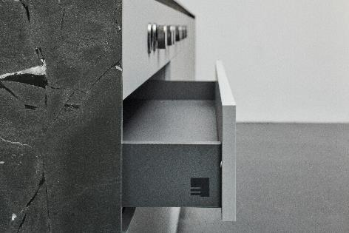

**212023_a**

Hettich's AvanTech YOU for eggersmann: high quality, versatile drawer design for eggersmann's new E4 system. Photo: eggersmann

**More on AvanTech YOU from Hettich:**

Product website (English):

<https://web.hettich.com/en-de/products-eshop/drawer-systems/avantech-you>

About Hettich

Founded in 1888, Hettich is one of today's largest and most successful manufacturers of furniture fittings on the international stage. The family owned company is based at Kirchlengern in the furniture making cluster of Germany's East Westphalia region. Some 8,000 members of staff in almost 80 countries work together to give the industry future proof solutions. Promising "It's all in Hettich", the Hettich brand provides a comprehensive portfolio of services that is consistently and resolutely geared to the needs of customers across the globe. By tradition, top priority has always been at the focus of everything we do to ensure sustainability at social, societal and ecological level. [www.hettich.com](http://www.hettich.com)