The new Evisys guiding hinge from Hettich:
high load bearing performance for extravagant looking kitchen design

Large surfaced design with floor to ceiling kitchen cabinetry and minimalist reveals: for many, this is the dream kitchen look. Yet the wider and taller the cabinet doors, the heavier they get. This calls for exceptional load bearing capacity. With the Evisys guiding hinge, Hettich provides a unique fitting solution for installing extra tall cabinet doors in front of built in refrigerators with fixed door connection.

The innovative Evisys guiding hinge features all of Hettich's expertise for the benefit of users: combined with Hettich fixed door hinges, it's now possible to install doors weighing up to 80 kg – a whopping 10 kg more than before. Evisys takes care of the additional load. Positioned in the top cabinet door section, Evisys ensures the necessary opening and closing stability and keeps reveals precisely aligned at all times for doors in widths up to 750 mm. The galvanised steel fitting can be used on the left and right of the door. The system is suitable for cabinet bodies with 16, 18 or 19 mm side panels. Evisys is available with or without integrated Silent System. The package with integrated Silent System cleverly upgrades convenience even further: because the refrigerator door too benefits from the Evisys damping effect, now closing more gently and quietly. An excellent performer, the Evisys guiding hinge now ensures that kitchen design can, quite literally, "rise to a new level".
Find out more about Evisys at: https://www.hettich.com/short/p8uk4zr
The following picture material is available for downloading from the "Press" menu at www.hettich.com:

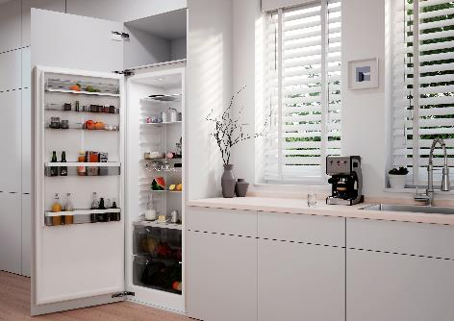
P104_a
Load bearing capacity for greater flexibility designing kitchens: the new Evisys guiding hinge from Hettich can be used for realising extra tall cabinet doors weighing up to 80 kg for built-in refrigerators. Photo: Hettich

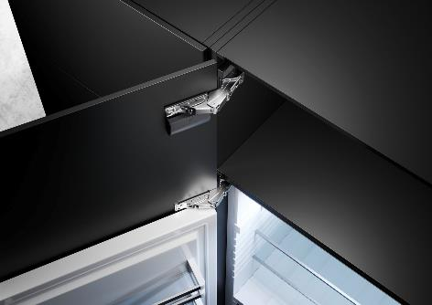
P104_b
The Evisys guiding hinge provides the necessary stability while opening and closing the cabinet door. This keeps reveals perfectly aligned. Photo: Hettich

About Hettich
Founded in 1888, Hettich is one of today's largest and most successful manufacturers of furniture fittings on the international stage. The family owned company is based at Kirchlengern in the furniture making cluster of Germany's East Westphalia region. Some 8,600 members of staff work together to provide our future proof solutions in over 100 countries. Promising "It's all in Hettich", the Hettich brand provides a comprehensive portfolio of services that is consistently and resolutely geared to the needs of customers across the globe. By tradition, top priority has always been at the focus of everything we do to ensure social, societal and ecological sustainability. www.hettich.com

