**2023 in-house exhibition highlight at SieMatic:**

**"The Joy of FurnSpin by Hettich"**

**Showcasing its FurnSpin fitting at Interzum in May, Hettich presented a compelling innovation that will add new drive to high end kitchen and furniture ranges. This has brought Hettich the prestigious "interzum award 2023", receiving the highest "Best of the Best" accolade. Manufacturing some of the world's highest quality kitchens, SieMatic will be presenting "The Joy of FurnSpin by Hettich" in a kitchen at its "SieMatic Interior Design Days 2023" in-house exhibition from 16 to 19 September in Löhne. At the world premiere of the new "SieMatic S2" handleless kitchen with its numerous hidden and aesthetically pleasing highlights, the fitting will be presented to SieMatic partners worldwide in jointly perfected applications, such as tall and base unit.**

Is there a way of completely reinventing the use of storage space? Hettich and SieMatic have found one: the innovative FurnSpin fitting for the high end segment does away with old style formats and puts a creative new spin on furniture design. Open doors or flaps no longer get in the way – most of the cabinet body can now be moved with effortless ease. Even in the case of large, heavily laden tall and base units. A stylish turn leaves furniture to reveal what's inside. Hiding everything from view again, a further spin returns cabinetry to its closed state – posing a particular challenge to the developers in view of the complex handleless solutions that give the SieMatic S2 such aesthetic appeal. Yet "The Joy of FurnSpin" can captivate in all types of furniture. The astounding part: FurnSpin would seem to cancel out centrifugal force. Torque is balanced so carefully that even very light objects don't fall over or slip about in furniture, but stay firmly in place.

**Exceptional spin on high quality furniture design**

Andreas Rieke, Head of Product Development at SieMatic: "Discerning furniture customers from the premium and luxury segment are looking for greater individuality, for distinctive perceived quality and astonishing solutions not everyone has – these are precisely the expectations we can meet by combining Hettich's innovate fitting with our exceptional cabinet solutions. Because FurnSpin permits ground breaking spatial and furniture concepts with stunning performance in a quality of design that clearly stands apart from the standard line-up. The characteristic "spin" is simply a pleasure and, in our opinion, gives users an emotional, magical furniture experience that leaves a lasting mark.

"SieMatic ID Days" will be showing FurnSpin along with many other new developed ideas in concept study form – also in the SieMatic S2. The plan is then to use customer feedback as the basis for deciding on whether to include them in SieMatic's own product range. To this end, SieMatic is presenting three different FurnSpin options: in a tall unit, in a base unit and also as a solution for a swivelling table. This will give interior designers and architects creative ideas on ways of using the fitting system to make their premium segment kitchens even more exceptional and boost their emotional appeal yet further.

Both partners, Hettich and SieMatic, are optimistic that international visitors to the in house exhibition in Löhne will instantly be gripped by FurnSpin fever too.

More information on FurnSpin can be found direct from Hettich at: <https://furnspin.hettich.com/>

The following picture material is available for downloading from **www.hettich.com**:

**Images**

**Captions**

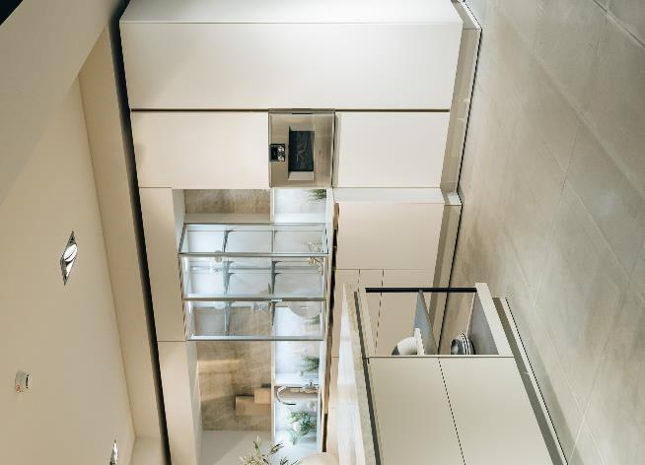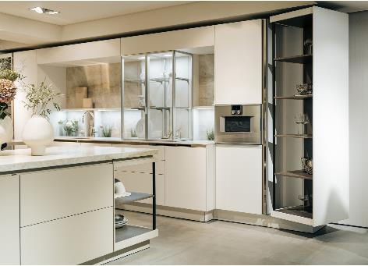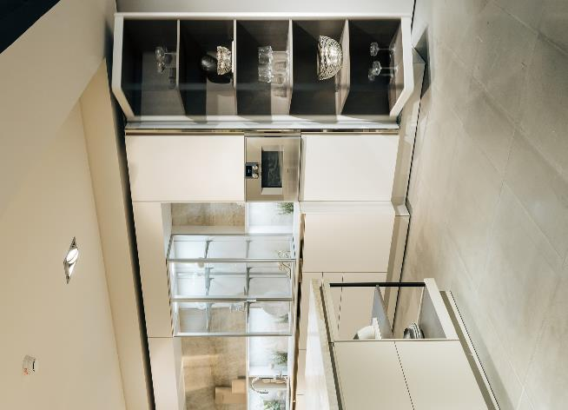

**322023_a, 322023_b, 322023_c**

FurnSpin brings elegant dynamic to high end interior design. With a sweep of the hand, the entire cabinet body can be turned from the closed to the open position. "SieMatic ID Days 2023" will be showing concept studies of Hettich's FurnSpin in the SieMatic S2 too. Photo: SieMatic

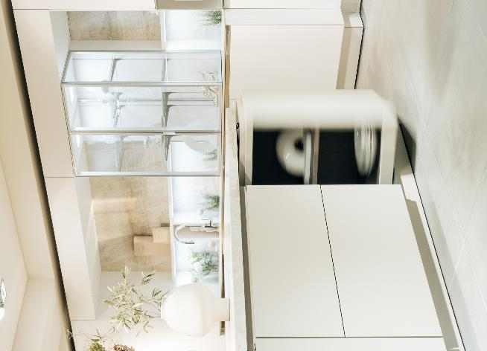

**322023_d**

FurnSpin is inspiringly different: open doors or flaps no longer get in the way – most of the cabinet body can now be moved with effortless ease. FurnSpin also offers new storage solutions in the base unit. Photo: SieMatic

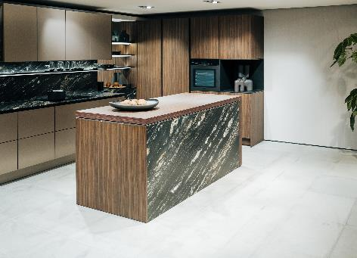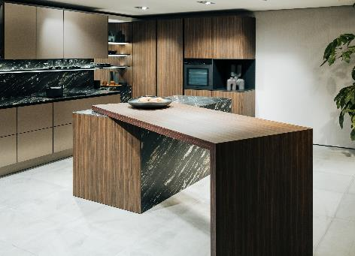

**322023_e, 322023_f**

FurnSpin will revolutionise the kitchen island: even large table elements easily swivel in or out exactly as required. Photo: SieMatic

About Hettich

Founded in 1888, Hettich is one of today's largest and most successful manufacturers of furniture fittings on the international stage. The family owned company is based at Kirchlengern in the furniture making cluster of Germany's East Westphalia region. Some 8,000 members of staff in almost 80 countries work together to give the industry future proof solutions. Promising "It's all in Hettich", the Hettich brand provides a comprehensive portfolio of services that is consistently and resolutely geared to the needs of customers across the globe. By tradition, top priority has always been at the focus of everything we do to ensure sustainability at social, societal and ecological level. [www.hettich.com](http://www.hettich.com)