**Hettich is member of "German Design Council"**

**German design makes history writing stories of success**

**As Germany's acknowledged authority on design and brands, the "German Design Council" (**[**German Design Council**](https://www.german-design-council.de/en/about-us)**) has been raising society's awareness of creativity and assisting businesses in all aspects of their brand and design development activities since 1953. To this end, it connects business with design in its cross-industry network – for circular design, transformation and economic success. This year, Hettich was able to win over the expert jury and is now officially a member of the "German Design Council".**

The "German Design Council" network is currently made up of around 330 prominent companies and individuals in various walks of the design-relevant industry. Publishing its book "The Major German Brands", the German Design Council Foundation every year showcases "outstanding German brand companies from the design relevant industry who successfully compete globally through 'designed in Germany'."

The new edition, "The Major German Brands 2025", includes Hettich for the first time. This year's brand book focuses on the topic of "Pushing Circular Design". – Fittings specialist Hettich was quick to recognise the potential of design for a sustainable future and, in its product development and design activities, is focusing on optimising material management. The aim is to identify design systems which, wherever possible, permit recycling by material type, simple disassembly and component separation without the need for tools. This provides the capability of returning materials to the material cycle at the end of a long product life.  
  
To get more about "The Major German Brands" in it newly published edition, go to: <https://www.german-design-council.de/en/themes/the-major-german-brands>

The following picture material is available [**www.hettich.com**](http://www.hettich.com) for downloading from the **"Press" menu**:

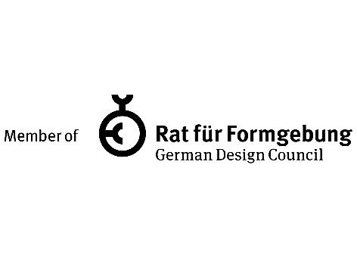

**392024_a**

Hettich is now an official member of the "German Design Council" and part of the book published under the title of "The Major German Brands 2025". Graphics: Rat für Formgebung/German Design Council

## About Hettich

Founded in 1888, Hettich is one of today's largest and most successful manufacturers of furniture fittings on the international stage. The family owned company is based at Kirchlengern in the furniture making cluster of Germany's East Westphalia region. Some 8,600 members of staff work together to provide our future proof solutions in over 100 countries. Promising "It's all in Hettich", the Hettich brand provides a comprehensive portfolio of services that is consistently and resolutely geared to the needs of customers across the globe. By tradition, top priority has always been at the focus of everything we do to ensure sustainability at social, societal and ecological levels. [www.hettich.com](http://www.hettich.com)