ProDecor: Inspired by Life
The new furniture handle collection from Hettich stuns with new releases that are right on trend
Good interior design embraces every last detail – this is where Hettich's latest ProDecor furniture handle range makes a "tangible" contribution to the furniture industry and trades: inspired by international home living and furniture trends, there are now even more shapes, colours and materials to choose from. Well assorted in the four ProDecor style worlds of "New Modern", "Deluxe", "Organic" and "Folk", the new portfolio reflects the sheer diversity of lifestyles. The online catalogue makes fast work of finding the right handle for any item of furniture.

Spanning every furniture segment, the ProDecor collection caters to all manner of styles: the "New Modern" style world is synonymous with technology, transparency and functionality while showing sharply defined contours for timelessly elegant furniture design. In contrast, "Deluxe" promises sensuality with a touch of luxury and takes delight in captivating with iridescent metals and majestic colours. "Organic", in turn, delights with its natural charm, bringing furniture to life with shapes and surfaces borrowed from nature. "Folk" exudes unadulterated zest for life and comes with astonishing diversity – earthy, lavish, subtle or full of cheer.
Twenty-six brand-new models extend the ProDecor collection, five of them available exclusively from Hettich: "Bonelli", "Campli", "Livorno", "Paliano" and "Torlano". On top of this, attractive additions have been made to 50 of the range's products, which means that no fewer than 182 new ProDecor items are now available from Hettich in accustomed quality. ProDecor also covers the increasingly popular "Outdoor" segment with handles that verifiably comply with standards and are also particularly weather resistant.

As such, the 2024 ProDecor online catalogue at https://www.hettich.com/short/tazujc8 provides plenty of inspiration for designing furniture that appeals – also quickly guiding users to the right products: the perfect handle can be selected by material, surface finish and colour, hole spacing, model and article type, and ordered from Hettich's e-shop direct.

The following picture material is available for downloading from www.hettich.com:
Images
Captions
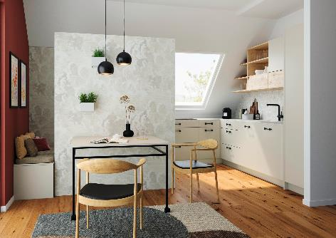
P103_a
Underscoring the design of furniture, a lovely handle also makes distinctive statements, as demonstrated here by "Limpio" in matt black from ProDecor. Photo: Hettich

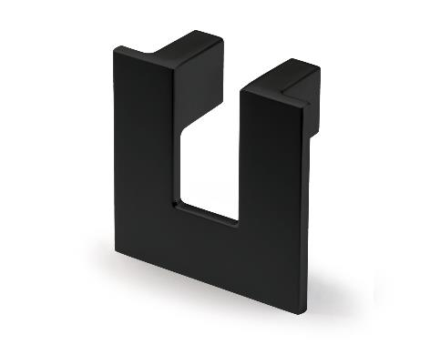
P103_b
Uncompromisingly clean lines: the "Vigilia" handle in a new black matt finish from the "New Modern" style world. Photo: Hettich

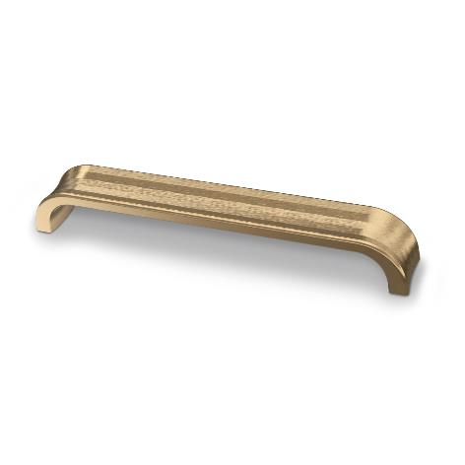
P103_c
Handles from the "Deluxe" style world give furniture a touch of luxury: the "Andria" model in antique brushed brass look. Photo: Hettich

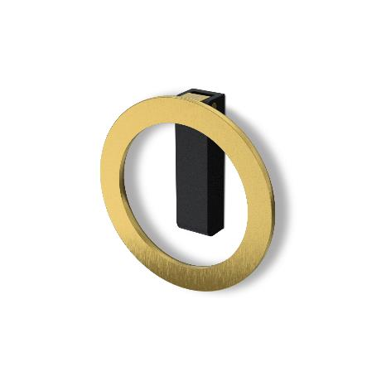
P103_d
New to the ProDecor range and available exclusively from Hettich: the "Campli" handle in antique pewter look from the "Organic" style world. Photo: Hettich

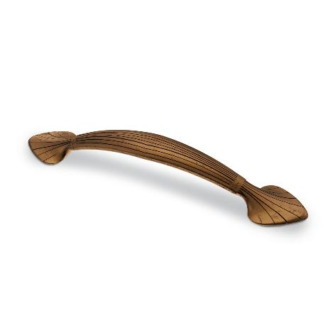
P103_e
The ‘Tribano’ handle in antique look is just one example from the diverse ProDecor "Folk" style world. Photo: Hettich

About Hettich
Founded in 1888, Hettich is one of today's largest and most successful manufacturers of furniture fittings on the international stage. The family owned company is based at Kirchlengern in the furniture making cluster of Germany's East Westphalia region. Some 8,600 members of staff work together to provide our future proof solutions in over 100 countries. Promising "It's all in Hettich", the Hettich brand provides a comprehensive portfolio of services that is consistently and resolutely geared to the needs of customers across the globe. By tradition, top priority has always been at the focus of everything we do to ensure social, societal and ecological sustainability. www.hettich.com

