**Sachsenküchen backs drawer technology from Hettich**

**AvanTech YOU for the new "AccuraBox"**

**Fittings specialist Hettich can announce a further cooperation partnership in the premium kitchen segment: as a manufacturer of high quality kitchens, living room and bathroom furniture, Sachsenküchen will be presenting its new "AccuraBox" drawer system for the first time at the "A30 Küchenmeile" kitchen show from 16 to 22 September 2023. Upgrading its portfolio, Sachsenküchen has deliberately opted for the versatile AvanTech YOU drawer platform from Hettich. The "AccuraBox" will be available at Sachsenküchen from the 1st quarter of 2024.**

Saxony based industrial craft manufacturer Sachsenküchen from Dippoldiswalde is a producer of high quality, bespoke kitchens. Switching to Hettich's versatile AvanTech YOU drawer platform based on Actro YOU runners, the aim is now to provide new incentives for discerning, design savvy kitchen buyers: perfecting its "AccuraBox", Sachsenküchen has chosen drawer side profiles in anthracite along with stainless steel profiles and DesignCapes in reproduction oak. Push-to-open Silent soft action opens and closes handleless drawers gently and quietly. "AvanTech YOU Illumination" LED signature lighting complements the new system in a way that's particularly attractive.

Commenting, Sachsenküchen Managing Director Elko Beeg says: "Design, customisability as well as the most exacting of demands on quality and practical functionality were key criteria in our decision to include the AvanTech YOU platform system in our product line up for the AccuraBox. This year at Küchenmeile, we are showcasing our product range under the 'New Inspiration' banner. This is where AccuraBox lets us present a highly compelling upgrade for our portfolio that leaves not a margin of doubt. Excelling in practical functionality, the new drawer system reflects the new 'inner values' that come with our premium kitchens. Our customers can also expect to be captivated by the exquisitely elegant look of our exclusive drawer design."

The following picture material is available for downloading from **www.hettich.com**:

**Images**

**Captions**

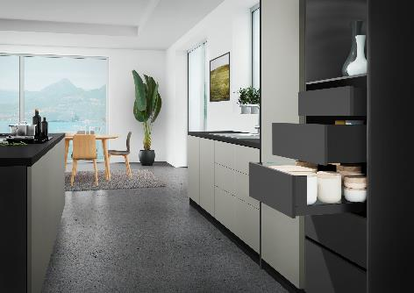

**292023_a**

The new "Accura Box": comprehensively upgrading its drawer system, Sachsenküchen now uses Hettich's incredibly versatile AvanTech YOU drawer platform. Photo: Hettich

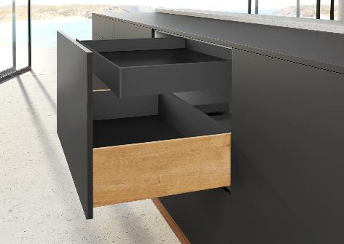

**292023_b**

Exclusive design from Hettich for Sachsenküchen's "Accura Box": an AvanTech YOU drawer side profile in anthracite, plus stainless steel profiles and DesignCapes in reproduction oak. Photo: Hettich

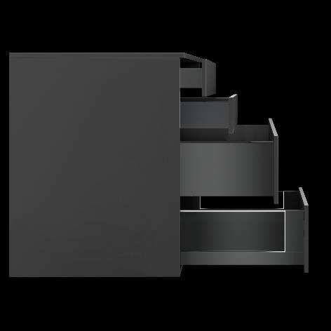

**292023_c**

Switching to the versatile AvanTech YOU drawer platform from Hettich, Sachsenküchen's aim is to reset the boundaries for discerning, design savvy kitchen buyers. Photo: Hettich

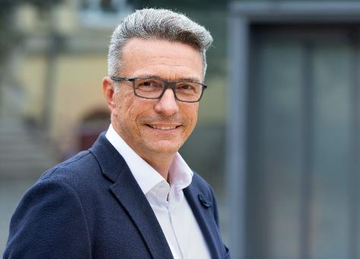

**292023_d**

Sachsenküchen Managing Director Elko Beeg: "Design, customisability as well as the most exacting of demands on quality and practical functionality were key criteria in our decision to include the AvanTech YOU platform system in our product line up for the AccuraBox." Photo: Sachsenküchen

**More on AvanTech YOU from Hettich:**

Product website (English):

<https://web.hettich.com/en-de/products-eshop/drawer-systems/avantech-you>

About Hettich

Founded in 1888, Hettich is one of today's largest and most successful manufacturers of furniture fittings on the international stage. The family owned company is based at Kirchlengern in the furniture making cluster of Germany's East Westphalia region. Some 8,000 members of staff in almost 80 countries work together to give the industry future proof solutions. Promising "It's all in Hettich", the Hettich brand provides a comprehensive portfolio of services that is consistently and resolutely geared to the needs of customers across the globe. By tradition, top priority has always been at the focus of everything we do to ensure sustainability at social, societal and ecological level. [www.hettich.com](http://www.hettich.com)