Hettich at Sicam 2024 in Pordenone/Italy
Innovative fittings with creative drive for the premium segment
At Sicam from 15 to 18 October, Hettich will be presenting a whole array of new and enhanced releases in the form of exceptional furniture ideas for contemporary home living and working environments in hall 5, stand A33/B32. The unique FurnSpin swivelling rotating fitting is the flagship of the innovation fleet, having already won the Interzum Award as "Best of the Best".

"It's all in Hettich" - this is the banner under which the globally active Hettich brand is adding impetus to its claim of giving customers everything to boost their success. This includes developing innovative fitting systems from the user's perspective, systems that make it easy to create bespoke solutions with an exclusive look.

"The Joy of FurnSpin"
The innovative FurnSpin fitting for the high end division gets rid of old style formats and puts a creative new spin on furniture design. Its unique "translatory rotational movement" can literally turn furniture inside out. Entirely unprecedented, this form of movement by individual furniture elements gives designers and manufacturers new creative inspiration for designing furniture and utilising premium segment storage space. This is where open doors and flaps no longer get in the way: most of the cabinet body can now be moved with effortless ease. A stylish turn leaves furniture to reveal what's inside. Hiding everything from view again, a further spin returns furniture to its closed state. As such, FurnSpin permits ground breaking spatial and furniture concepts with stunning performance in a quality of design that clearly stands apart from the norm.

System platforms for top class furniture design
As inventor of the platform principle, enhancing drawer systems is close to Hettich's heart. Also featuring in the fittings specialist's show line up are its top new product releases for the AvanTech YOU drawer system as an easy way of upgrading to a higher price segment. The "AvanTech YOU Illumination" design feature now even gives furniture its very own lighting signature. With its exclusive look, Hettich is presenting its minimalist AvoriTech system which, with immaculate drawer side profile measuring a slender 8 mm across, is ideal for high end cabinetry and kitchens. Hettich is also presenting a new generation of the Actro 5D runner system for wooden drawers with intuitive 5 way adjustment capability for perfect reveal alignment at all times.
"It's all in Hettich" – this claim also embraces maximum design flexibility. The optimised WingLine L folding sliding door system with new features comes with exactly what it takes to become a designer's favourite. Whether in the living room, bedroom or kitchen – WingLine L makes opening cabinets a sheer pleasure.

Anyone unable to make it to Sicam can discover the exciting furniture concepts in 3D on Hettich's "roominspirations" website and begin envisioning their own furniture designs.
https://roominspirations.hettich.com

The following picture material is available for downloading from the "Press" menu at www.hettich.com

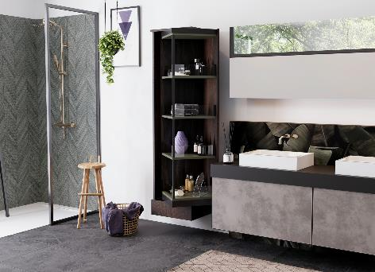
252024_a
Hettich's FurnSpin top innovation: turned, the furniture element changes from closed to open. This provides the key to redefining storage space from scratch. Photo: Hettich

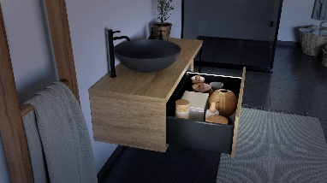
252024_b
Illuminated AvanTech YOU drawers look so exquisite and give users added value. The LED light strip simply clips onto the drawer side profile and requires no mains electricity as it's powered by rechargeable battery. Photo: Hettich

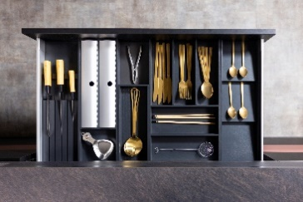
252024_c
Elegant contours and immaculate design: the AvoriTech drawer system with slender side profile is the ideal choice for high end furniture. Photo: Hettich

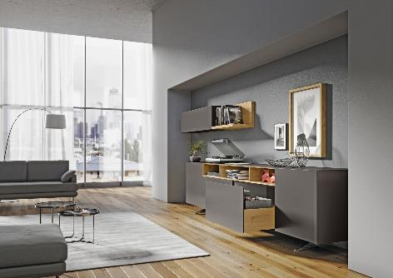
252024_d
High quality handleless design for large format fronts: the Actro 5D drawer runner makes it incredibly easy to achieve perfectly aligned front panel reveals. Photo: Hettich

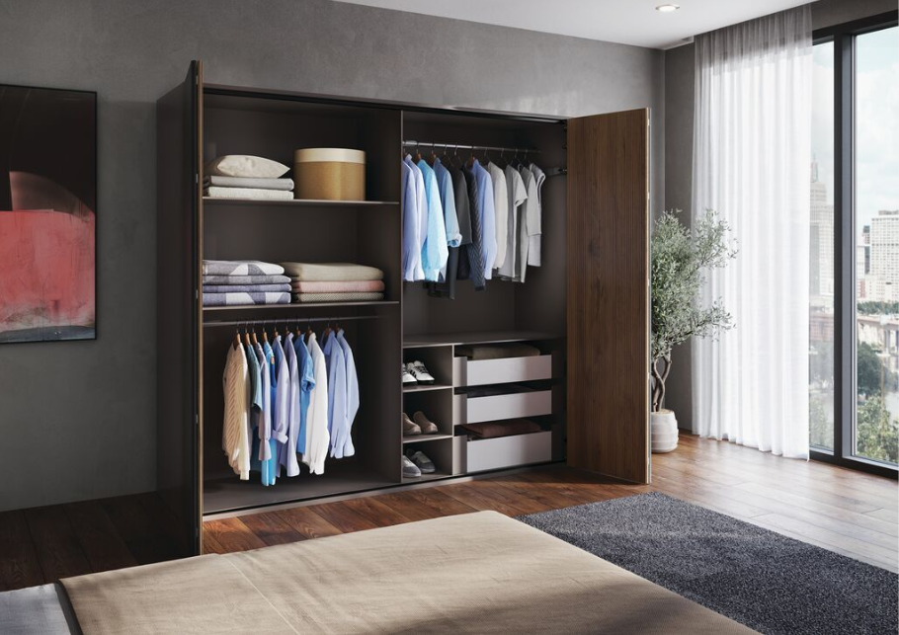
252024_e
WingLine L folding sliding door fitting: the new generation brings enhanced running performance and quality of design to wardrobe doors of any size. Photo: Hettich

About Hettich
Founded in 1888, Hettich is one of today's largest and most successful manufacturers of furniture fittings on the international stage. The family owned company is based at Kirchlengern in the furniture making cluster of Germany's East Westphalia region. Some 8,600 members of staff work together to provide our future proof solutions in over 100 countries. Promising "It's all in Hettich", the Hettich brand provides a comprehensive portfolio of services that is consistently and resolutely geared to the needs of customers across the globe. By tradition, top priority has always been at the focus of everything we do to ensure social, societal and ecological sustainability. www.hettich.com

