New Hettich products for the carpentry trade
"Furniture Fittings & Applications 2025": find and order easily online
At Hettich, customers from the carpentry and cabinet making trade will find precisely the right products for their projects. The latest "Furniture Fittings & Applications 2025" online flip page catalogue, "F&A" for short, provides round the clock access to Hettich's entire product expertise and lets users order all items directly online in total relaxation. Now, it also comes with a whole raft of interesting new product releases to discover.

Regarding product range and packaging size, the new "Furniture Fittings & Applications 2025" online flip page catalogue is tailored specifically to the needs of the carpentry trade. In "Furniture Fittings & Applications 2025", each product is linked to useful information that can simply be clicked open or accessed by scanning a QR code. The item number then takes you to the actual item in the Hettich eShop: this not only lets you order online but also view and download the very latest versions of key documents for each Hettich product, such as planning information in the form of CAD data, product data sheets as well as practical instructions on assembling and fitting products.

Simply browse the lineup, get all the news straight away
The latest new products and additions to the Hettich portfolio are each marked with an eye catching blue "News" button. All new products can be seen at a glance in the online new products tour.
WingLine L folding door system: even more "Aaah"!
Hettich has optimised every part of its system of fittings for sliding doors. The result: even greater convenience, quieter running action, faster opening, easier installation – and altogether more flexibility in designing high end furniture with the WingLine L. Virtually hidden from view, the fitting technology provides a perfect look, whether in the kitchen wall unit, in the splashback zone or in large wardrobes. Door wings can have a maximum height of 2,600 mm, width of 600 mm and weight of up to 25 kg. The "Push to move" opening mechanism opens the door set all the way in response to just a single push. This is where the unique panoramic effect really impresses and permits access to everything inside. The absence of any profiles to get in the way on the furniture base panel makes the interior even more easily accessible and enhances versatility of use. Door protrusion is minimal, and the door is securely held in the open position. Drawers and runner components can now run past the door leaf collision free. And any item of furniture can be upgraded for yet greater user friendliness by giving WingLine L the luxurious feel of soft opening or closing.

Quadro runners: the new platform generation
Introducing the latest Quadro generation, Hettich now offers an end to end platform for runners that also provides the option of switching between wooden and system drawers. This makes it possible to plan any item of furniture as chosen and only at the end decide which runners to use. The Quadro 25 2D partial extension runner has been included in the product portfolio as a cost efficient gateway option. Also new is the Quadro V6 5D full extension runner with a 30 kg load capacity: it comes with an intuitive 5 way adjustment capability and now makes precision reveal alignment the standard in wooden drawers too. The platform also provides the option of upgrading very large, heavy pull-outs to the Actro 5D runner. This now gives Hettich a unique Quadro lineup that brings elevated drawer convenience and precision to every furniture segment.

Evisys guiding hinge: top load carrying performer for spacious kitchen design
A newcomer at Hettich is the Evisys guiding hinge that opens up new creative options for kitchen planners. Positioned in the top door section, Evisys brings the necessary opening and closing stability to heavy, extra tall cabinet doors in front of built in refrigerators. In combination with Hettich's fixed door hinges, it's now possible to install doors weighing up to 80 kg – a whopping 10 kg more than before. This means users can load their refrigerator door more heavily while still keeping reveals perfectly aligned. The Evisys with integrated Silent System comes with further added convenience that's highly welcome in everyday kitchen routine: the hinge's damping effect now also closes the refrigerator door gently and quietly.

AvanTech YOU Synchro Access: useful in storage space
A simple solution from Hettich for significantly more drawer convenience: on pulling the pot-and-pan drawer out all the way, the "Synchro Access" upgrade function simultaneously opens internal drawers as well whenever they're needed. This provides a full view of contents and unobstructed access to storage space. And does so with effortless ease and no visible working components – because here, there's no longer any need for a catch.

AvanTech YOU drawers: New DesignProfiles
Individualisation made easy: the latest range of DesignProfiles for clipping onto the AvanTech YOU drawer side profile is made of recycled plastic sheathed in aluminium. The profiles with their particularly scratch resistant, quality surfaces create new design highlights: anodised and lacquered in the drawer side profile colours of white, silver and anthracite, or also in a brushed stainless steel look. What's more, customers can paint them themselves in any preferred colour.

Hettich's new "Furniture Fittings & Applications 2025" online flip page catalogue comes with several advantages: doing away with the print version saves no end of paper, and everything you need is available from any place around the clock at:
https://catalog.hettich.com/General/TA_2025/en_DE/

The following picture material is available for downloading from the "Press" menu at www.hettich.com:
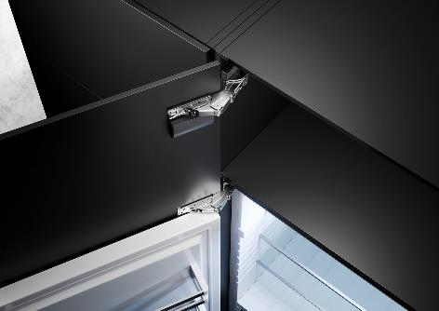
012025_a
High load capacity for spaciously designed kitchens: the new Evisys guiding hinge from Hettich provides the necessary opening and closing stability for heavy, extra tall cabinet doors in front of built in refrigerators – while leaving reveals perfectly aligned. Photo: Hettich

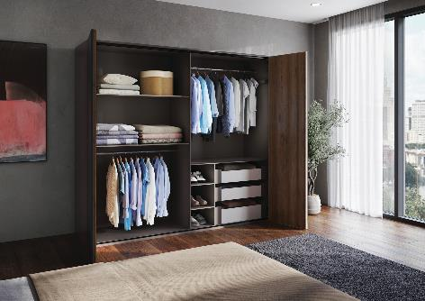
012025_b
All parts of Hettich's WingLine L folding sliding door system have just been optimised: the new generation brings better running performance and quality of design to almost any size of wardrobe door. Photo: Hettich

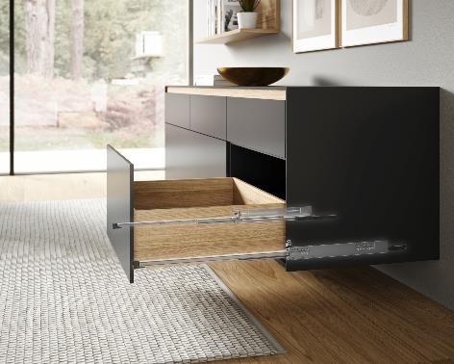
012025_c
Perfect reveal alignment: the Quadro V6 D5 runner from the latest platform generation provides 5 way adjustment convenience for precise front panel alignment in respect of vertical and lateral positioning, depth, tilt and radius. Photo: Hettich

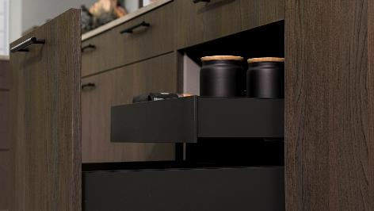
012025_d
AvanTech YOU Synchro Access: pulling out the pot-and-pan drawer all the way also opens the internal drawer as if by magic. Here, no catch is needed. Photo: Hettich
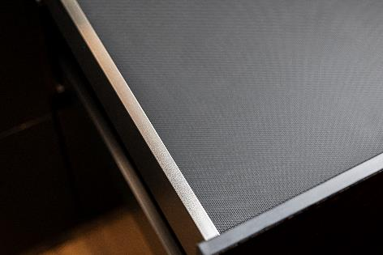
010205_e
Clipping on any chosen design: new, quality profile surfaces bring creative highlights to the AvanTech YOU drawer side profile. Photo: Hettich

About Hettich
Founded in 1888, Hettich is one of today's largest and most successful manufacturers of furniture fittings on the international stage. The family owned company is based at Kirchlengern in the furniture making cluster of Germany's East Westphalia region. Some 8,600 members of staff work together to provide our future proof solutions in over 100 countries. Promising "It's all in Hettich", the Hettich brand provides a comprehensive portfolio of services that is consistently and resolutely geared to the needs of customers across the globe. By tradition, top priority has always been at the focus of everything we do to ensure sustainability at social, societal and ecological levels. www.hettich.com

