**Veosys stainless steel hinge from Hettich**

**Defies damp, cold and hot conditions**

**An outdoor kitchen stands outside in all weathers: cold, heat, fog, rain, snow or salty sea air – even under extreme conditions, the furniture needs to stay fully functional. This demands top quality from every component. Special fittings made of stainless steel are particularly corrosion resistant and make outdoor furniture fit for use outside. The new Veosys fast assembly concealed hinge from Hettich is a rugged all rounder for all weathers.**

Veosys is made of robust stainless steel to meet the most exacting of requirements and comes in a high quality look. It is not affected by temperature fluctuations, moisture or salt. Even after 120 hours in the neutral salt spray test (NSS), the concealed hinge system demonstrates its exceptional corrosion resistance in compliance with DIN EN ISO 9227. Besides use outdoors, in shipbuilding or in coastal areas, Veosys is also suitable for applications in spa centres, gyms or laboratories and hospitals. Veosys is quickly installed thanks to practical clip on installation as well as convenient 3D adjustment for precision lateral, vertical and depth alignment - and, if required, the adjustment screws can be hidden from view behind stainless steel cover caps.

But this concealed hinge can do even more: with Veosys, the user friendly functions familiar from indoor furniture can now also be enjoyed in the garden or on the roof terrace. The integrated Silent System provides excellent soft closing performance at low and high outdoor temperatures. And with its wide self closing angle of 35°, Veosys closes furniture doors almost by itself.

The following picture material is available for downloading from **www.hettich.com, menu: Press**:

**Images**

**Captions**

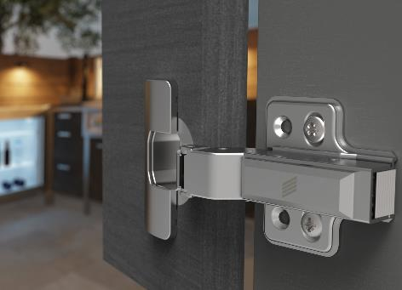

P97_a

Ideal for outdoor use: whether camping in winter or barbecue evenings at the height of summer – you can always rely on Veosys hinge's integrated Silent System. Photo: Hettich

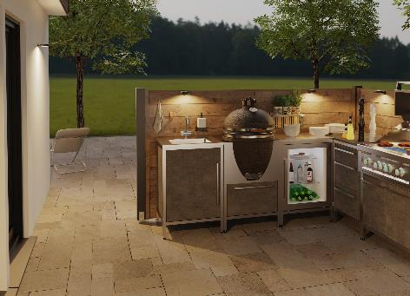

P97_b

The Veosys stainless steel hinge from Hettich is a rugged all rounder for outdoor use. Photo: Hettich

About Hettich

Hettich was founded in 1888 and is today one of the world's largest and most successful manufacturers of furniture fittings. Over 6,600 members of staff in almost 80 countries work together towards the objective: developing intelligent technology for furniture. Hettich thus inspires people all over the world and is a valuable partner for the furniture industry, trade and craft. The Hettich brand stands for consistent values: for quality and innovation. For reliability and customer proximity. Despite its size and international significance, Hettich has remained a family business. Being independent of investors means that the company has a free hand in shaping its future with a focus on the human element and sustainability. [www.hettich.com](http://www.hettich.com)