Opening of Hettich Vietnam
Together into a sustainable future with Hettich & FGV

In January 2025, the first joint subsidiary of Hettich and FGV will be opened: Hettich Vietnam. For a year now, the two family-owned companies have been joining forces in the furniture hardware industry globally. With Hettich Vietnam, they are creating a company to offer customised solutions for the dynamic Vietnamese furniture industry and distribution.

Advantages of a subsidiary in Vietnam

The official establishment of the company in Vietnam marks an important step in view of the growing furniture market. This strategic investment by the Hettich Group demonstrates their long-term vision to expand and foster sustainable development in growth markets throughout Asia, while continuing to set trends and lead markets in their industry. Jana Schönfeld, Managing Director of the Hettich Group, explains: ‘We want to be more than just present in the market. We want to become part of the Vietnamese community and share our innovations and experiences from Germany and Italy.’

Local approach: tailored strategies

The establishment of the official branch in Vietnam, which sells Hettich and FGV products, not only enhances sales opportunities but also fosters strong partnerships with renowned local companies. Matthias Bertl, Managing Director of Hettich Southeast Asia, explains: ‘In a rapidly developing market like Vietnam, it is important to understand local conditions. That is why Hettich Vietnam is the only supplier that distributes unmatched high-quality products and innovations, paired with comprehensive support for professionals, to jointly develop solutions that enrich the lifestyle of consumers across the country. While Hettich Vietnam expands its distribution channels nationwide to enhance visibility and drive growth through strengthened dealer partnerships, it also focuses on getting closer to local design and furniture communities as well as homeowners to deliver the innovative, functional solutions that cater to the local market's preferences.”

Worldwide quality: product portfolio

Hettich and FGV both offer an extensive product portfolio that ideally complements each other and is able to address a various range of market needs across different segments. Uwe Kreidel, Managing Director of FGV, says: ‘With Hettich and FGV, two family-owned companies with comparable roots and shared values have joined forces. Together, we bring 200 years of industry experience and strengths to offer our customers in Southeast Asia real added value. Our presence in Vietnam marks an important milestone on our path to shared success.’

The following picture material is available for downloading from the "Press" menu at www.hettich.com:

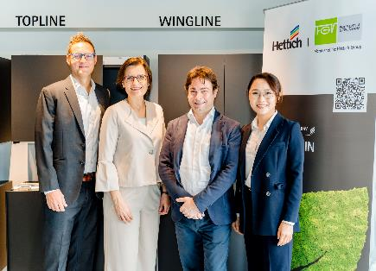
032025_a
Opening ceremony of Hettich Vietnam. Matthias Bertl - Managing Director of Hettich Southeast Asia & General Director of Hettich Vietnam, Jana Schönfeld - CEO of Hettich Group, Andrea Casoni - Sales Manager of FGV, Thanh Pham - Communication Director of Hettich Southeast Asia & Deputy General Director of Hettich Vietnam.
Photo: Hettich

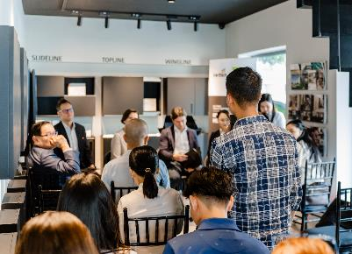
032025_b
Hettich Vietnam is the first joint subsidiary of Hettich and FGV. Photo: Hettich

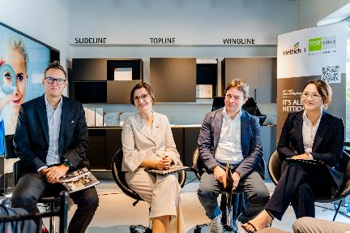
032025_c
Opening ceremony of Hettich Vietnam. Hettich Vietnam is the first joint subsidiary of Hettich and FGV. Photo: Hettich

About Hettich
Founded in 1888, Hettich is one of today's largest and most successful manufacturers of furniture fittings on the international stage. The family owned company is based at Kirchlengern in the furniture making cluster of Germany's East Westphalia region. Around 8.600 colleagues work together to deliver our future proof solutions to over 100 countries. Promising "It's all in Hettich", the Hettich brand provides a comprehensive portfolio of services that is consistently and resolutely geared to the needs of customers across the globe. By tradition, top priority has always been at the focus of everything we do to ensure sustainability at social, societal and ecological level. www.hettich.com

