Panorama effect rediscovered: Hettich presents second generation WingLine L folding door fitting
Convenience meets design: optimised components for top running performance in a modern look

For Hettich, consistently optimising products is a matter close to its heart. Just because something's good doesn't mean it can't be improved: the overhauled fitting solution offers precision running action and an impressive panorama effect: folding doors open with a mere sweep of the hand, effortlessly revealing the wardrobe's entire contents. Comprehensive optimisation now makes the system quicker and easier to open, more installation friendly and adjustable to suit any preference.

The new WingLine L boasts optimised running performance, resulting in door action that's particularly quiet and smooth: enhanced running and guide components ensure precision and stability in controlling door movement while soft opening and closing speeds can be adjusted as chosen to provide a level of practical convenience that's matched to personal needs. Users have the choice between the handleless Push-to-Move system and the Pull-to-Move-Silent option with classic handle.

Flexible and space saving design options
As a space saving alternative to hinged doors, the WingLine system is ideal for living spaces, bedrooms, kitchen and study. Hidden away, the fitting system produces a high quality look as no profiles are visible on furniture bottom panels. With minimal door protrusion, the folding door remains securely in the open position without bouncing back into the wardrobe interior. Drawers and pull-outs reliably glide past the fitting, letting wide drawers provide optimum access to storage space.

Carefully considered and easy installation
The new comfort units not only open doors far more quickly and easily, they also impress with aesthetic appeal: available in various colours and surface finishes, they harmonise perfectly with the particular colour of the cabinet body.
The new adjustable centre hinges leave neatly aligned reveals once the doors are closed. New adjustment capabilities and intelligent mounting accessories make installation so straightforward that WingLine L can even be fitted by one person with effortless ease.
Identical hole positions simplify switching to the new system and facilitate integration into manufacturing processes.

Introducing the new WingLine L generation, the fittings specialist is combining convenience, flexibility and innovative design to satisfy the most exacting of demands in the modern home.

The following picture material is available for downloading from the "Press" menu at www.hettich.com:
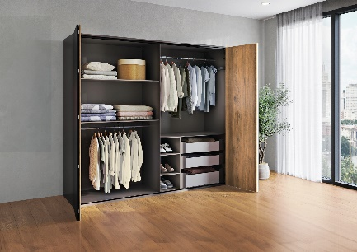
P102_a
Never failing to impress – the panorama effect: a sweep of the hand is all it takes to open the folding doors, effortlessly revealing everything inside the wardrobe. Optimised system components now make opening the wardrobe even faster, easier and quieter. Photo: Hettich

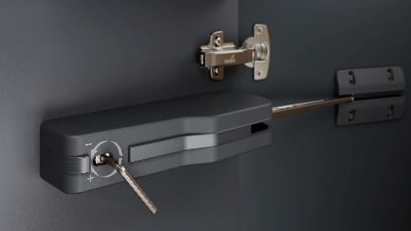
P102_b
The comfort unit has been redesigned with careful attention to detail. Nice feature: soft opening and closing performance that adjusts by Allen key to suit any need. Photo: Hettich

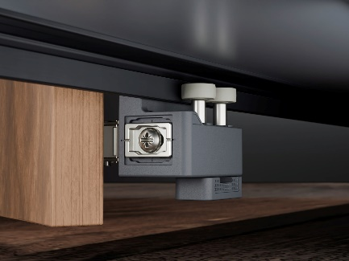
P102_c
Precision and stability on opening and closing: the new, installation friendly guide components permit exact and reliable door control. Photos: Hettich

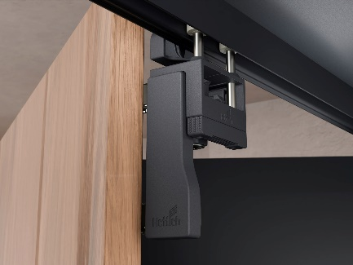
P102_d
Smooth performers that make hardly a sound: optimised running and guide components deliver impressively gentle and quiet movement. Photos: Hettich

About Hettich
Founded in 1888, Hettich is one of today's largest and most successful manufacturers of furniture fittings on the international stage. The family-owned company is based at Kirchlengern in the furniture making cluster of Germany's East Westphalia region. Some 8,600 members of staff work together to provide our future proof solutions in over 100 countries. Promising "It's all in Hettich", the Hettich brand provides a comprehensive portfolio of services that is consistently and resolutely geared to the needs of customers across the globe. By tradition, top priority has always been at the focus of everything we do to ensure social, societal and ecological sustainability. www.hettich.com

