Share acquisition completed: FGV and Hettich join forces
New CEO named at FGV

The eagerly awaited acquisition of FGV Group by Hettich Group, announced in early September, has now reached its successful conclusion, marking the formal completion of the aquisition. In addition to the necessary approvals from the antitrust authorities, all other closing conditions for the aquistion have been met. FGV and Hettich are now shaping their future together in the furniture fittings industry.

Both companies are characterized by their long-term vision, expertise in furniture fittings, presence in the same industry, and close relationships with their customers. "We are two family businesses with a combined experience of more than 200 years," says Jana Schönfeld, Managing Director of the Hettich Group. "And together we are now more than 9,000 colleagues all over the world who use all their energy, passion and ideas to bring about the best for our customers every day. These similarities have inspired us and convinced us to want to shape our future together."

"Hettich and FGV will complement each other with their strengths in order to continuously develop existing business activities and offer their customers even better value-added solutions," emphasises Dr. Andreas Hettich, shareholder and Chairman of the Advisory Board of the Hettich Group, which is now a 100% shareholder in the FGV Group. Within the overall Hettich Group, Hettich and FGV will remain independent brands and companies. Customers of both companies will retain their familiar contacts.
Continuously developing together and being there reliably for the customers of Hettich and FGV is also of particular importance to Uwe Kreidel. FGV's accomplished management team will be joined in future by Uwe Kreidel as CEO. In addition to his more than 30 years of experience in the industry and in a Hettich management role, he also contributes his knowledge of the Italian market, acquired among other things in his function as Regional Director for Hettich Italia. Uwe Kreidel, now CEO of the FGV Group, is very much looking forward to his new role and working with the FGV management team: "The Formenti e Giovenzana Group is a company with many great employees. I am very much looking forward to shaping the growing of FGV and Hettich together with all my colleagues. We will bring together our diverse know-how and experience and develop successfully together, as independent brands."

Special thanks go to Silvana Riboldi, Head of Sales at FGV, and Giulia Luigetti, CFO of the FGV Group, who also acted as interim CEO during the transition phase from the previous to the new shareholders. Both made a significant contribution to the success of the process.

The following image material is available for download at www.hettich.com, menu: Press for download:
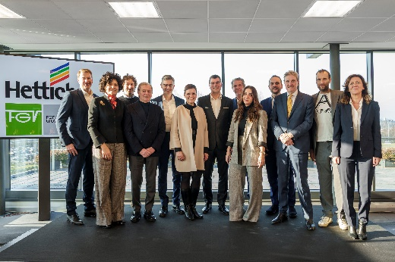

032024_a

Together at the handover ceremony in Veduggio, the headquarters of the Formenti e Giovenzana Group: representatives of the FGV and Hettich management team with Dr Andreas Hettich and the former shareholders of Formenti e Giovenzana and their families. Photo: Hettich

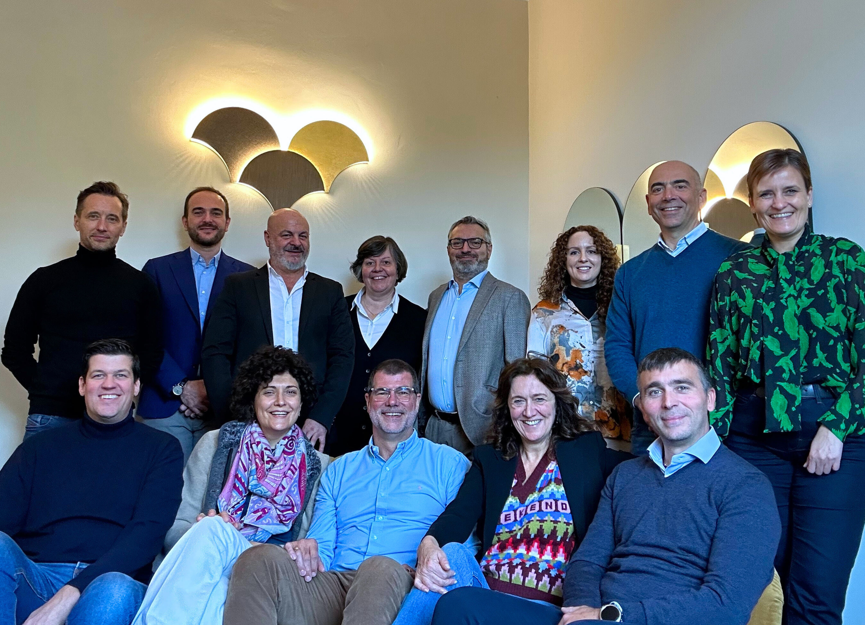

032024_b

Representatives of the FGV and Hettich management team.
Photo: Hettich

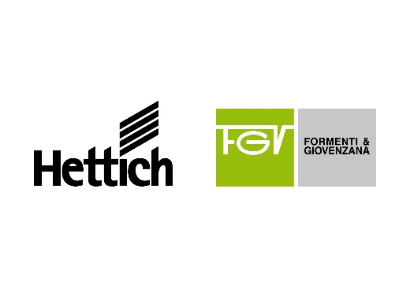

032024_c

FGV and Hettich join forces. Photo: Hettich

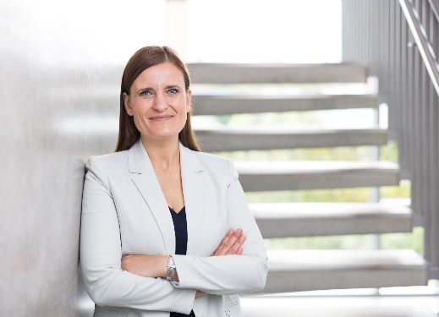

032024_d

Jana Schönfeld, Managing Director of the Hettich Group: "We are two family businesses with a combined experience of more than 200 years. And together we are now more than 9,000 colleagues all over the world who use all their energy, passion and ideas to bring about the best for our customers every day. These similarities have inspired us and convinced us to want to shape our future together." Photo: Hettich

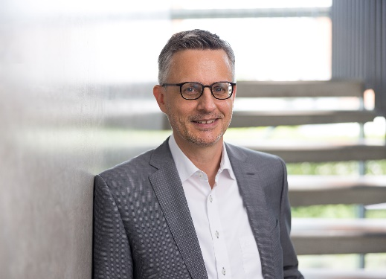
032024_e
Dr. Andreas Hettich, shareholder and Chairman of the Advisory Board of the Hettich Group: "Hettich and FGV will complement each other with their strengths in order to continuously develop existing business activities and offer their customers even better value-added solutions." Photo: Hettich

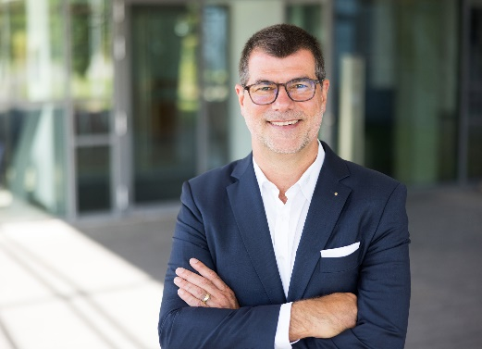
032024_f

Uwe Kreidel, now CEO of the FGV Group: "The Formenti e Giovenzana Group is a company with many great employees. I am very much looking forward to shaping the growing of FGV and Hettich together with all my colleagues. We will bring together our diverse know-how and experience and develop successfully together, as independent brands." Photo: Hettich

About Hettich
Founded in 1888, Hettich is one of today's largest and most successful manufacturers of furniture fittings on the international stage. The family owned company is based at Kirchlengern in the furniture making cluster of Germany's East Westphalia region. Some 8,000 members of staff in almost 80 countries work together to give the industry future proof solutions. Promising "It's all in Hettich", the Hettich brand provides a comprehensive portfolio of services that is consistently and resolutely geared to the needs of customers across the globe. By tradition, top priority has always been at the focus of everything we do to ensure sustainability at social, societal and ecological level. www.hettich.com

About FGV
Quality, innovation and functionality at the right price, together with “Made in Italy” design and production: this is FGV. A leading company in the production of fittings and solutions for furniture, FGV offers a complete range of products. Among them hinges, drawers, slides, hanging brackets, alternative openings and sliding systems suitable to meet the most demanding market needs.
Founded in 1947 in the heart of Brianza, in Veduggio con Colzano, FGV is now present in all continents with six production and seven distribution sites together with a network of more than 70 distributors. FGV stands for innovation in opening systems for furniture and offers state–of-the-art solutions for your home. The R&D team is committed to developing solutions where functionality and design come together in the best way, always keeping a clear focus on the optimal quality-price ratio. From product design to quality control, from equipment selection to assembly every steps of each process is meticulously taken care of. This enables FGV not only to meet customer needs but creates a true, lasting collaboration with our customers. www.fgv.it

