**Highlights from Hettich for the DIY store**

**New solutions and online services at the 2022 International Hardware Fair**

**Hettich is presenting its latest products and services in hall 11.1, stand G004 H005, as well as on the DIY boulevard at the 2022 International Hardware Fair in Cologne. At the focus of this year's show lineup are new product displays, numerous hardware innovations plus user friendly online tools designed specifically for DIY and specialist retail stores.**

Hettich's attractive product displays provide an effective way of getting consumers to make purchases at DIY stores and specialist hardware retailers. Besides innovative product presenters and attractive packagings, the new applications and product demonstrations for a direct, in store "try me out experience" are equally as compelling. Logical guidance systems and clearly structured product layout quickly help consumers to find the right solution for their particular project.

**New solutions for point of sale and cross channel**

Introducing user friendly, cross channel tools, Hettich is also building a bridge between brick and mortar selling and online commerce. All applications can also be opened quickly and in compact form via smartphone or tablet. Hettich's full lineup for consumers is presented in clearly structured form at <https://web.hettich.com/en-de/services/service-for-end-customers>

no matter whether customers want to make their own furniture, need replacement parts for a cabinet or are planning to purchase an item of furniture – Hettich's services for the DIY sector make it so easy: the "DIY Hettich Technical Assistant" is an effective instrument for providing online consumer support. This is where consumers can find the answers to a whole host of technical questions, and also get practical help with assembling, installing or adjusting Hettich products.

All new are the "Hettich PrintOut" print files for downloading free of charge. This now makes it easy to print out assembly templates and replacement parts on your own 3D printer. In the online "Design Gallery", you can discover all manner of creative ideas for product applications and download extensive planning details, such as pictures, CAD drawings and assembly videos free of charge. Hettich's practical online "Product Finder" lets consumers find the ideal product solution in just a few clicks of the mouse. Besides the "hinges" and "furniture glides" ranges, this is where "sliding door fittings" can now be retrieved too.

The brand new Hettich e-shop at shop-diy.hettich.com/ is also a valuable source of information for consumers. Providing a modern and user friendly experience, it helps consumers in their search for the right Hettich solution. This way, they can quickly find the right product and also get all of the main details on it straight away. You can print off your own "online shopping list" and take it to your nearest Hettich DIY partner to get the products you want.

**New trends in furniture handles**

Not only are copper and matt black great for making statements on furniture: extending its lineup, Hettich has added new on trend surfaces and shapes for handles, knobs or coatracks. Furniture handles and knobs as well as coatracks are now available in the new on trend colours of brushed matt gold, rosé, brushed brown, brushed copper and matt black - not only in traditional styles but also catering to individual tastes.

**Quiet closing for RTA furniture too**

"Pimp up my furniture" – with immediate effect, Hettich is also offering roller runners with integrated soft closing for more convenience in the ready to assemble furniture segment. They can either be used to replace faulty roller runners without soft closing function or for upgrading existing furniture at any later date.

**Veosys – the outdoor concealed hinge**

Hettich now also offers a concealed hinge for outdoors. The Veosys stainless steel hinge, for example, can be used for outdoor kitchens, and defies damp, cold and hot conditions: integrated soft closing at the same time provides the customary level of practical convenience. Doors both large and small always close gently and reliably in any weather.

**InnoTech Atira – order preassembled drawers direct**

Looking for new drawer? Hettich now also offers its tried and tested InnoTech Atira drawer system as a preassembled drawer in the DIY segment. Consumers can easily put together the drawer of their choice in the DIY online shop. Because all components within the platform can easily be combined with each other. This way, you select the drawer runner with integrated soft closing function or with push to open, rear panel heights of 70 mm for drawers or 144 mm for pot-and-pan drawers, and the cabinet body width in 400, 500 or 600 mm. Hettich delivers the drawers in ready assembled form to the consumer direct - they only have to make a separate order for their fronts.

**Industrial Pipe: creative furniture design with an industrial look**

Hettich's "Industrial Pipe" product range provides the capability of constructing hallway units, tables, doors, shelving, bottle holders and much more besides in a trendy industrial look. The "Industrial Pipe" system consists of several pipe lengths and various connectors that can be combined in all sorts of different ways: the connectors not only permit right angled connections but also T connections or 4-way connections. The novel wall hooks are a real eye catcher: the stylised tap, the pressure gauge or the valve perfectly complement the industrial look on the DIY designer-style piece. The robust, black design of the "Industrial Pipe" product range harmonises well with warm wood tones and concrete look.

**Sustainable packaging for Hettich Do-It-Yourself**

Acting today – with a thought for tomorrow! The Hettich Group has been committed to operating a sustainable corporate policy for many decades. As a family business, it aims to act sustainably in a global environment with the aim of linking business success with environmental and social responsibility.

The company's "Hettich Do-It-Yourself" segment also helps to do this with its activities, such as gradually introducing sustainable retail packaging. Some of Hettich's packaging is made from recycled materials even now. Over the next few years, this is where the company aims to reach the 100% mark and also increase the percentage of loose goods for the DIY segment.

**Social media: every Tuesday is DIY Tuesday**

For all inquisitive Hettich fans, the latest news from the world of DIY is posted every Tuesday on the hettich_deutschland Instagram channel. This is where exciting stories and content are presented under these six headings: "DIY ideas", "How to" instructions, "Good to know", "Get DIY advice", "Customer projects" and "Product news". The #myhettichdiy hashtag makes content even easier to find. It's worth looking in.

The following picture material is available for downloading from the Press section at **www.hettich.com**:

**Images  
Captions**

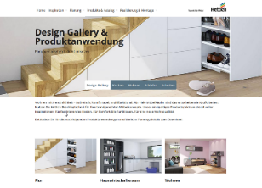

**282022_a**

The Hettich "Design Gallery" provides creative ideas and planning assistance for customising furniture with fitting technology from Hettich. Photo: Hettich

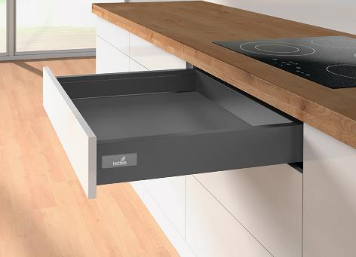

**282022_b**Hettich now also offers preassembled drawers with InnoTech Atira. Photo: Hettich

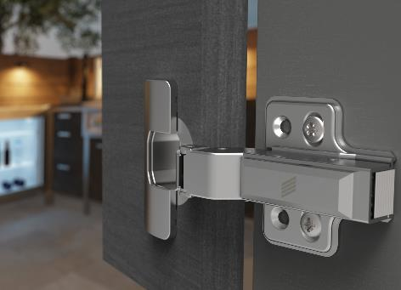

**282022_c**

Ideal for outdoor use: whether camping in winter or barbecue evenings at the height of summer – you can always rely on the Veosys outdoor hinge's integrated Silent System. Photo: Hettich

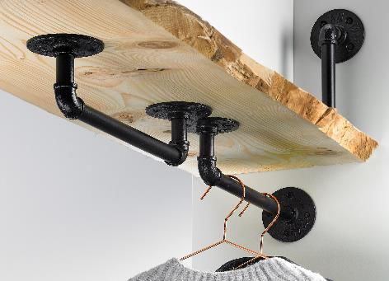 **282022_d**

Hettich's "Industrial Pipe" product range provides the capability of constructing hallway units, tables, doors, shelving, bottle holders and much more besides in a trendy industrial look. Photo: Hettich

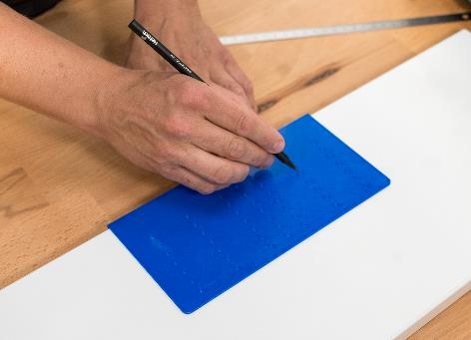

**282022_e**

"Hettich PrintOut" lets DIYers print out practical assembly templates or replacement parts themselves on the home 3D printer. Photo: Hettich

About Hettich

Hettich was founded in 1888 and is today one of the world's largest and most successful manufacturers of furniture fittings. Over 7,400 members of staff in almost 80 countries work together towards the objective of developing intelligent technology for furniture. On this basis, Hettich inspires people across the globe and is a valuable partner to the furniture industry, retailers and the trades. The Hettich brand is synonymous with consistent values: with quality and innovation. For reliability and closeness to customers. Despite its size and international significance, Hettich has remained a family run business. Independent of investors, the company is free to shape its future in a human and sustainable manner.