**Hettich showcases innovations at Eurobois 2022**

**Customised furniture design and transformable spaces**

**Fittings specialist Hettich will be presenting new highlights in hall 6.1, stand 6G60/6H60 at Eurobois 2022, France's leading wood industry event in Lyon. The spotlight's not only on the latest design features for the customisable AvanTech YOU drawer platform but also on solutions for transformable rooms with the WingLine L folding door system, along with multifunctional homeworking furniture and the highly efficient AvanFit 300 Advanced assembly machine. Already claiming a plethora of international awards, Hettich’s "Tiny Home" storage wizard is something trade visitors shouldn’t miss out on.**

Individuality is what it's all about: a new generation of furniture that can be designed in many different ways comes with clear added value for all those who want to put their very own stamp on their furniture. Hettich shows how this can be done both creatively and cost effectively.

**AvanTech YOU Illumination: showing furniture in its best light**

The versatile and adaptable AvanTech YOU drawer system from Hettich takes every effort out of customising design to meet any preference in colour, format and material. The platform principle means all components can be combined in any chosen way. This opens up a vast range of creative options for furniture with an individual look and for exclusive interior design. Offering new DesignCapes in copper and concrete look, Hettich has added two on trend design options to its standard AvanTech YOU range. And now "AvanTech YOU Illumination" even gives furniture its own signature lighting: clip on LED DesignProfiles or illuminated glass inlays create stunning mood effects and a touch of elegance. A practical rechargeable battery pack provides the necessary energy,without the need for any costly and complicated wiring. Hettich has already won several international design awards for its bright idea this year alone.

**WingLine L: for more room in the room**

The WingLine L folding sliding door system with Push/Pull to move will opens ceiling height, handleless wardrobe doors almost by themselves in response to a light press – doing so too with impressive panorama effect. Even an entire kitchen block can vanish from view behind the folding doors. The fitting can be provided with soft opening and closing. Under stairs and sloping ceilings, WingLine L provides the answer to utilising previously wasted storage space with visual appeal. And wherever space comes at a premium, the folding sliding door system comes with a high level of user convenience and ergonomic accessibility, such as in smaller type wall units or top mounted cabinets in the kitchen. With minimal door protrusion, WingLine L also makes it possible to fit drawers and pull-outs behind the folding sliding door.

**Actro 5D: stability and luxuriously smooth running action for large wooden drawers**

Permitting precision adjustment, the new Actro 5D runner from Hettich for wooden drawers guarantees perfectly aligned front panels. The sturdy runner system provides a load capacity of up to 70 kg and, when pulled open, keeps wooden drawers particularly level. Agreeable low opening forces as well as Actro 5D's smooth, quiet running action give the user an added feel of luxurious convenience – optimised synchronous control makes it possible: safely protected by the runner profile, it ensures a smooth movement cycle between the profiles and minimises running noise. Fitted with Push to open Silent, wooden drawers open with effortless ease in response to a mere tap on the front panel, leaving them to close again softly and silently. Thanks to effective multisynchronisation beyond cabinet body width, the system can also be used for extra wide front panels across two wooden drawers: a light press at any point on the XXL front reliably triggers the opening function every time.

**"Tiny Home": has everything on just 18 m2**

Living space in the urban environment is scarce and expensive, and floor plans are getting smaller. Does that mean restricting yourself? Not with Hettich: the fully equipped "Tiny Home" single person apartment lacks absolutely nothing. Put to optimum use, spaces combine all the necessary function zones and also provide maximum storage space from floor to ceiling. The "Tiny Home" only uses standard products from Hettich. They provide the key to integrating the user friendly functions from a conventional home into the micro floor plan. The mini apartment shows superb design quality in every last detail, leaving the predominantly handleless furniture fronts to create surfaces that speak spaciousness. The "Tiny Home" from Hettich demonstrates that it's possible to live comfortably even in the smallest of spaces.

**AvanFit 300 advanced: digital assistance for even greater assembly efficiency**

The new generation of semi automated AvanFit 300 advanced assembly machine from Hettich now makes it even easier to assemble AvanTech YOU drawers and pot-and-pan drawers. Because the AvanFit 300 advanced "knows" which width to set next before constructing each and every drawer. This obviates the need for any manual adjustment. But how? The assembly machine can be operated externally via any online network. Using a planning software tool, the appropriate values within a cabinet body, such as drawer width and depth or back panel and drawer side profile height, can be set automatically for each drawer on the basis of the CAD data. If the machine's not to be accessed externally, settings can also be made via an optical system, such as a scanner, or it can be programmed directly on the control panel. The machine is connected to the tapio digital ecosystem which means that the current machine status and settings can be viewed from an external source at any time. As such, AvanFit 300 advanced significantly boosts efficiency in the production process makes it far more cost effective to provide customised drawer designs.

Hettich's comprehensive product range is packed with inspiration for appealing design and convenient functions for the modern home and work environment. Discover even more refreshing furniture ideas on the megatrends of individualisation, urbanisation and new work at [www.hettich.com](http://www.hettich.com)

or the portal <https://xdays.hettich.com/>

The following picture material is available for downloading from **www.hettich.com, menu: Press**:  
**Images**

**Captions**

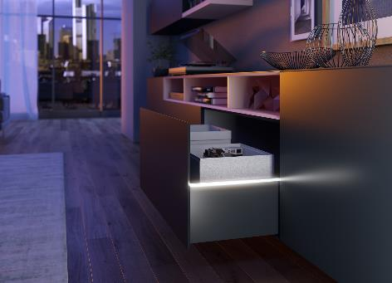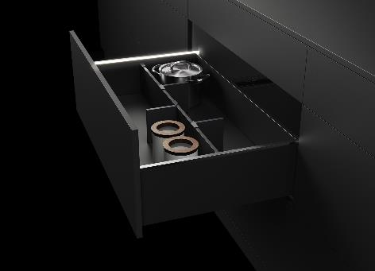

**032022_a, 032022_b**

Stunning mood effects and a touch of elegance: as an option, AvanTech YOU from Hettich now gives drawers their own LED signature. Photo: Hettich

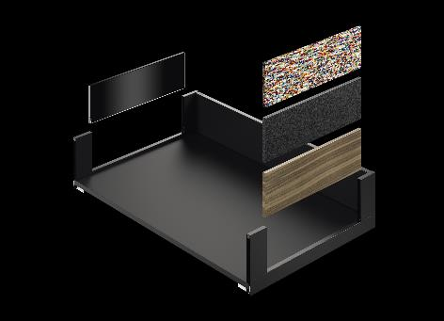

**032022_c**

The versatile and adaptable AvanTech YOU drawer system from Hettich takes every effort out of customising design to meet any preference in colour, format and material. The platform principle means all components can be combined in any chosen way. Photo: Hettich

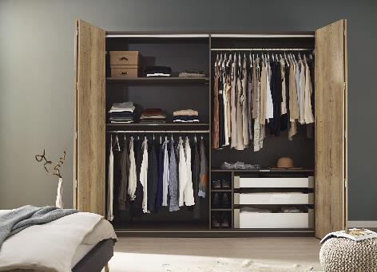

**032022_d**

The WingLine L folding door system scores with the ultimate in practical convenience and on trend, handless furniture design. The Hettich system comes with an element of surprise in large sized wardrobes with its panorama opening effect. Photo: Hettich

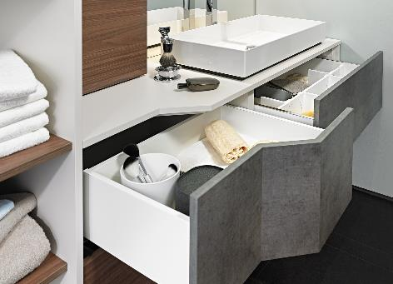

**032022_e**

The new Actro 5D drawer runner provides even more options: thanks to flexible synchronisation adapters, Push to open Silent also works on asymmetrically shaped wooden drawers. Photo: Hettich

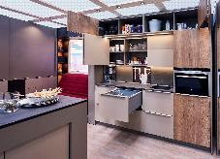

**032022_f**

The "Tiny Home" has absolutely everything: 18 m² of living space feature intelligent Hettich storage solutions from floor to ceiling. This makes living in comfort possible on a tiny floor plan too. Photo: Hettich

About Hettich

Hettich was founded in 1888 and is today one of the world's largest and most successful manufacturers of furniture fittings. Over 6,600 members of staff in almost 80 countries work together towards the objective: developing intelligent technology for furniture. Hettich thus inspires people all over the world and is a valuable partner for the furniture industry, trade and craft. The Hettich brand stands for consistent values: for quality and innovation. For reliability and customer proximity. Despite its size and international significance, Hettich has remained a family business. Independent of investors, the company's future is shaped freely, humanely and sustainably. www.hettich.com