**Keys to success: reliability, diversity, innovations**

**Hettich at Prowood: this you can rely on!**

**Being a success making furniture calls for reliable partners with time honoured products and a forward looking approach. Whether product quality, process stability or ease of assembly – reliability gives added value every step of the way. As a partner to makers of hand crafted furniture and the furniture industry, Hettich goes much further: product thinking is system based from start to finish, with top innovations opening up new potential. Hettich will be showing how this can be utilised at Prowood in hall 2, stand 2230.**

Reliability at the fittings specialist begins with the words "Made by Hettich". This is where customers can expect a quality product that provides elevated functionality and long service life. At the same time, process, product and service quality at Hettich undergo a process of continuous improvement. Whatever the application and furniture range, this makes every product a first class fitting.

**Flagship for new furniture design: FurnSpin**

The FurnSpin turning swivelling fitting is a true Hettich innovation. It lets entire furniture elements turn about their own axis – silently and smoothly with a simple movement of the hand. The fitting has attracted a whole raft of awards for its ingenious technology that permits new creative solutions in construction and design. Whether ceiling height furniture or small glass display elements – FurnSpin brings rotation to everything while showing off the interchange between closed and open with stunning effect. Remaining almost hidden from view, the fitting comes with the customary user friendly features such as soft closing or push to open for handleless furniture design. At Prowood, Hettich extends an invitation to experience FurnSpin first hand.

**Added touch of luxury for every hinged door: Sensys**

Sensys hinges with integrated soft closing function for hinged doors come with a quality feel that's also transported through into furniture. Anyone having used the fast assembly concealed hinge soon becomes a Sensys fan and can discover in the product family a diverse range of options. Whether overlay, half overlay or inset, for thick, thin or glass doors, as angle, wide angle or aluminium frame hinge – whatever the door design, Sensys is the quick and easy answer to adding a touch of luxury and user friendly convenience. Soft closing excellence often saves a hinge on many larger type doors. Low or high room temperatures have no impact either on Sensys' unrivalled closing performance. The hinge always cuts an elegant figure, particularly in obsidian black. This means quality can be designed into practical detail too. Hettich's system concept even provides the capability of combining two hinge families: sharing the same mounting plate, Sensys and Intermat are compatible.

**Diversity as a constant factor: AvanTech YOU**

Benefits to makers of furniture also bring a smile to its users. AvanTech YOU is clearly geared towards the wish for greater individuality and design flexibility. As one of the most frequently used furniture elements, the drawer gives Hettich the perfect playing field for diversifying design, scaling size and using light to create emotional quality. The platform principle not only makes this diversity attractive in economic terms, it also provides a simple way of upgrading to higher end product ranges.

The slim line, 13 mm side profile provides the basis for designing timelessly beautiful drawers. Purist design without visible holes, openings or cover caps meets even the most exacting demands on design. AvanTech YOU drawers can be configured in three colours and five heights with steel, aluminium or wooden rear panels. Within the product range, incredibly diverse design options can be created using DesignProfiles, DesignCapes as well as glass inlay side profiles.

On top of this, any chosen materials can be used as drawer side profile inlays as well. What's more, an LED light profile provides a very simple way of creating elegant lighting concepts in the drawer – two more great selling points.   
In terms of cost effectiveness and flexibility, AvanTech YOU is hard to top: sharing the same cabinet body drilling pattern, the drawers can be used on the two different runners. This creates the opportunity to address different market segments and fields of application. Within the platform, components are easily combined and made to feature all manner of user-friendly functions. By way of option, wooden drawers can be used on the runners too.   
  
The best way to discover the potential that's available to every trade business or furniture maker from Hettich's comprehensive line up is to visit Hettich's trade show line up in hall 2, stand 2230.

The following picture material is available for downloading from the "**Press**" **menu** at **www.hettich.com**:

Ein Bild, das Menschliches Gesicht, Person, Wand, Im Haus enthält.
**312024_a**

Big on design: given its shallow cup depth, Sensys permits particularly thin fronts. Finished in obsidian black, the hinge blends in with the look of dark surfaces. Photo: Hettich

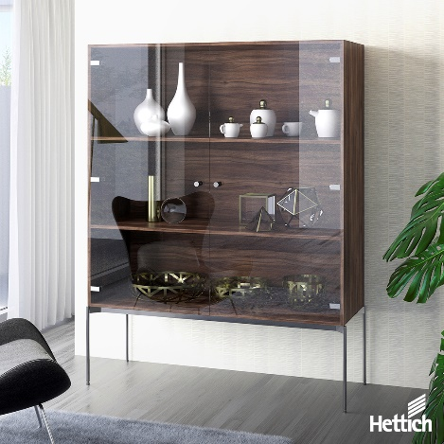

**312024_b**

Purist look: invisibly integrated in the hinge arm, soft closing makes Sensys particularly elegant. Gentle, reliable closure additionally protects delicate glass doors. Photo: Hettich

Ein Bild, das Softdrink, Im Haus, Wand, Kunst enthält.

**312024_c**

Significant differentiation potential: AvanTech YOU makes drawer individualisation and meeting customer wishes requirements standard practice. Photo: Hettich

Ein Bild, das Im Haus, Inneneinrichtung, Wand, Möbel enthält.

**312024_d**

Platform makes it possible: AvanTech YOU drawers can use two different runners that share the same hole pattern. Switching to wooden drawers is easily done too. Photo: Hettich

Ein Bild, das Mobiliar, Im Haus, Regale, Regal enthält.

**312024_e**

Acknowledged as an outstanding innovation, the FurnSpin turning swivelling fitting from Hettich has already won the "interzum award 2023" in the "Best of the Best" category. Photo: Hettich

About Hettich

Founded in 1888, Hettich is one of today's largest and most successful manufacturers of furniture fittings on the international stage. The family owned company is based at Kirchlengern in the furniture making cluster of Germany's East Westphalia region. Some 8,600 members of staff work together to provide our future proof solutions in over 100 countries. Promising "It's all in Hettich", the Hettich brand provides a comprehensive portfolio of services that is consistently and resolutely geared to the needs of customers across the globe. By tradition, top priority has always been at the focus of everything we do to ensure social, societal and ecological sustainability. www.hettich.com