Hettich at Sicam 2023 in Pordenone/Italy
Innovative fittings set trends

Following the sensational product presentations at the world's leading Interzum trade fair in Cologne as well as the notable Küchenmeile and MOW trade events in Germany, Hettich is now clearly underscoring its prowess as trendsetter in furniture and kitchen design by taking part in Sicam in Italy. At Sicam, the second most important trade fair for European manufacturers, the fittings specialist will be showcasing its new products to an international audience from 17 to 20 October.

"It's all in Hettich" - this is the banner under which the globally- playing Hettich Group is adding impetus to its claim of giving customers everything to boost their success. The focus here is on developing innovative fittings solutions from the user perspective that provide answers that are as individual as they are exclusive. At Sicam, Hettich will be presenting an array of new and enhanced releases in the form of exceptional furniture ideas for contemporary home living and working environments. The unique FurnSpin swivelling rotating fitting is the flagship of the innovation fleet, having made its debut in Cologne where it won the "Best of the Best" Interzum Award.

"The Joy of FurnSpin"
FurnSpin puts a creative spin on furniture design. With just one turn, the innovative swivelling rotating fitting transforms a closed furniture front into an open shelf. Thanks to advanced kinematics, the cabinet body rotates about its own axis, enabling furniture to turn itself inside out. Entirely unprecedented, this form of movement by individual furniture elements gives designers and manufacturers new creative inspiration for designing furniture and utilising premium segment storage space.

"The Great Heart of Furniture"
As inventor of the platform principle, enhancing drawer systems is close to Hettich's heart. Also featuring in the fittings specialist's show line up are its top new product releases for the AvanTech YOU drawer system as an easy way of upgrading to a higher price segment. With its exclusive look, Hettich is presenting its minimalist AvoriTech system which, with immaculate drawer side profiles measuring just a slender 8 mm across, is ideal for high-end cabinetry and kitchens. Hettich is also presenting a new generation of the Actro 5D runner system for wooden drawers with intuitive 5-way adjustment capability for perfect reveal alignment at all times.
"It's all in Hettich" – this claim also embraces maximum design flexibility for the makers of hand crafted furniture and the furniture industry. The optimised WingLine L folding sliding door system with new features comes with exactly what it takes to become a designer's favourite. Whether in the living room, bedroom or kitchen – WingLine L makes opening cabinets a sheer pleasure.

Anyone unable to make it to Sicam can discover the exciting furniture concepts in 3D on Hettich's "roominspirations" website and begin envisioning their own furniture designs.
https://roominspirations.hettich.com

The following picture material is available for downloading from the "Press" menu at www.hettich.com:

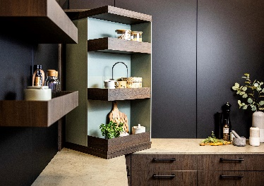
352023_a
Top innovation from Hettich: FurnSpin. Turned, the furniture element changes from closed to open. This, for instance, provides the key to redefining kitchen storage space from scratch. Photo: Hettich

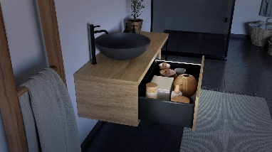
352023_b
Illuminated AvanTech YOU drawers couldn't look more exquisite and give users added value. The LED light strip simply clips onto the drawer side profile and requires no mains electricity as it's powered by rechargeable battery. Photo: Hettich

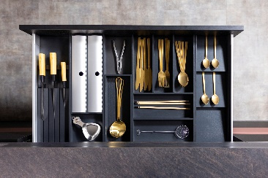
352023_c
AvoriTech drawer system: minimalist drawer side profiles without visible drill holes for high end furniture. Photo: Hettich

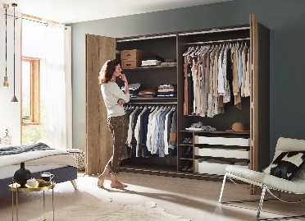
352023_d
WingLine L folding sliding door fitting: the new generation brings enhanced running performance and quality of design to wardrobe doors of any size. Photo: Hettich

About Hettich
Founded in 1888, Hettich is one of today's largest and most successful manufacturers of furniture fittings on the international stage. The family owned company is based at Kirchlengern in the furniture making cluster of Germany's East Westphalia region. Some 8,000 members of staff in almost 80 countries work together to give the industry future proof solutions. Promising "It's all in Hettich", the Hettich brand provides a comprehensive portfolio of services that is consistently and resolutely geared to the needs of customers across the globe. By tradition, top priority has always been at the focus of everything we do to ensure sustainability at social, societal and ecological level. www.hettich.com

