**Hettich presents new product releases at Technomebel 2022**

**Solutions customised for the modern home and working world**

**At last, it's now show time again in Bulgaria: fittings specialist Hettich will be using Technomebel in Sofia from 18 to 21 April 2022 to present its new products and services. The focus is on innovative and creative fittings solutions for customised furniture design. Highlights on Hettich stand 6 in hall 1 include new design features for the AvanTech YOU drawer platform and the high performance TopLine XL sliding door system. Trade visitors will also find pleasure in the technical modules: this is where Hettich products can be explored in detail and tried out first hand.**

Back in 2021, Hettich was responding to all of the cancelled trade fairs with its "Hettich on tour" roadshow – where a van based tour took all of the main new releases to Bulgarian customers direct. This personal contact was important to the Hettich team. And now, Hettich is looking forward to the opportunity of being able to present even more trends and innovations to trade fair visitors in Sofia on a spacious 150 square metre stand.

Individuality is one of the big megatrends: this is where platform systems are opening up significantly more design flexibility for anyone wanting to give their furniture a very personal stamp. Hettich shows how this can be done both creatively and cost effectively.

**AvanTech YOU Illumination: showing furniture in its best light**

The versatile and adaptable AvanTech YOU drawer system from Hettich takes the effort out of customising design to meet any preference in colour, format and material. The platform principle means all components can be combined in any chosen way. This opens up a wide range of design options for interior design. By way of option, "AvanTech YOU Illumination" now even gives furniture its own signature lighting: clip on LED DesignProfiles or illuminated glass inlays create stunning mood effects and a touch of elegance. A practical rechargeable battery pack provides the necessary energy, without the need for any costly and complicated wiring.

Wherever space is small yet the need for storage space great, sliding or folding sliding doors from Hettich can demonstrate their benefits with amazing effect. In the bedroom, TopLine XL provides unsurpassed, smooth running action for very large wardrobe doors. SlideLine M comes with immense creative freedom in the bathroom cabinet. And the WingLine L folding sliding door fitting can make new practical and visual statements for sideboards and spaces for working from home.

**TopLine XL sliding door system: strong for extra large wardrobe formats**

Developed specially for large and heavy fronts, TopLine XL from Hettich sets new standards in bringing purist design to ceiling height wardrobes. Its extremely shallow design with inconspicuously integrated Silent System makes the fitting almost invisible. The ease of installing the system alone is nothing short of impressive: the large format door panels can be set down on the floor without the risk of damaging the bottom fittings, quickly hung and easily adjusted. With "TopLine XL", doors weighing up to 100 kg gently open and close with effortless ease. Specially developed rollers with particularly good shape retention provide the basis for this new, easy running action. The system also takes you by surprise with a technical innovation for even greater practical convenience in three door wardrobes: the middle door opens intuitively both to the left and right. Whether on opening with incredible ease or gently closing – TopLine XL always runs smoothly and quietly.

Besides numerous on trend exhibits, Hettich won't be neglecting the technical aspect either: by tradition, the manufacturer will be using dedicated technical modules to demonstrate the creative finesse that goes into all of its products: here, trade visitors will be given the opportunity to study in detail the qualities of its fittings and systems, discover how easy they are to install and talk shop at length with the Hettich team about any questions they may have.

The following picture material is available for downloading from **www.hettich.com, menu: Press**:

**Images**

**Captions**

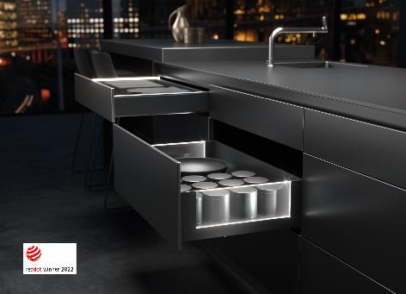

**112022_a**

Stunning mood effects and a touch of elegance: as an option, AvanTech YOU from Hettich now gives drawers their own LED signature lighting. Photo: Hettich

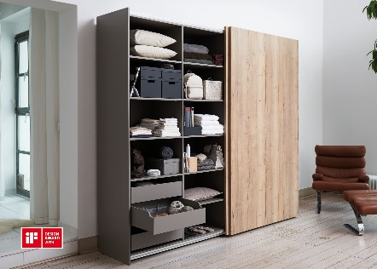

**112022_b**

Awarded for outstanding design: with its extremely shallow design,

the TopLine XL sliding door fitting blends into the design of furniture where it can hardly be seen. Photo: Hettich

About Hettich

Hettich was founded in 1888 and is today one of the world's largest and most successful manufacturers of furniture fittings. Over 6,600 members of staff in almost 80 countries work together towards the objective: developing intelligent technology for furniture. Hettich thus inspires people all over the world and is a valuable partner for the furniture industry, trade and craft. The Hettich brand stands for consistent values: for quality and innovation. For reliability and customer proximity. Despite its size and international significance, Hettich has remained a family business. Independent of investors, the company's future is shaped freely, humanely and sustainably. www.hettich.com