**Hettich at "architect@work" in Munich:**

**"RoomSpin. Your room changer" instantly turns spaces into a whole new world**

**"Architect meets innovations" is the motto underlying 'architect@work' on 5 and 6 June in Munich. The study that fittings specialist Hettich is presenting in display 40 is more than just innovative, it is unique: for the first time, 'RoomSpin’ makes it possible to transform entire spaces with just one movement of the hand, making them perfect for all sorts of uses.**

New Work concepts have in common that they offer flexibility and diversity for their users. A planned arrangement loses its form due to mobile furniture, which affects the original room structure and limits functionalities. With "RoomSpin", Hettich presents a solution to this problem: a unique "translatory rotation" allows users to effortlessly rearrange room elements in a curated movement that resembles choreography, creating the ideal space as needed: In no time, the team meeting environment transforms into a personal space for a video conference or for focused, quiet work. The system base of "RoomSpin" can be individually equipped with furniture and walls. "Unlike furniture on wheels, the 'RoomSpin' always stays in a defined place. This guarantees an orderly room effect and creates clear zoning," explains Daniel Rehage from Hettich's Concept Development.

With this visionary solution, following the invention of ComfortSpin and FurnSpin, Hettich is setting the next accent for innovative fitting technology that follows a curated movement. Successful implementation requires specially qualified partners who work closely with the fittings specialist. "Strategic partnerships ensure that the 'RoomSpin' does not remain just an innovative idea but becomes a gamechanger in interior design," explains Sebastian Voss, Sales Director for the Workplace & Living Division at Hettich.

The following picture material is available for downloading from the "Press" menu at www.hettich.com:

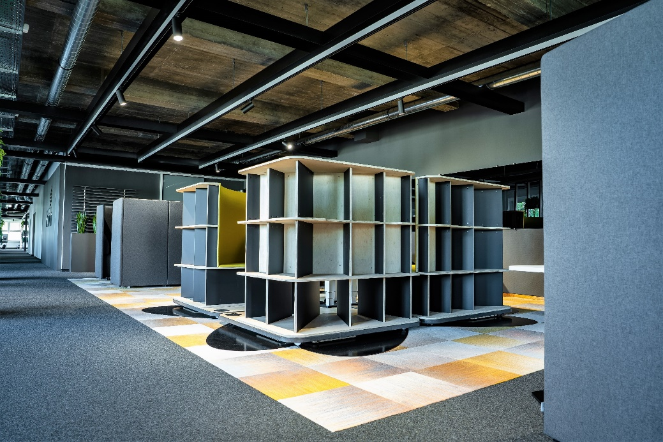

172024_a

The office becomes a quick change act: Hettich's "RoomSpin" creates adaptable, multifunctional spaces that can be turned around to permit all sorts of room constellations. Photo: Hettich

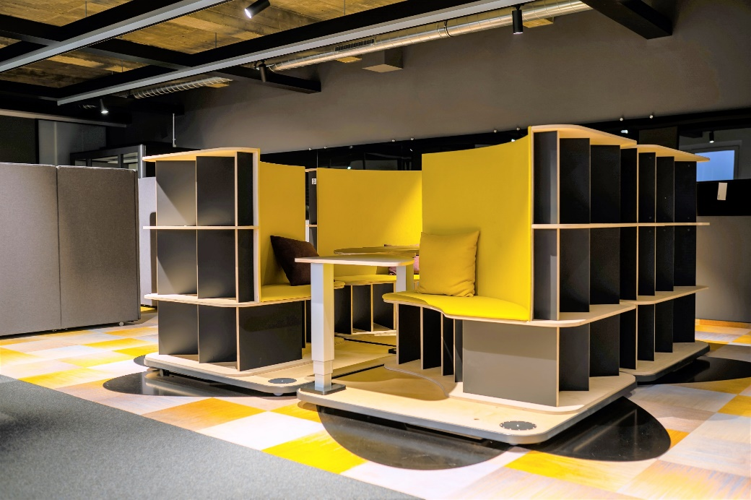

172024_b

Flexibility and spatial structure combined in one and the same solution: Hettich's 'RoomSpin' study is making its debut at the ‘architect@work’trade show on 5 and 6 June 2024 in Munich. Photo: Hettich

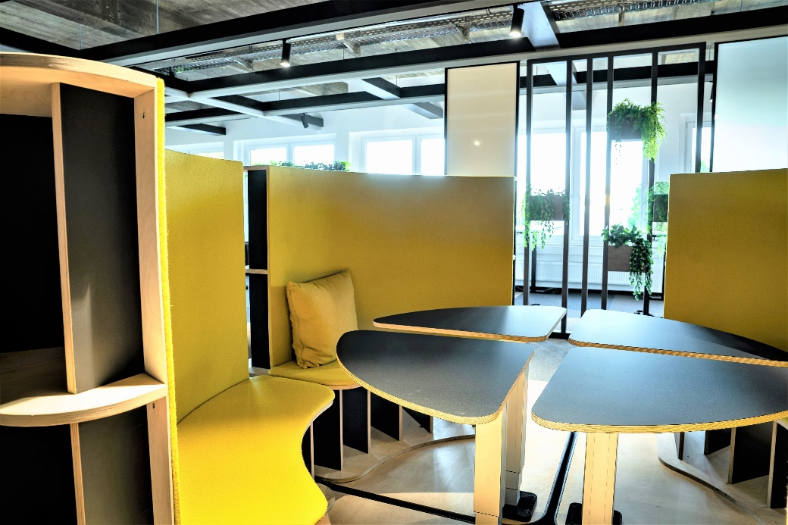

172024_c

"RoomSpin" from Hettich lets users actively create ‘their’ space. Photo: Hettich

About Hettich

Founded in 1888, Hettich is one of today's largest and most successful manufacturers of furniture fittings on the international stage. The family-owned company is based at Kirchlengern in the furniture-making cluster of Germany's East Westphalia region. Some 8,600 members of staff work together to provide our future-proof solutions in over 100 countries. Promising "It's all in Hettich", the Hettich brand provides a comprehensive portfolio of services that is consistently and resolutely geared to the needs of customers across the globe. By tradition, top priority has always been at the focus of everything we do to ensure sustainability at social, societal and ecological levels. [www.hettich.com](http://www.hettich.com)