**Hettich Goes Outdoor!**

**Tough systems for outdoor furniture**

**Cold, heat, fog, rain, snow or salty air – even under extreme conditions, outdoor furniture needs to remain fully functional at all times. This is where every component counts. With it's weatherproof solutions from drawers to refrigerator hinges, Hettich delivers the key to superb quality in the open air environment too. A compendium of all products for outdoor use can now be found at** [**outdoor.hettich.com**](https://outdoor.hettich.com) **with the option of ordering direct via the Hettich eShop.**

Today's new lifestyle happens outdoors. And taking life into the garden or onto the roof terrace is fun because with the right dedicated fittings, life's just as comfortable here as it is indoors. Hettich can offer what's now needed for living outdoors. The extensive line up lets providers configure customised designer style, modular outdoor furniture and kitchens that come with remarkable ease of use, ample storage and practical value, none of which ever fails to astonish.

An extremely hard wearing all rounder is the Veosys fast installation stainless steel hinge. Tested for corrosion resistance, it defies all weathers while at the same time providing exceptional user friendly convenience: integrated Silent System gives excellent soft closing performance at low and high outdoor temperatures. And with its wide self closing angle of 35°, Veosys closes furniture doors almost by itself.

High quality design, unmatched practical functionality and numerous individualisation options – that's what you get with the tried and proven InnoTech Atira drawer system from Hettich. For outdoor use, it's available in silver, white and anthracite, with a wide range of add on elements and OrgaTray cutlery inserts making it possible to organise and appoint drawers in any way you choose.

The custom finished Quadro Compact runner for the InnoTech Atira drawer system is weatherproof too. Here as well, Hettich's innovative Silent System leaves no margin of doubt with smooth running performance, maximum stability and perfectly controlled, quiet closing action with a load capacity of up to 40 kg. In combination with the Push to open system, handleless fronts are not a problem either. Designed specifically for outdoor kitchen use, the Quadro Compact system features a gas bottle pull-out for installing on any floor or ground surface. A further practical addition comes in the form of the CargoPlus wire shelves for well ventilated drawers and pot-and-pan drawers.

Hettich's line up also includes a non corroding solution for outdoor refrigerators: Hettich's K hinges provide a fixed connection between refrigerator door and furniture front. The K99 hinge and the K08 hinge with self-closing for fixed door systems now also make it possible to conceal electrical appliances behind outdoor cabinet fronts too. A generous opening angle not only makes room for every refrigerator drawer, it also provides easy access. Whilst on the subject, this also draws attention to other "cool" solutions from Hettich – drawer runners from the Quadro Compact product family for crisper compartments and refrigerator drawers. ﻿Fitted with optional Silent System, they close gently and quietly.﻿ And Hettich completes its broad range of products for outdoor use with robust waste sorting systems, stainless steel handles, matching stainless steel screws for various products and, of course, the ComfortSpin turntable in transparent and anthracite look.

Set out in clearly structured form, the entire portfolio is presented on the new "Hettich Goes Outdoor" website, with a separate online flip page catalogue now also listing all products for outdoor use. Ever fancied creating new ways of enhancing outdoor furniture and kitchens? If so, you have until 31 December 2023 to enter Hettich's competition draw as a chance to take part in an attractive "Design Thinking Workshop". What are you waiting for? Every good reason to stop by at [outdoor.hettich.com](https://outdoor.hettich.com).

The following picture material is available for downloading from the **"Press" menu** at **www.hettich.com**:

**Images**

**Captions**

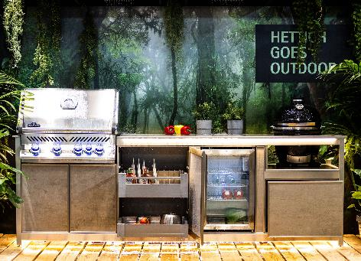

**172023_a**

New product variety from Hettich for outdoor use: the entire outdoor range is now available for ordering online via the Hettich eShop at [outdoor.hettich.com](https://outdoor.hettich.com) Photo: Hettich

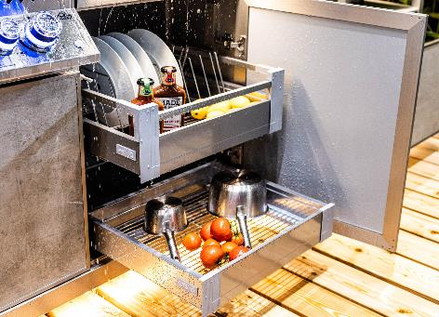

**172023_b**

Hettich makes it possible: the freedom of living outdoors coupled with the convenience of indoor furniture. Created here from the Veosys, InnoTech Atira, Quadro Compact and CargoPlus systems. Photo: Hettich

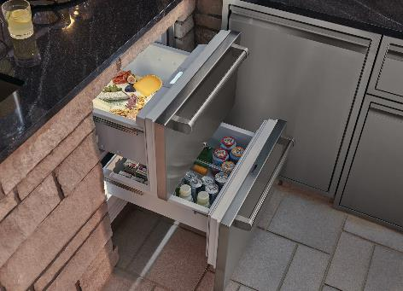

**172023_c**Outdoor reliability: Hettich's Quadro Compact drawer runners not only provide amazing practical convenience in crisper compartments but in refrigerator drawers too. Photo: Sub-zero

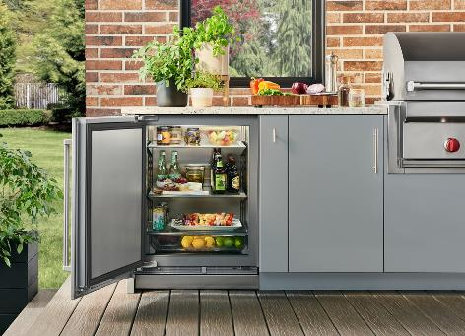

**172023_d**

Hettich's K99 hinge and K08 hinge with self-closing also permit fixed door solutions in the outdoor refrigerator. A generous opening angle not only makes room for every refrigerator drawer, it also provides easy access. Photo: Sub-zero



**172023_e**

Just one click takes you to Hettich's outdoor product line up direct: [outdoor.hettich.com](https://outdoor.hettich.com) Graphic: Hettich

About Hettich

Founded in 1888, Hettich is one of today's largest and most successful manufacturers of furniture fittings on the international stage. The family owned company is based at Kirchlengern in the furniture making cluster of Germany's East Westphalia region. Some 8,000 members of staff in almost 80 countries work together to give the industry future proof solutions. Promising "It's all in Hettich", the Hettich brand provides a comprehensive portfolio of services that is consistently and resolutely geared to the needs of customers across the globe. By tradition, top priority has always been at the focus of everything we do to ensure sustainability at social, societal and ecological level. www.hettich.com