**New to the Hettich Forum and on "roominspirations":**

**Ideas for successful furniture concepts**

**Interzum 2023 gave Hettich the opportunity to present its top innovations to an international trade audience. Now, even more highlights and solutions can be discovered at the manufacturer: the newly designed presentation at the Hettich Forum in Kirchlengern brings together all sorts of themed worlds for living and working. Hettich's "roominspirations" website features a comprehensive virtual showroom where you can find structured search filters and get targeted inspiration from new concepts for all different areas of the home.**

Hettich answers how the megatrends of urbanisation, new work and individualisation are changing our homes and how we live. And the company provides everything the industry now needs for innovative and future-proof furniture concepts. Embedded in individual furniture worlds and themed apartments, everything showcased at Interzum 2023, and other exciting concepts can now be found on the new "roominspirations" website.

The inspiration provided in "roominspirations" is broad and varied: new product applications, attractive furniture ideas, trend-focused rooms, and furnishing solutions for every demand and expectation. The premium segment expects exceptional cabinetry that dazzles with exclusive design and astonishing performance. But Hettich also shows how multifunctional furniture concepts can make a success of living in small spaces without sacrificing comfort and convenience. The creative furniture ideas even integrate space for working from home and are a boon to perfecting the work-life balance. On "roominspirations", anyone targeting their search in the categories of kitchen, living room, bathroom, bedroom, utility room, hallway, stairs, outdoor kitchen, shop, and new work will quickly find exactly the right furniture solution they are looking for.

Not only can furniture designs be discovered online in 3D, but many of them can also be recreated: in "roominspirations", Hettich provides the requisite CAD data, assembly information and images for downloading free of charge and also extends an invitation to take Hettich's ideas further for designing their own furniture.

<https://roominspirations.hettich.com>

The following picture material is available for downloading from the "**Press**" **menu** at **www.hettich.com**:

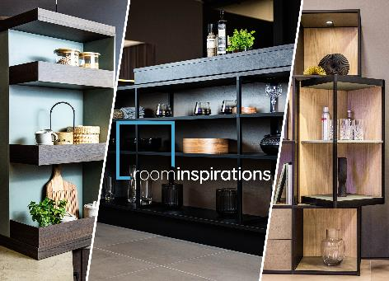

**202023_a**

Hettich's new "roominspirations" website: the virtual showroom immerses you in the various themed worlds with a search filter that lets you find targeted inspiration from new concepts for different parts of the home and lifestyles. Photo: Hettich

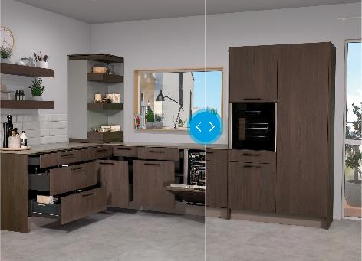

**202023_b**

"roominspirations" from Hettich gets graphic: to compare images, the slider can be used to view open and closed furniture solutions. Photo: Hettich

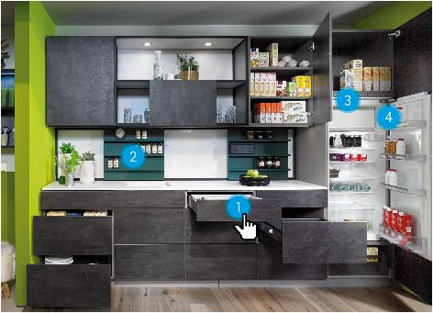

**202023_c**

On "roominspirations", Hettich products are just a mouse click away: clicking the furniture solution "hotspots" provides detailed information on the Hettich products shown, including videos, instructions, links and much more besides. Photo: Hettich

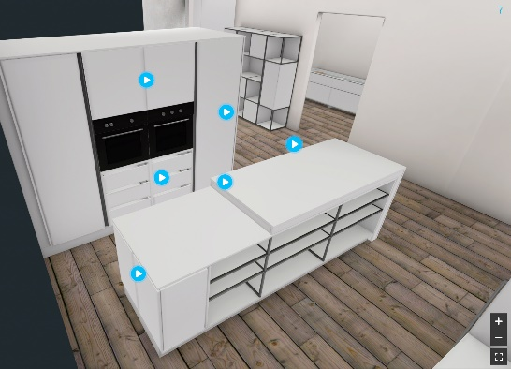

**202023_d**

"roominspirations" from Hettich invites you to embark on a 3D exploration: this is where you can experience furniture solutions from different perspectives in 3D and get inspiration from stop motion animations and camera flights. Photo: Hettich

About Hettich

Founded in 1888, Hettich is one of today's largest and most successful manufacturers of furniture fittings on the international stage. The family-owned company is based at Kirchlengern in the furniture-making cluster of Germany's East Westphalia region. Some 8,000 staff members in almost 80 countries work together to give the industry future-proof solutions. Promising "It's all in Hettich", the Hettich brand provides a comprehensive portfolio of services that is consistently and resolutely geared to customers' needs across the globe. By tradition, top priority has always been at the focus of everything we do to ensure social, societal and ecological sustainability. [www.hettich.com](http://www.hettich.com)