Always on trend: kitchen appliances with ergonomic appeal
IFA sees Midea present dishwashers with lift fitting from Hettich

A 100 years of IFA bear testimony to rapid advances in technology and how these have shaped the way society lives. Zeitgeist phenomena like the Walkman made their debut at IFA, revolutionising the expectations placed on electronic devices. This transformation has also left its mark on "white goods": once large and bulky, refrigerators, dishwashers and the like are now smart high-tech appliances that hugely simplify life. Yet in spite of all the artificial intelligence and connectivity, ergonomics and convenience remain a key focus. A case in point here is the practical ComfortSwing lift system in Midea's "Opal Elite Series".

The unbroken call for user convenience and ergonomics isn't just a constant driver of innovation for kitchen and appliance manufacturers. As a fittings specialist, Hettich too always places a focus on the added value given to users by the products it develops. Cooperation with Midea – one of the world's leading tech companies for electrical appliances – has resulted in Hettich's innovative ComfortSwing lift fitting being featured in the new "Opal Elite Series" dishwashers. Showcased by Midea at this year's IFA, these kitchen appliances not only combine state of the art technology with the capability of integrating them behind the kitchen front, they also meet the long held wish on the part of users to empty and load a dishwasher without stooping. Thanks to ComfortSwing, the world's first dishwasher lift system, the bottom rack can be moved to the convenient working height of the top rack where it is easy to load and empty. Not only preventing back complaints, it also makes convenience in the kitchen a real joy across the generations. Added to this, the new dishwashers from Midea score with other user-friendly features, such as a cutlery drawer that adjusts to suit any amount of cutlery, an automatic detergent dosing system and a purpose designed sprinkler that reliably cleans taller type items like bottles. Hettich congratulates Midea on making such a success of presenting its range of electrical appliances at IFA 2024 and looks forward to sharing future projects.

ComfortSwing is the perfect feature to put manufacturers of electrical appliances on the very forefront of user orientation and ergonomics in the dishwasher. Further information:
https://web.hettich.com/en-de/products-eshop/fittings-solutions-for-domestic-appliances/quadro-runners-for-dishwashers

The following picture material is available for downloading from the "Press" menu at
www.hettich.com:

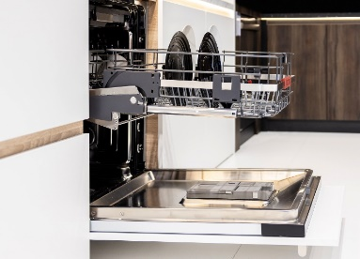
272024_a
Midea's new "Opal Elite Series" dishwashers let advances in technology and ergonomics go hand in hand: Hettich's ComfortSwing lift fitting makes filling and emptying the dishwasher a back friendly job. Photo: Hettich

About Hettich
Founded in 1888, Hettich is one of today's largest and most successful manufacturers of furniture fittings on the international stage. The family-owned company is based at Kirchlengern in the furniture making cluster of Germany's East Westphalia region. Some 8,600 members of staff work together to provide our future proof solutions in over 100 countries. Promising "It's all in Hettich", the Hettich brand provides a comprehensive portfolio of services that is consistently and resolutely geared to the needs of customers across the globe. By tradition, top priority has always been at the focus of everything we do to ensure social, societal and ecological sustainability. www.hettich.com

