**Beeck Küchen: individuality meets innovation**

**Kitchen line featuring FurnSpin presented on the Küchenmeile**

**The Küchenmeile trade fair in East Westphalia-Lippe/Germany showcases kitchens to experience firsthand at their places of origin, and this year the city of Bad Oeynhausen was a particularly exciting one: the line up on display at Beeck Küchen left the many trade visitors amazed on encountering a turning tall unit and a swivelling corner cabinet below a kitchen island top. Behind all this is innovative furniture hardware from Hettich: FurnSpin, the turning swivelling fitting.**

Beeck Küchen's presentation spotlights a creative and boldly coloured spectrum of kitchen designs. "Every Beeck kitchen can be customised. We give our customers the choice – that's what makes our kitchens so special," explains managing director Tristan Beeck. "And we're always good for a surprise with unusual solutions. Be it with practical details, outstanding design or with highlights like FurnSpin from Hettich." The new "Stretta" range of kitchens is a prime example. Distinctive hallmark: slimline fronts set in a slender, solid wood frame. Making its debut at Küchenmeile, Beeck demonstrated how FurnSpin can provide fascinating contrasts at tall unit level and beneath the island top. The scheme of colours from surfaces finished in real light oak veneer and champagne lacquer leaves a modern, well balanced impression. Contrasting with this, the FurnSpin elements cut a exciting figure with their black metal shelf framing. These become visible on turning from closed to open. The dynamic movement also underscores the light and airy feel of the kitchen's design. Hardly any trade visitor was able to resist the temptation of taking a "spin", soon realising what little effort was needed to do so. There was astonishment too at the perfect flow of movement that made decorative items and dishes seem glued in place. The FurnSpin turning swivelling fitting makes it possible to create turning cabinet bodies in different material thicknesses. Shelves can even be made of natural stone to pick up, for example, on the design of the worktop. Beeck Küchen illustrates the creative flexibility that comes with Hettich's FurnSpin, capturing today's style with the delicacy of design that's reflected in "Stretta".

To get more on FurnSpin's potential, go to: <https://furnspin.hettich.com/?lang=en>

The following picture material is available for downloading from the **"Press" menu** at

**www.hettich.com**:

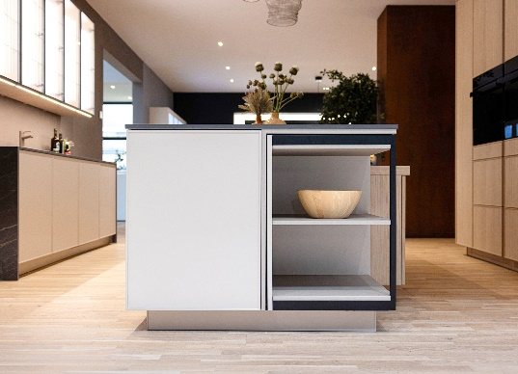

**372024_a**

Modern duo: the new "Stretta" kitchen range with its slender real wood framing and Hettich's FurnSpin – forming the basis here for the kitchen island's swivelling corner shelf element. Island in Stretta L silk matt champagne finish combined with Stretta H wall cabinetry featuring fronts in real light oak veneer. Photo: Hettich

Ein Bild, das Im Haus, Wand, Möbel, Schrank enthält.

**372024_b**

Right on trend: real wood veneer in light oak from the "Stretta H" range conjures a pleasingly calm and homely mood. The FurnSpin swivelling tall unit makes a stunning contrast while offering two views in one piece of furniture – open with shelving or closed to match adjacent door. Photo: Hettich

About Hettich

Founded in 1888, Hettich is one of today's largest and most successful manufacturers of furniture fittings on the international stage. The family owned company is based at Kirchlengern in the furniture making cluster of Germany's East Westphalia region. Some 8,600 members of staff work together to provide our future proof solutions in over 100 countries. Promising "It's all in Hettich", the Hettich brand provides a comprehensive portfolio of services that is consistently and resolutely geared to the needs of customers across the globe. By tradition, top priority has always been at the focus of everything we do to ensure social, societal and ecological sustainability. www.hettich.com