Milan furniture trends 2024:
Individuality as a reflection of personality

In April, international design fairs Eurocucina and Salone del Mobile had Milan celebrate the beauty and diversity of living at home. In essence, anything goes. Once again, this shows how important it is to give furniture an individual stamp. In Milan, the world’s best kitchen and furniture manufacturers put on a stunning display of ideas for home living and kitchens. This is where the clear focus was on, providing unique solutions, the key to realising which frequently lay in innovative fittings from Hettich. Evoking huge emotional appeal, the award-winning turning swivelling fitting FurnSpin and AvanTech YOU Illumination drawer lighting design were the highlights for many visitors.

Anyone looking for the one defining trend encountered many key directions in Milan. Existing trends were intensified or given a broader creative edge. Featuring coloured surface finishes and all manner of different materials soon to be found in kitchen and furniture retail, the designs were shown to exhibit a level of diversity to match. Combined with pastel shades, soft and warm tones, like cream, beige or latte macchiato, take centre stage as furniture surface finishes. Highlight features take the form of anthracite and various metallic shades, such as gold, pink gold, steel, bronze and copper. In the kitchen, exciting contrasts come predominantly from coloured sinks, taps, fittings and aluminium framed doors. Soon though, bright green, blue and red will also be making inroads into kitchen and furniture retail – accompanied by a profusion of marble. The high-quality, natural material is right on trend for worktops and splashbacks, also with vibrant, colourful veining. Structured patterns that ensure semi-transparency are particularly noticeable on glass fronts. Alongside these, fluted surface textures remain widely prevalent in all variations. Besides highly minimalist concepts, opulent and expressive colour and material combinations feature strongly in kitchen and bathroom design. Matt fronts predominate overall, with an occasional gloss surface still only found in living spaces.

Lighting from practical to atmospheric
Indirect lighting enhances the perceived quality and emotion of furniture while deliberately emphasising contours and materials. In this way, LED lighting is primarily found in, on or below finger pulls, cabinetry, drawers and kitchen worktops. International premium manufacturers, such as Rastelli, L'Ottocento, OREA, DA Group, Agape and Minimal, staged impressive presentations using Hettich's AvanTech YOU Illumination lighting solution. This makes opening storage spaces in kitchens and living room furniture an emotional experience and a mark of exceptional perceived quality.

Innovations perfectly presented
Whenever something new appears, it's in the kitchen first. Because this is where all expectations on furniture come together. Storage is always a major issue. The innovative FurnSpin turning swivelling fitting from Hettich lets you rotate entire furniture elements. Alternating between closed and open, it defines two different design perspectives in one and the same piece of furniture. In Milan, luxury kitchen manufacturers SieMatic, Eggersmann and Gama Decor as well as other Italian high-end manufacturers demonstrated the potential of this unique fitting = in terms of completely reshaping the use of storage space. Generally speaking, kitchen designs are dominated by tall shelf units and glass doors – also on wall units – with aluminium frames in dark hues and matching coloured hinges. Doors leading through to utility rooms or other spaces are perfectly integrated into the kitchen. Elaborate shelf units double up as room dividers too. Rounded elements and standalone furniture provide a contrast to angular purism. Sumptuously upholstered seating and dining furniture paired with eye-catching luminaires create the ideal setting for the modern designer-style kitchen. Luxury also continues to abound in cabinet interiors and the convenience stakes. Finger pulls and recessed grips have taken the place of real handles. Instead, furniture uses no-handle systems like Push-to-open and Silent system. Drawers remain slender and sleek. Real wood in light and dark finishes is the material that dominates interior organisation systems. And for all wine lovers, premium manufacturers provide large-format wine refrigerators with a mark of exclusivity. Meanwhile, outdoor kitchens now feature equipment and furniture of such high quality that bring year-round attraction to outdoor enjoyment.

Smart furniture is on the way
Digitisation and AI-assisted systems are taking the home by storm. The solutions not only range from interconnected, app-controlled appliances and managing the kitchen with voice commands, but also extend through to self-learning kitchen gadgets that adapt to users' needs. These include automatic, preference-based recipe suggestions or connected food management capabilities that generate shopping lists.

Providing many examples, you can find out more about furniture trends for 2024 here:
https://web.hettich.com/en-de/inspiration/furniture-and-interior-trends

The following picture material is available for downloading from the "Press" menu at www.hettich.com:
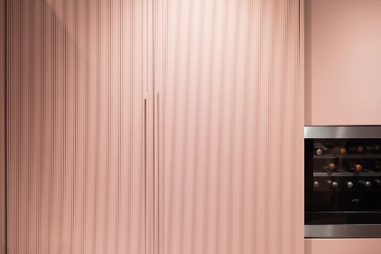
112024_a
Design trend for kitchens: pastel shades and textured surfaces, seen at Arrex. Photo: Hettich

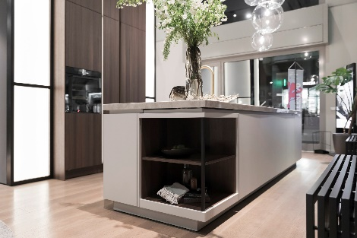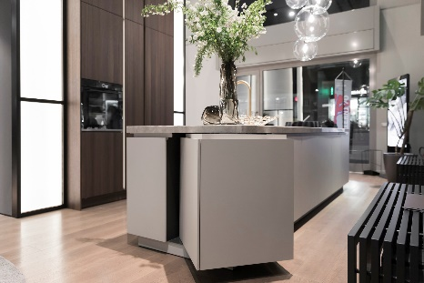
112024_b + c
The new S2 from SieMatic combines matt surface finish with real wood and stone. SecretSpace – the rotating shelf element in the kitchen island, made possible with FurnSpin from Hettich – features a combination of these materials. Photo: Hettich

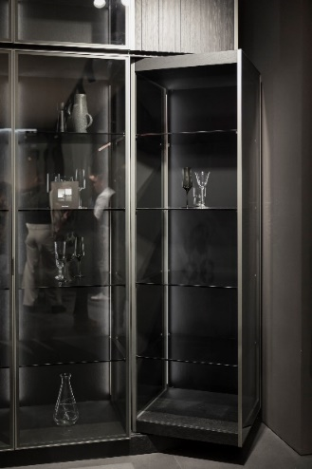
112024_d
Design in a class of its own: Eggersmann showed a rotating glass display element in a tall unit with integrated lighting, realised with the innovative FurnSpin turning swivelling fitting. Photo: Hettich

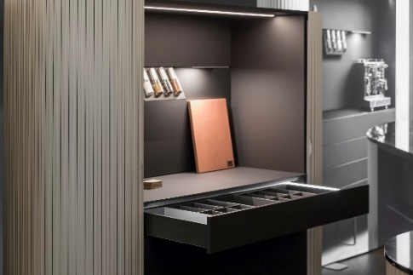
112024_e
Emotive light show in the kitchen from OREA: when the drawer is opened, the elegant LED light profile from AvanTech YOU makes magical eyecatchers. Photo: Hettich

About Hettich
Founded in 1888, Hettich is one of today's largest and most successful manufacturers of furniture fittings on the international stage. The family-owned company is based at Kirchlengern in the furniture-making cluster of Germany's East Westphalia region. Some 8,600 members of staff work together to provide our future-proof solutions in over 100 countries. Promising "It's all in Hettich", the Hettich brand provides a comprehensive portfolio of services that is consistently and resolutely geared to the needs of customers across the globe. By tradition, top priority has always been at the focus of everything we do to ensure sustainability at social, societal and ecological levels. www.hettich.com

