**Novisys from Hettich for Express Küchen**

**Integrated soft closing convenience ex works for all furniture doors**

**One of this year's in house exhibition highlights at Express Küchen in Melle/Germany is the new Novisys fast installation concealed hinge from Hettich: it lets the manufacturer give its kitchens the convenience of soft closing hinged doors as standard – and all at no extra cost to kitchen customers.**

At Express Küchen, the luxury of quietly closing hinged doors on furniture is now a standard feature: a light tap is all it takes to close the door gently and reliably. The innovative Novisys concealed hinge with integrated soft closing function from Hettich now comes as standard with the manufacturer's kitchens. All Express Küchen buyers can benefit from this quality initiative.

**Cost efficiency producing kitchen lines with added value**

The platform principle behind Novisys means it can be combined with other hinge systems from Hettich, thereby fostering process optimisation: adding user friendly convenience, it provides the capability of upgrading to the wide angle version of the versatile Sensys premium hinge, an option that will be introduced as the changeover is made to Novisys. Even now, Express Küchen is using the Sensys mounting plate for the new Novisys without a problem. Benefiting from integrated hinge soft closing, there is no need for any add-on components, leaving Novisys to cut an impressive figure on furniture with its clean look that creates an impression of perfect harmony. Its shallow cup depth means Novisys can be used in the front thicknesses commonly used by Express Küchen. A further advantage for the kitchen manufacturer is the ability to quickly change from a non soft closing front to a soft closing front at any later date thanks to the practical fast installation sets with expanding sockets. Saving material is ecologically and economically effective: Novisys can also meet the demand Express Küchen places on using a product that is as sustainable as possible. Because applying its innovative hinge technology, Hettich is treading new paths towards resource efficiency by following the principle of "as much as necessary, as little as possible". Here, less material too ensures sound functionality and long product life.

Opting for Novisys, Express Küchen is making soft closing hinged doors a luxurious furniture standard for everyone, and is looking forward to heralding in a significant hike in quality in its standard line up that will pay dividends for the manufacturer and its customers alike.

The following picture material is available for downloading from **www.hettich.com**:  
**Illustration**

**Caption**

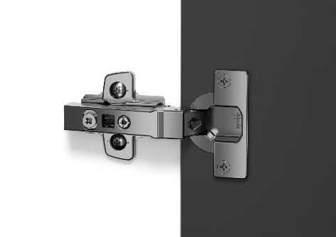

**302023_a**

Express Küchen is setting store by "soft closing convenience for everyone": Hettich's new Novisys fast installation hinge with integrated soft closing function conjures perceived quality and luxurious convenience as standard. Photo: Hettich

About Hettich

Founded in 1888, Hettich is one of today's largest and most successful manufacturers of furniture fittings on the international stage. The family owned company is based at Kirchlengern in the furniture making cluster of Germany's East Westphalia region. Some 8,000 members of staff in almost 80 countries work together to give the industry future proof solutions. Promising "It's all in Hettich", the Hettich brand provides a comprehensive portfolio of services that is consistently and resolutely geared to the needs of customers across the globe. By tradition, top priority has always been at the focus of everything we do to ensure sustainability at social, societal and ecological level. [www.hettich.com](http://www.hettich.com)