Orgatec: debut for "Layers moved by Hettich RoomSpin"
Choreographed rotation as new interior design principle

Transforming office spaces into multifunctional rooms with adaptable structures remains the office sector's big topic. At Orgatec, Hettich is teaming up with subsidiary Kuhn to present the first office furnishing concept that features unique movement sequences to make office spaces flexible usage rooms with defined zoning: "Layers moved by Hettich RoomSpin".

This year, visiting Hettich at Orgatec, hall 8, stand B058 C059, is particularly worthwhile because awaiting the showgoer here is a sensational new product release: "RoomSpin – Your Room Changer". It gives interior architects, designers and project developers new perspectives for creating transformable, multifunctional spaces: unlike furniture that can be moved about on castors and glides, Hettich uses the benefits of choreographed rotation as a new and revolutionary interior design principle. Together with its subsidiary Kuhn, the fittings specialist is presenting the first office furnishing concept that turns normal office space into an area permitting flexible usage.
Utilising lever forces, turning RoomSpin based furnishing solutions is far more convenient than moving mobile furniture items which, into the bargain, often end up standing around in disorganised array and need rearranging on a daily basis. These can be configured in any chosen way – from cabinets and room dividers permitting use from both sides to single person workstations and areas for holding meetings. Nonetheless, office space remains clearly zoned, making it possible in advance to do a perfect job of planning ambiance, lighting and sockets. The idea is based on Hettich's innovative turning swivelling fitting and was developed in collaboration with the Münster School of Architecture and Professor Ulrich Blum, Senior Associate at Zaha Hadid Architects.

New work with "Layers moved by Hettich RoomSpin"
The "Layers" interior design approach from Kuhn gives the Hettich Group the first office furnishing concept. "It's our fantastic joint interpretation of new work," says a smiling Norman Kuhn, managing director at the company specialising in room in room solutions and sliding door systems for the contract segment. The line up not only includes stunningly designed seating and meeting solutions in steel and recycled felt but covers storage furniture too. "Layers" follows an intelligent grid system while remaining dynamic and permitting modular individualisation without the need for tools.
Hettich additionally provides assistance in planning customised RoomSpin solutions through its exclusive "workplace2architecture" support for architects. The interior furnishings are produced by cabinet makers and furniture manufacturers who can obtain certification as RoomSpin partners from Hettich. In future, the aim is for the partner network to get the uniquely rotating interior design principle into as many creative applications and furniture ranges as possible.

The following picture material is available for downloading from the "Press" menu at www.hettich.com:
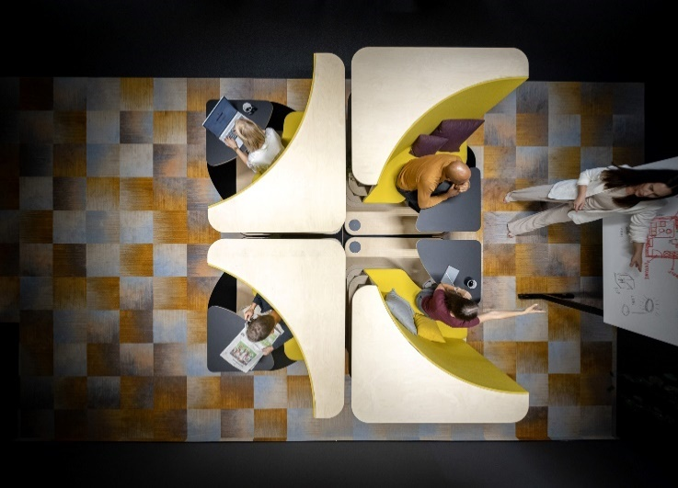
292024_a
The application idea based on Hettich's RoomSpin technology shows how efficiently office spaces can be used through curated movement sequences. Whether working in silence or workshop – the workstation modules can be rotated through 180 degrees to suit any requirement and need. Photo: Hettich

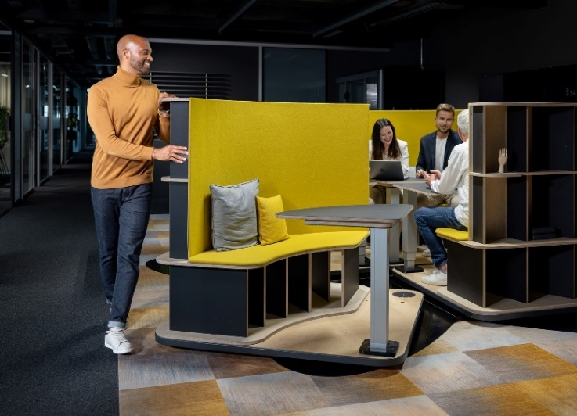
292024_b
The workstation modules easily rotate into the chosen position within seconds. The rear panels provide sound insulation, making it possible to work in peace. Photo: Hettich

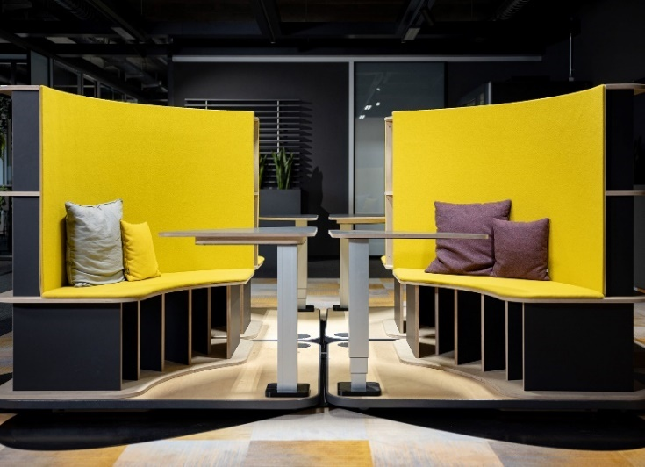
292024_c
RoomSpin technology is the basis for innovative interior design concepts with clear zoning. Unlike the situation with mobile office furniture, office structures remain intact, giving architects certainty in planning lighting and sockets, for example. Photo: Hettich

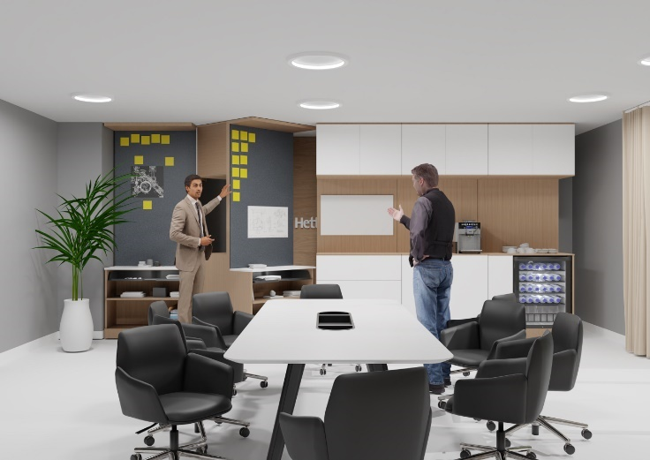
292024_d
RoomSpin technology provides the capability of using storage units from two sides. This makes efficient use of space, giving it a completely new function simply by rotating cabinet elements. Photo: Hettich

About Hettich
Founded in 1888, Hettich is one of today's largest and most successful manufacturers of furniture fittings on the international stage. The family owned company is based at Kirchlengern in the furniture making cluster of Germany's East Westphalia region. Some 8,600 members of staff work together to provide our future proof solutions in over 100 countries. Promising "It's all in Hettich", the Hettich brand provides a comprehensive portfolio of services that is consistently and resolutely geared to the needs of customers across the globe. By tradition, top priority has always been at the focus of everything we do to ensure social, societal and ecological sustainability. www.hettich.com

