New platform for wooden drawers
Hettich's Quadro 5D generation broadens compatibility

Launching the new Quadro generation for wooden drawers, the fittings specialist is giving its customers an end-to-end platform for all drawer runners. Compatible in design with the Actro range, furniture manufacturers and carpenters now have a unique product lineup that can bring luxurious convenience and precision to every furniture segment. The new Quadro 5D runner combines tried and proven technology, precision, and cost efficiency in a way that's truly exceptional.

Perfectly aligned front panels with narrow reveals are a reflection of exquisite quality in any piece of furniture. As the new Quadro runner comes with the same intuitive 5-way adjustment capability as the Actro 5D runner, precision reveal alignment is assured with wooden drawers too. Given the compatibility of both runner systems, Quadro partial and full extension runners as well as Actro full extension runners can now, for example, be featured within one and the same furniture item on a cost-efficient basis. Thanks to consistently dimensioned wooden drawers with an installed width of 21 mm, this means design modifications are no longer necessary when changing between systems. Quadro and Actro runners share the same platform.

Precision in all dimensions
The Quadro's intuitive 5-way adjustment facility makes aligning front panels nothing short of child's play: involving no tools, adjusting them vertically and laterally as well as in terms of depth, tilt and radius is incredibly easy. Radial adjustment quickly eliminates any gap on one side or any offset between adjacent cabinet bodies. This produces perfect, minimalist reveals which bring large surface impact, in particular to furniture designed without handles. The new Quadro 25 2D partial extension runner is being added to the product portfolio as a cost-efficient gateway option. Even here, vertical and lateral adjustment is made very easy. User friendly functions, such as Silent System, Push to Open or Push to Open Silent, are also part of the new Quadro generation. As the existing Quadro range can still be ordered with the installed width typical for Hettich, customers have the choice and can design their furniture concepts with consistency throughout every segment.

Interchange between wooden and system drawers
The trend towards drawer systems with metal drawer side profiles remains unbroken as they make it particularly easy to design drawers with a purist, slimline look. This is why Hettich has broadened the new Quadro platform to permit an interchange between wooden and system drawers. As a result, the new Quadro V6 YOU full extension runner can also be used for the versatile AvanTech YOU and minimalist AvoriTech drawer system. A huge benefit for customers wanting a look of individuality.

Further details on the new Quadro generation at:
https://www.hettich.com/short/0kasir7
The following picture material is available for downloading from www.hettich.com:
Images
Captions
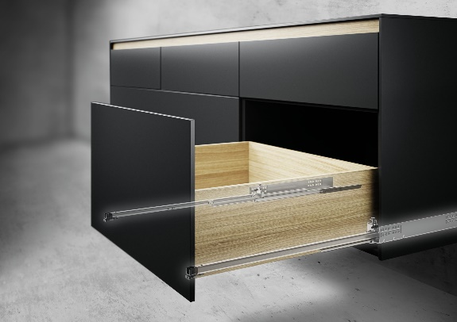
P100_a
Involving no design modifications, the new Quadro 5D runner for wooden drawers weighing up to 30 kg can be combined without a problem with the Actro 5D up to 70 kg load capacity. Photo: Hettich

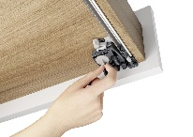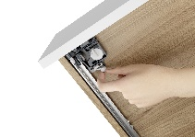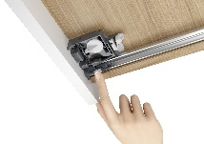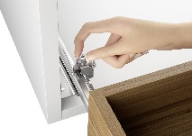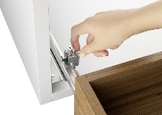
P100_b, P100_c, P100_d, P100_e, P100_f
From left to right: The new Quadro generation provides straightforward 5-way adjustability for ultra precise front panel alignment: height, side, depth, tilt and radius can be adjusted intuitively and without the need for tools. Photos: Hettich

About Hettich
Founded in 1888, Hettich is one of today's largest and most successful manufacturers of furniture fittings on the international stage. The family owned company is based at Kirchlengern in the furniture making cluster of Germany's East Westphalia region. Around 8.600 colleagues work together to deliver our future proof solutions to over 100 countries. Promising "It's all in Hettich", the Hettich brand provides a comprehensive portfolio of services that is consistently and resolutely geared to the needs of customers across the globe. By tradition, top priority has always been at the focus of everything we do to ensure sustainability at social, societal and ecological level. www.hettich.com

