Eye-to-Eye Partnership, Hettich-Style: HOLZ-HANDWERK Sets a New Benchmark in Service Excellence

As both a manufacturer and a collaborator with artisans of the furniture industry, Hettich distinguishes itself with a legacy of blending high-volume industrial production with a dedication to bespoke, hand-crafted furniture. This approach is showcased at the HOLZ-HANDWERK exhibition, held from 19 to 22 March 2024, where Hettich embarks on a mission to elevate service levels, guiding professionals through the entire journey from concept to completed furniture piece.

"Experience the essence of Hettich!" This could very well be the standout moment for furniture crafting enthusiasts at HOLZ-HANDWERK 2024. The message is clear: an equal partnership. Despite its global scale and international focus, Hettich eschews a one-size-fits-all mentality. "For us, a solution only becomes optimal when crafted together. We're committed to engaging deeply with the trade, fostering connections across the industry's innovative spectrum," explains Sales Director Jan Hübschmann, capturing the spirit of collaboration. At Hettich, this partnership is grounded in the reality that many of its sales team are experienced cabinet makers or wood technicians themselves. By actively participating in regional woodworking associations and forming networks within the industry, Hettich has created platforms for open, wide-ranging discussions on various challenges and opportunities, such as the Innovation Pioneers initiative. This commitment to dialogue has propelled Hettich's service capabilities to new heights, offering tangible benefits at every stage of the value chain for trade businesses.

Dialogue and Networking Opportunities
Hettich prioritises open dialogue as the foundation of a successful partnership, especially at HOLZ-HANDWERK. Beyond the exhibition's standard hours, Hettich's Open Bar concept offers a unique space for conversations to flourish over a chilled post-work beer, fostering an informal yet engaging atmosphere for idea sharing.

Practical Service Demonstrations
Hettich's stand not only features groundbreaking products like FurnSpin and other innovative furniture concepts but also introduces a hands-on service experience. Visitors can navigate through a custom-designed service loop to assess how Hettich's offerings can streamline planning, procurement, and assembly processes. This practical approach allows each visitor to gauge the relevance and advantages of Hettich's services for their own operations. Among the highlights is a focus on CAD planning, with daily presentations from various Hettich CAD partners, offering firsthand insights and tips.

Paul, Hettich's assembly expert, will be eager to gather feedback for new instructional videos, ensuring easier installation processes. Special promotional offers on Hettich assembly aids and the chance to win in the grand prize draw add further excitement to the event.

Illuminating Furniture with Emotional Resonance
In today's market, no furniture concept is complete without an integrated lighting solution. Hettich, in partnership with Halemeier, will showcase innovative LED lighting solutions from their stand, demonstrating the transformative effect of light on furniture's aesthetic and functional appeal. The "LightTower," featuring AvanTech YOU drawers with sophisticated LED lighting, will highlight the emotional impact of lighting in furniture design.

For those unable to attend HOLZ-HANDWERK 2024 in Nuremberg, Hettich offers an online platform to explore all showcased solutions: https://web.hettich.com/de-de/inspiration/messe-events/holz-handwerk

Downloadable press images are available from the "Press" section on the Hettich website at www.hettich.com:

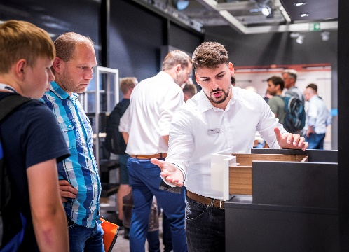
052024_a
Time for dialogue: not only will the Hettich team be available to tradespersons during show hours but afterwards too. Sharing ideas and views can be continued in a relaxed atmosphere at the Open Bar until 9 pm. Photo: Hettich

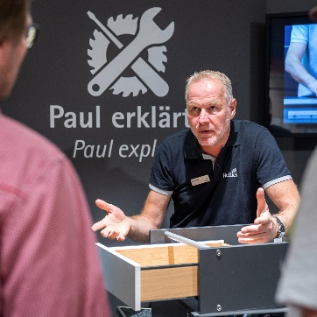
052024_b
Eye to eye partnership: at one of the stations on the service loop at HOLZ-HANDWERK, installation specialist Paul from Hettich will be giving tips and tricks on all aspects of fitting furniture products. Photo: Hettich

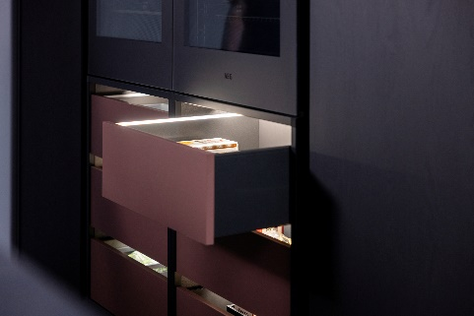
052024_c
Lighting solutions for furniture: teaming up with Halemeier at HOLZ-HANDWERK and using an AvanTech YOU drawer for example, Hettich will be showing how easy it is to emotionalise furniture with light. Photo: Hettich

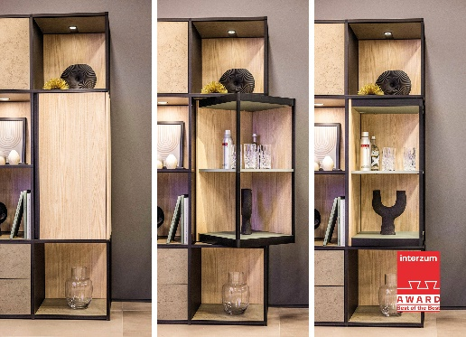
052024_d
Top new release from Hettich at HOLZ-HANDWERK 2024: FurnSpin makes furniture elements turn full circle. This will give new impetus to creative furniture making and leave customers amazed. Photo: Hettich

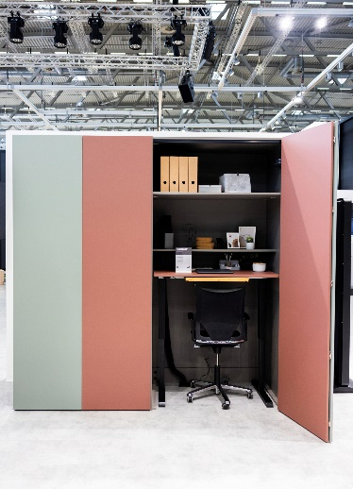
052024_e
Homeworking from the wardrobe: at HOLZ-HANDWERK, Hettich will be presenting attractive furniture ideas that save space while offering added value, e.g. with the WingLine L folding sliding door fitting. Photo: Hettich

About Hettich
Founded in 1888, Hettich is one of today's largest and most successful manufacturers of furniture fittings on the international stage. The family-owned company is based at Kirchlengern in the furniture-making cluster of Germany's East Westphalia region. Some 8,000 members of staff in almost 80 countries work together to give the industry future-proof solutions. Promising "It's all in Hettich", the Hettich brand provides a comprehensive portfolio of services that is consistently and resolutely geared to the needs of customers across the globe. By tradition, top priority has always been at the focus of everything we do to ensure sustainability at social, societal and ecological levels. www.hettich.com

