Hettich: Global network for sustainable growth

Since 1888, Hettich has reinvented itself time and again, seeing change as an opportunity. The will to take destiny into one's own hands, to question the status quo with far-sightedness and to reinvent oneself again and again with determination are the characteristics of the company's founders, and of Hettich as a fourth-generation family business. Safeguarding the work of generations, and thus, the medium and long-term future of the Hettich Group is a shared commitment for the entire Hettich team.

The volatile global market environment, geopolitical developments, the advancement of artificial intelligence and increasing regulation (e.g. in the EU: ETS (Emissions Trading System) and CBAM (Carbon Border Adjustment Mechanism)) require far-sighted action today. Hettich is constantly thinking about how they can open up new markets, develop innovative furniture solutions and optimise the future-proof value chain for the benefit of its customers.

"A world that is changing faster and faster challenges us to think in terms of possibilities and to become even more sustainable in the interests of present and future generations," says Michael Lehmkuhl, Managing Director at Hettich. "We are putting ourselves in the driving seat to reach the next level: even more creative, even more connected, even more global."

Actions to ensure future sustainability

European logistics processes are being optimised to better serve customers around the world. The 45-year-old logistics centre in Vlotho is reaching the limits of its capacity. The aim is to work with experienced external logistics partners to establish a future-oriented, efficient and scalable supply chain. Transparent communication and regular progress reports for all parties involved are already a matter of course. It is essential to work together with the 120 colleagues affected and the work councils to find the best possible solutions.

Hettich is proud of its global manufacturing network in 8 countries. This global presence offers advantages in terms of delivery reliability, risk management and more sustainable supply chains. Regulatory challenges such as the CBAM are easily met through this structure. Production capacity is optimised across all brands under the umbrella of the Hettich Group and across all countries, taking into account geopolitical aspects and sustainability criteria.

The Hettich Group continues to focus on networking and cross-company collaboration in order to remain competitive. Process optimisation, end-to-end processes, digitalisation and the efficient use of the global infrastructure are key elements of this strategy. The aim is to increase efficiency and achieve profitable growth.

‘When thinking about possibilities for shaping Hettich's future, we rely on the strengths, passions and ideas of our colleagues around the world. As we shape change, it is important to us that we work together respectfully and transparently along the way,’ says Jana Schönfeld, Managing Director at Hettich, describing the way people work together at the company.

The following picture material is available to download from the "Press" menu at www.hettich.com:

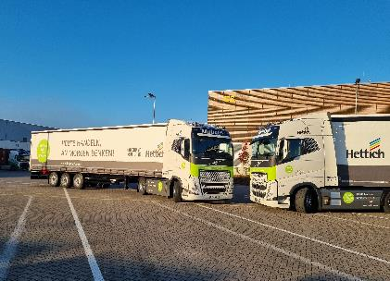
062025_a
Optimising logistics processes for a future-proof and sustainable value chain - Hettich relies on global networking and efficient collaboration. Photo: Hettich

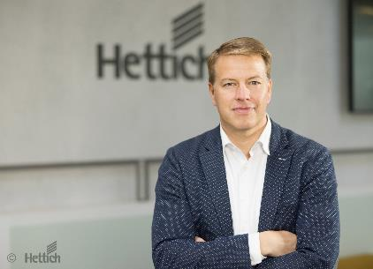
062025_b
Michael Lehmkuhl, managing director at Hettich, believes in global networking to meet the challenges of the future. Photo: Hettich

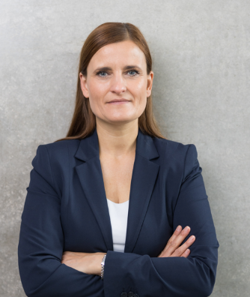
062025_c
Managing change with respect and transparency: Jana Schönfeld, Managing Director at Hettich. Photo: Hettich

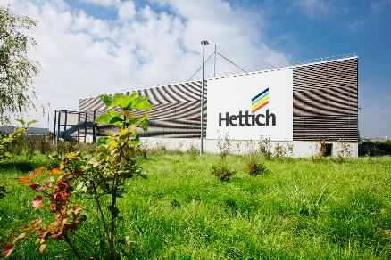
062025_d
Global networking in production: Hettich is optimising processes for the future. Photo: Hettich

About Hettich
Founded in 1888, Hettich is one of today's largest and most successful manufacturers of furniture fittings on the international stage. The family-owned company is based in Kirchlengern, in the furniture-making cluster of Germany's East Westphalia region. Around 8,600 colleagues work together to deliver our future proof solutions to over 100 countries. Promising "It's all in Hettich", the Hettich brand provides a comprehensive portfolio of services that is consistently and resolutely geared to the needs of customers across the globe. By tradition, top priority has always been at the focus of everything we do to ensure sustainability at social, societal and ecological level. www.hettich.com

